# Table of grammar contents – B1

## Complete list of B1 grammar contents

This is a list of all the grammar topics covered in level B1. But if you want to learn B1 grammar, we recommend studying the lessons in the order that they appear in: Grammar points » [B1 Grammar lessons and exercises](https://test-english.com/grammar-points/b1/).

### Present tenses

B1 [Present simple or present continuous](https://test-english.com/grammar-points/b1/present-simple-present-continuous/)  
B1 [Past simple or present perfect?](https://test-english.com/grammar-points/b1/past-simple-present-perfect/)  
B1 [Present perfect simple and present perfect continuous](https://test-english.com/grammar-points/b1/present-perfect-simple-present-perfect-continuous/)

### Past tenses

B1 [Past simple, past continuous, past perfect](https://test-english.com/grammar-points/b1/past-simple-past-continuous-past-perfect/)

### Future

B1 [Future forms: Will, be going to, present continuous](https://test-english.com/grammar-points/b1/future-forms/)

### Verb tense reviews

B1 [Review of all verb tenses B1](https://test-english.com/grammar-points/b1/review-verb-tenses-b1/)

### Modals, the imperative, phrasal verbs, etc .

B1 [Have to, must, should: Obligation, prohibition, necessity, advice](https://test-english.com/grammar-points/b1/have-to-must-should/)  
B1 [Can, could, be able to: Ability and possibility](https://test-english.com/grammar-points/b1/can-could-be-able-to/)  
B1 [Modal verbs of deduction: Must, might, could, can’t](https://test-english.com/grammar-points/b1/modal-verbs-of-deduction/)  
B1 [Usually, used to, be used to, get used to](https://test-english.com/grammar-points/b1/usually-used-to-be-used-to-get-used-to/)  
B1 [Had better… it’s time](https://test-english.com/grammar-points/b1/had-better-its-time/)  
B1 [Would rather & Would sooner](https://test-english.com/grammar-points/b1/would-rather-would-sooner/)  
B1 [B1 Phrasal verbs 1: Exercises and explanation](https://test-english.com/grammar-points/b1/b1-phrasal-verbs-1-exercises-explanation/)  
B1 [B1 Phrasal verbs 2: Exercises and explanation](https://test-english.com/grammar-points/b1/b1-phrasal-verbs-2-exercises-and-explanation/)  
B1 [B1 Phrasal verbs 3: Exercises and explanation](https://test-english.com/grammar-points/b1/b1-phrasal-verbs-3-exercises-and-explanation/)

### Conditionals, ****if****, ****wish****, etc.

B1 [First conditional, future time clauses](https://test-english.com/grammar-points/b1/first-conditional-future-time-clauses/)  
B1 [Second conditional: Unreal situations](https://test-english.com/grammar-points/b1/second-conditional-unreal-situations/)  
B1 [First and second conditionals](https://test-english.com/grammar-points/b1/first-and-second-conditionals/)  
B1 [Third conditional: Past unreal situations](https://test-english.com/grammar-points/b1/third-conditional-past-unreal-situations/)

### Passive

B1 [Passive verb forms](https://test-english.com/grammar-points/b1/passive-verb-forms/)  
B1 [Active and passive voice](https://test-english.com/grammar-points/b1/active-passive-voice/)

### Reported speech

B1 [Indirect speech / Reported speech](https://test-english.com/grammar-points/b1/reported-speech-indirect-speech/)

### -ing and the infinitive

B1 [Gerund or infinitive: Do, to do, doing](https://test-english.com/grammar-points/b1/gerund-or-infinitive-do-to-do-doing/)

### Articles, nouns, pronouns, and determiners.

B1 [A(n), the, no article](https://test-english.com/grammar-points/b1/an-the-no-article/)  
B1 [Reflexive pronouns: Myself, yourself](https://test-english.com/grammar-points/b1/reflexive-pronouns-myself-yourself/)  
B1 [Much, many, a lot, little, few, some, any, no: Quantifiers](https://test-english.com/grammar-points/b1/much-many-lot-little-no/)  
B1 [All, both: Quantifiers](https://test-english.com/grammar-points/b1/all-both/)  
B1 [Both, either, neither: Quantifiers](https://test-english.com/grammar-points/b1/both-either-neither/)  
B1 [Any, no, none: Quantifiers](https://test-english.com/grammar-points/b1/any-no-none/)  
B1 [Another, other, others, the other, the others](https://test-english.com/grammar-points/b1/another-other-others-the-other-the-others/)

### Relative clauses, relative pronouns and adverbs

B1 [Defining and non-defining relative clauses](https://test-english.com/grammar-points/b1/defining-and-non-defining-relative-clauses/)

### Auxiliary verbs

B1 [Question tags: Aren’t you? don’t you?](https://test-english.com/grammar-points/b1/question-tags/)

### Adjectives and adverbs

B1 [Comparative and superlative adjectives and adverbs](https://test-english.com/grammar-points/b1/comparative-superlative-adjectives-adverbs/)  
B1 [-Ed/-ing adjectives: Adjectives from verbs](https://test-english.com/grammar-points/b1/ed-ing-adjectives-adjectives-verbs/)  
B1 [So, such, such a, so much, so many](https://test-english.com/grammar-points/b1/so-such-such-a-so-much-so-many/)  
B1 [Compound adjectives with numbers: ‘A two-day trip’](https://test-english.com/grammar-points/b1/compound-adjectives-with-numbers-a-two-day-trip/)

### Conjunctions and clauses

B1 [Clauses of contrast, purpose and reason](https://test-english.com/grammar-points/b1/clauses-contrast-purpose-reason/)

### Prepositions

B1 [Verb + preposition](https://test-english.com/grammar-points/b1/verb-preposition/)  
B1 [Adjective + preposition](https://test-english.com/grammar-points/b1/adjective-preposition/)  
B1 [During, for, while](https://test-english.com/grammar-points/b1/during-for-while/)  
B1 [For, since, from: What’s the difference?](https://test-english.com/grammar-points/b1/for-since-from-difference/)

## Present simple vs present continuous: Form

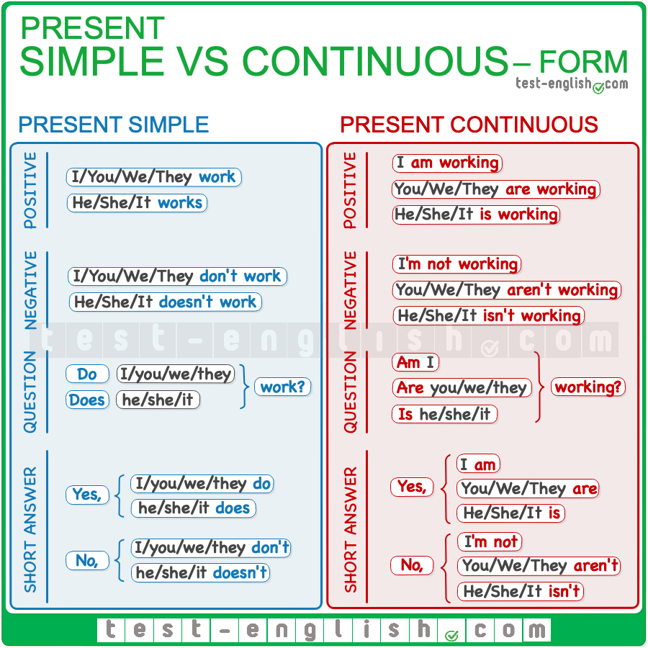

#### Present simple: Short forms

We normally use **short forms in spoken English**.

‣ do not = **don’t**  
‣ does not = **doesn’t**

#### Present continuous: Short forms

We normally use **short forms in spoken English**.

‣ am not doing = **‘m not**  
‣ is not = **isn’t/’s not**  
‣ are not = **aren’t/’re not**

## Present simple vs present continuous: Use

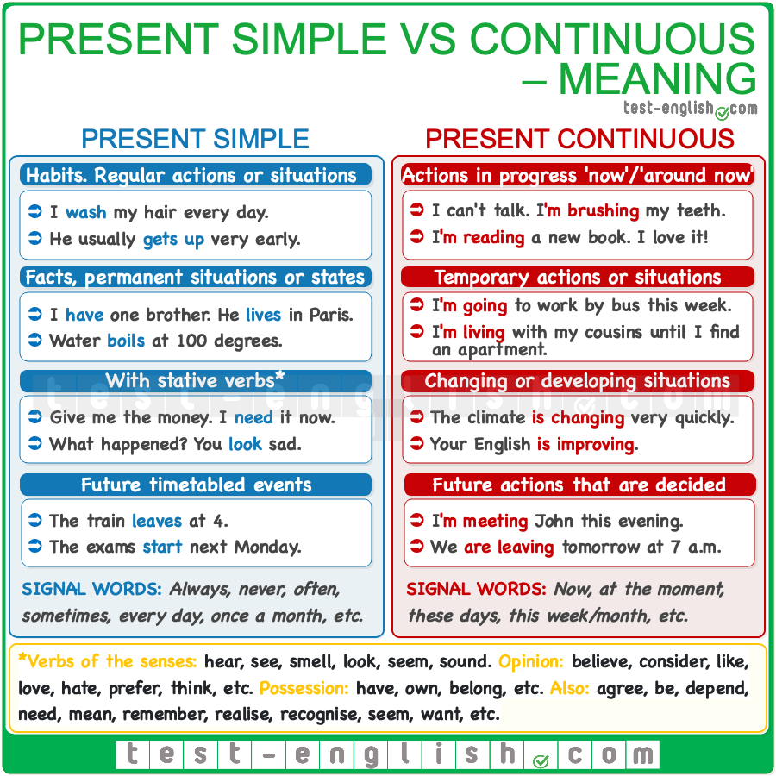

## Present simple use

#### Habits or situations that happen regularly

We use the present simple to talk about actions that we do (o we don’t do) regularly:

* I **wash** my hair every day.
* I never **go** to the library.
* I sometimes **go** to the library.

#### Permanent situations or things that are usually or often true

* I **don’t drink** coffee.
* She**’s** very tall.
* I **have** two brothers.
* Water **boils** at 100 degrees.
* I **like** soup.

#### Adverbs of frequency

We often use the present simple with [**adverbs of frequency**](https://test-english.com/grammar-points/a1/adverbs-frequency/) (always, sometimes, etc.) and **expressions of frequency** (once every three months, twice a week, every other day, etc.).  
  
**Adverbs of frequency** go in mid position (before the main verb or after **be**).

* She doesn’t **often** eat hamburgers.
* He **usually** gets up very early.
* I am **never** late.

**Expressions of frequency** go at the end of the sentence

* We go to the cinema **once a month**.
* I buy clothes **twice a year**.

#### Future events that are timetabled

We use the present simple to talk about future events that are scheduled or timetabled.

* The train **leaves** at 4.
* Shops **close** at 6.
* My yoga class **is** tomorrow at 10.

## Present continuous use

#### Actions in progress

We use the present continuous to talk about things that are happening now or ‘around now’ (a time around this moment, such as these days, weeks or months)

* I can’t talk now. I’**m brushing** my teeth.
* I finished the Lord of the Rings and now I**’m reading** a new book.

#### Temporary actions

The present continuous is used to talk about temporary actions:

* I’**m going** to work by bus this week because my car is at the garage.
* I’**m living** with my cousins until I find a flat.

#### With expressions meaning ‘now’ or ‘around now’.

The present continuous often appears next to expressions such as **now**, **these days, this week/month,** or **at the moment**.

* He’**s studying**a lot this week.
* I’**m not feeling** very well these days.

#### Situations that are changing or developing

* The climate **is changing** very quickly.
* More and more people **are trying** to eat more healthily nowadays.
* Your English **is improving**.

#### Future arrangements

We use the present continuous to talk or ask about future actions that are already planned or decided.

* I**‘m meeting** John this evening. Do you want to come?
* We **are leaving** tomorrow at 7.

## Stative verbs

[**Non-action verbs**](https://test-english.com/grammar-points/a2/stative-vs-dynamic-verbs-or-non-action-vs-action-verbs/) (or **stative verbs**) cannot be used in present continuous. They must be used in present simple.

The most frequent stative verbs are the verbs of the senses (**hear, see, smell, look, seem, sound**), verbs of opinion (**believe, consider, like, love, hate, prefer, think, etc.**) verbs of possession (**have, own, belong, etc.**). Other common non-action verbs are: **agree, be, depend, need, mean, remember, realise, recognise, seem, want, etc.**

* Please, give me my money; I **need** it now.
* Look at her; she **seems** sad.

Some verbs have an **action** and a **non-action** meaning; for example, have or think:

* I **have** a car (=possession) / I’**m having** a siesta (=action)
* I **think** he is great (=opinion) / What **are** you **thinking**? (=action)

The verb **see** also has a dynamic and a stative meaning.

* I**‘m seeing** the doctor tomorrow at 9. (see= ‘have an appointment’)
* What **do** you **see** in this picture? (see= ‘see with your eyes’)

## Present perfect: Form

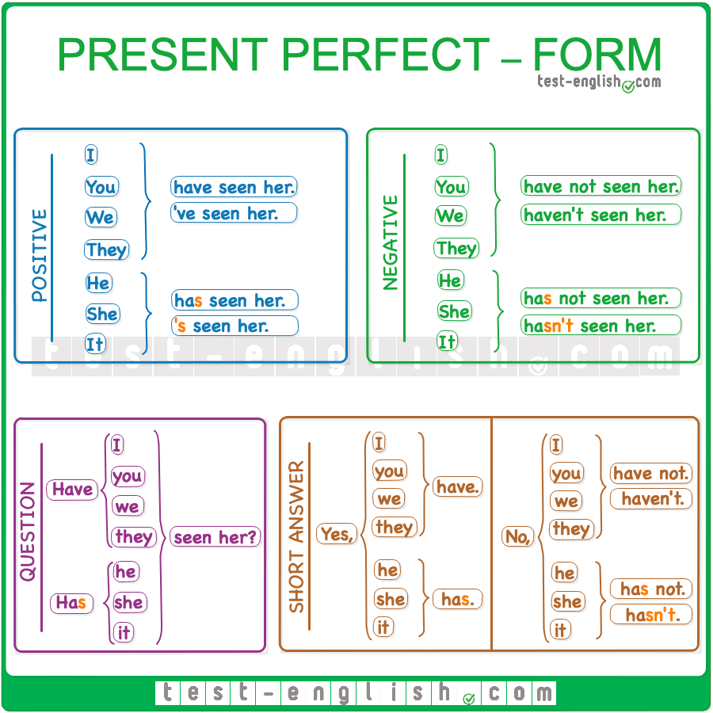

#### Short forms

‣ has= **‘s**  
‣ have= **‘ve**  
‣ have not= **haven’t**

❗ **Note** that short forms are **not** used **in positive short answers**.

* ‘Have you washed the dishes yet?’ ‘Yes, I**‘ve**.’ 
* ‘Have you washed the dishes yet?’ ‘Yes, I **have**.’  

## Present perfect: Use

### Summary chart

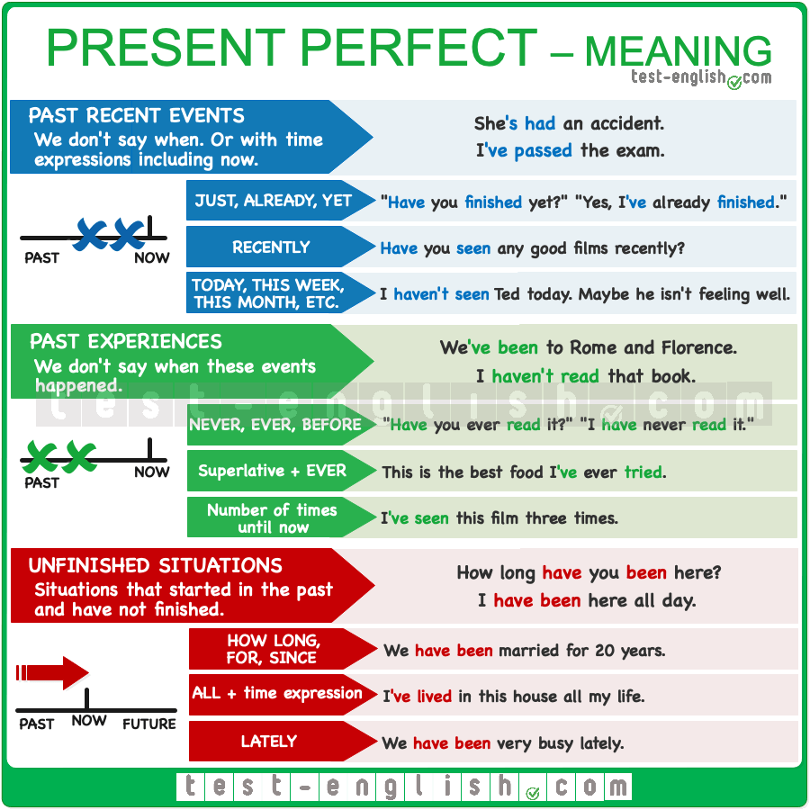

### Past events when time is not mentioned

We use the **present perfect** to talk about **past actions** or events when **time** is **not mentioned**, i.e. we don’t say **when** these events happened.

* I**‘ve broken** my arm.
* I**’ve passed** the exam.
* She**’s found** a job.

#### ****Just already, yet****

We often use the **present perfect** with **just**,**already** and **yet**. We can use **just** after the verb **have**to emphasise that these events are very recent.

* Tony **has just called**.

We use **already** in **positive sentences** to talk about actions that we have **completed sooner than we expected**. **Already** goes after the verb **have**.

* I**‘ve already finished** my homework.

We use **yet** in **negative sentences** and **questions** to talk about things that we expect to happen soon. **Yet** goes at the end of the sentence.

* **Have** you **finished** your homework **yet**?
* I **haven’t finished** my homework **yet**.

#### ****Recently****

We often use the present perfect with **recently** to talk about past recent actions.

* They**‘ve recently bought** a new car.

#### ****Today, this week, this month, this year****

We can use the present perfect with time expressions when the time we mention has not finished.

* I**‘ve seen** John **today**. (=Today has not finished.)
* **Has** she **called** you **this week**?

### Past experiences: ****Never, ever, before****

We use the **present perfect** to talk about past experiences when we **don’t say** or we don’t know **when**something happened.

* He **has been** to the moon. He’s an astronaut.
* I **haven’t been** to India.

#### ****Never, ever, before****

We often use the words **never, ever,**or **before** to talk about experiences.

* I**‘ve never read** this book.
* **Have** you **ever seen** a John Wayne film?
* I **haven’t experienced** anything like this **before**.

#### The best thing I’ve ever done

We can use the present perfect simple with a superlative adjective and **ever**.

* This is the **best** meal I**’ve ever had**.
* It’s the **most amazing** place we**’ve ever travelled** to.

#### How many times

We can also use the **present perfect** to say **how many times** something has happened until now.

* I’ve watched this film **three times**.
* We’ve been to Paris **twice**.

#### ****Have gone to**** or ****have been to****?

We say **someone has gone somewhere** when this person is still away, and we say **someone has been somewhere** when this person has already come back from that place.

* Tom **has gone** to Ireland. He’ll be there for a couple of weeks. (=He’s in Ireland now.)
* We **have been** to Ireland three times. We love it. (=We are not in Ireland now.)

### Duration from the past until now: ****For, since****

We can use the **present perfect** with **for**, **since** and **how long** to ask or talk about **situations** that started in the past and have **not finished**.

* We**‘ve been** married for 25 years.
* I**‘ve had** this watch since I was a kid.
* **How long** **have** you **been** friends?

Compare:

* We**‘ve been** married for 20 years. (=We are married now)
* We **were** married for 20 years. Then we divorced. (We are not married now)

#### ****For**** + period of time; ****since**** + moment in the past

We use **for**+ period of time (**two hours, three days, ten years, etc**.), and we use **since**+ the moment in the past when something started.

* I’ve been here **for hours**.
* She’s been my teacher **for three years**.
* I’ve been unemployed **since May**.
* I’ve lived in this town **since I was born**.

#### ****Lately, all morning/day/year/etc.****

We can also use the present perfect with **lately** or with **all** + period of time (**all day, all morning, all my life, etc**.) to talk about actions that started in the past and continue in the present.

* She’s been with me **all day**.
* I’ve been very busy **lately**.

#### Don’t use ****ago****

We can’t use **ago** with the **present perfect**.

* I’ve had my watch **since** two years **ago**. 
* I’ve had my watch **for** two years. 

## Past simple or present perfect?

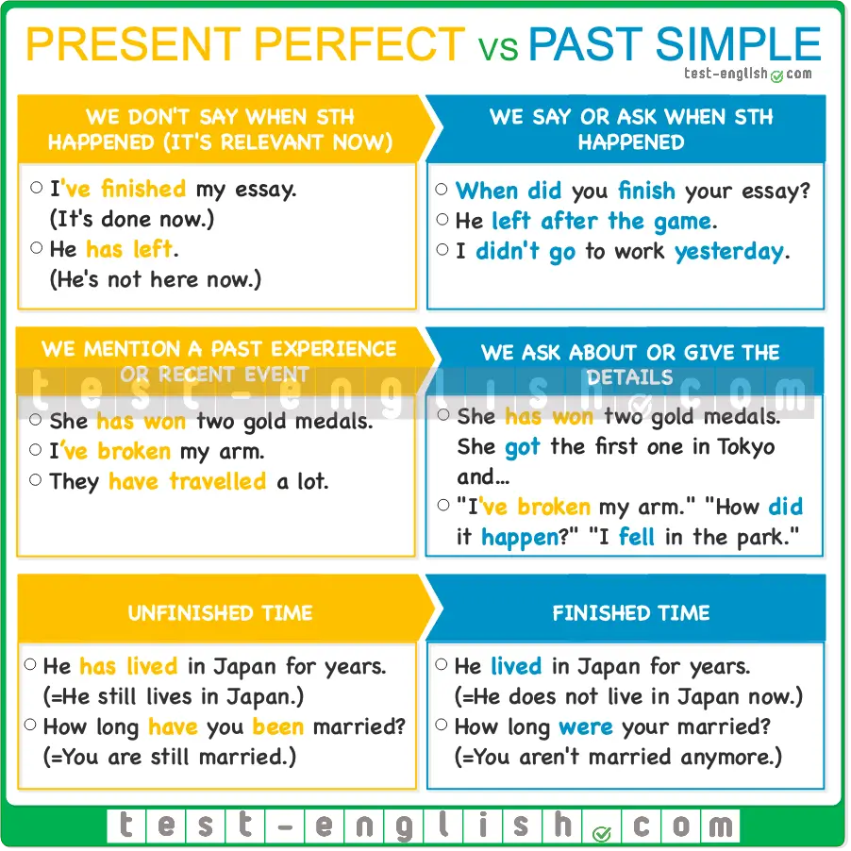

#### When did it happen?

We use the **present perfect** (NOT past simple) to talk about past experiences and actions when we **don’t say**or don’t know **when**they happened.

* I**’ve lost** my keys.
* We**‘ve been** to a very nice restaurant.

We use the **past simple** (NOT present perfect) when we mention or ask about **when something happened** or when **the time is known** by the speaker and the listener. We often use a past expression (**last week, yesterday, when I was a child, etc**.)

* We**‘ve arrived yesterday**. 
* We **arrived yesterday**. 
* **When has** the accident **happened**? 
* **When did** the accident **happen**? 

#### Giving details in the past simple

We use the **present perfect** to introduce a past event or experience, but if we continue talking and we give details, then we use the **past simple**.

A: I**‘ve been** to the cinema.  
B: What **did** you **see**?  
A: I **saw** a very good film by…

A: Oh, you**‘ve broken** your arm.  
B: Yes, I **have**.  
A: How **did** it **happen**?

## Present perfect simple: Use

#### Grammar chart



We use the [present perfect simple](https://test-english.com/grammar-points/b1/past-simple-present-perfect/) with **past finished actions or experiences** when we **don’t mention**, or we don’t know **when** they happened. We also use the present perfect simple to ask or talk about **situations** that started in the past and have **not finished**.

## Present perfect continuous: Form

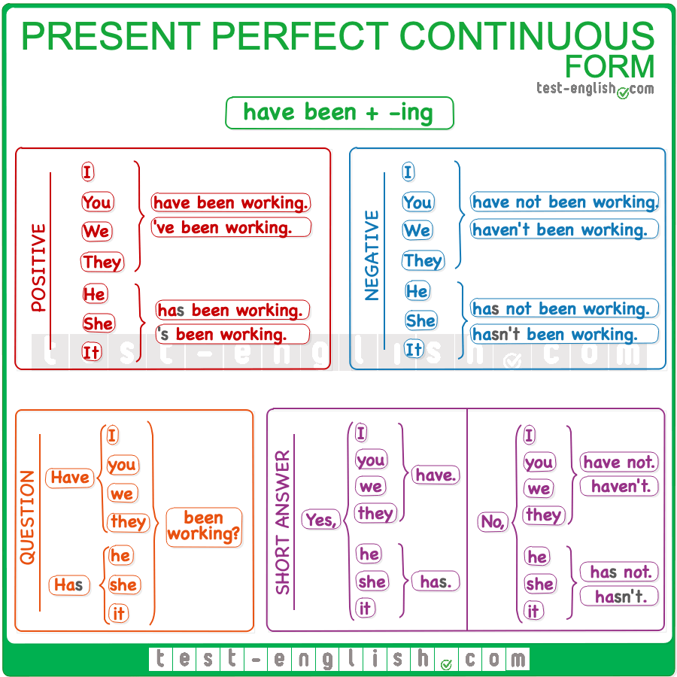

We form the present perfect continuous with the present perfect simple of **be** + the **-ing** form of the main verb.

## Present perfect continuous: Use

#### Grammar chart

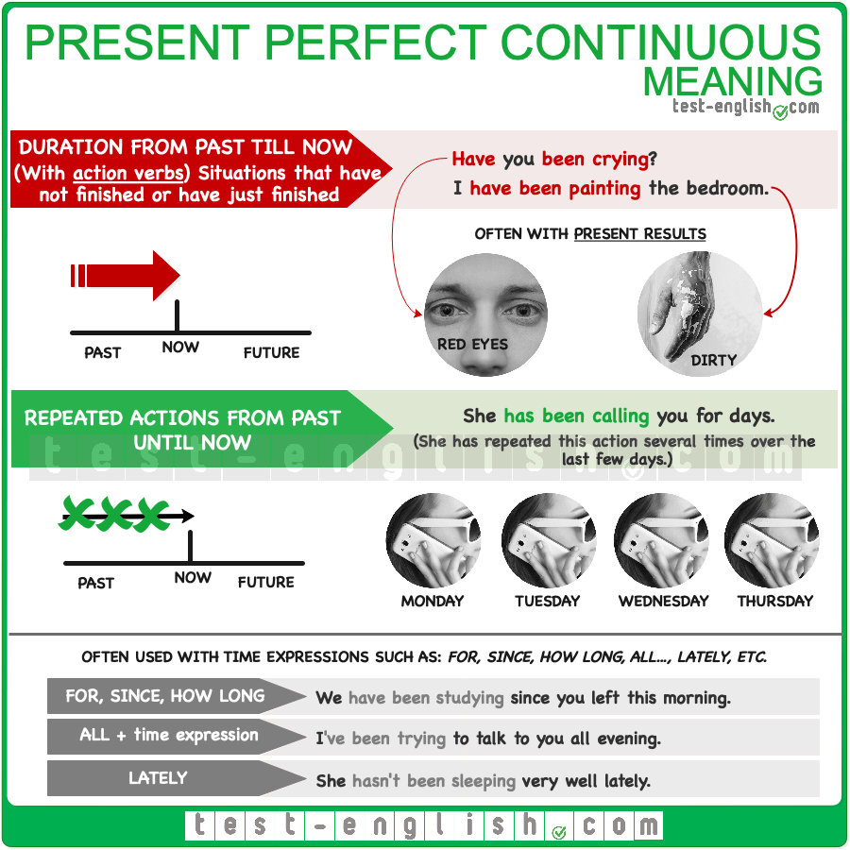

### Actions from the past till now: Duration

We use the **present perfect continuous** with **action verbs** (dynamic verbs) to talk about situations that started in the past and **have not finished** or **have just finished**.

* **Have** you **been crying**?
* Sorry I am so dirty, but I**‘ve been painting**.

There is often a **present result** from doing these actions.

* You**‘ve been crying**. (Your eyes are red.)
* I am dirty because I**‘ve been painting**.

We can use the present perfect continuous to talk about **continuous or repeated** actions or situations from the past till now.

* She‘**s been calling** you for days. (=She has repeated this action for several days.)
* I**‘ve been studying** since you left. (=I have done this action continuously without stopping.)

#### ****For, since, how long, lately, all day/week/month/etc.****

We can use **for, since, how long, lately, all day/week/month/etc.** to ask or say **how long** a situation has been happening.

* I haven’t been feeling well **lately**.
* He’s been annoying us **all evening**.
* She’s been studying very hard **for weeks**.
* **How long** have you been playing golf?

## Present perfect simple or continuous?

#### Situations that started in the past and still continue

We can use the present perfect simple and the present perfect continuous to talk about situations that started in the past and still continue. But we must use the **present perfect simple** with [non-action verbs](https://test-english.com/grammar-points/a2/present-simple-continuous/) (stative verbs), and we normally use the **present perfect continuous** with **dynamic verbs** (although the present perfect simple is also possible.)

* We**‘ve had** this car for years.
* I **haven’t been sleeping** well lately.

We use the **present perfect continuous** (and NOT simple) with dynamic verbs for situations that started in the past and still continue when we want to **emphasise how long** the situation has lasted.

* I have been waiting **for hours**! (=I want to emphasise that I’ve been waiting for a long time).
* I couldn’t do the dishes. I’ve been working **all day**.

#### Finished and unfinished situations

We use the **present perfect simple** for **finished** actions in the past when we don’t say **when**. We use the **present perfect continuous** for actions or situations that maybe have not finished or that maybe have finished (very recently)

* Who **has eaten** my cookies? (=We would say this if there were no cookies left. The action is finished.
* Who **has been eating** my cookies? (=We would say this if there are some cookies left)
* I**‘ve been watching** the series you recommended. I’ll tell you about it when I finish watching it.
* I**‘ve watched** the series you recommended. I watched the last episode yesterday.

#### Actions with present results

We can use present perfect simple and present perfect continuous for actions with **present results**. We use the **present perfect simple** if the **present results** come **from completing the action**.

* Look how nice my car looks. I**‘ve washed** it. (=The car looks nice because I have finished washing it.)
* Something is different in this house. **Have** you **painted** it? (=The house looks different because you have completed the action of painting it.)

We use the **present perfect continuous** if the **present results** come **from the process of doing the action**.

* Sorry, I’m so sweaty. I**‘ve been washing** my car. (=I am sweaty because of the physical activity that washing the car involves.)
* How come you are so dirty? **Have** you **been** **painting**? (=You are dirty because of the process of painting.)

#### ****How long**** vs ****how many/much****

We use the **present perfect continuous** to talk about the duration of an action, i.e. about **how long** we have been doing something. And we use the **present perfect simple** to talk about **how many** things or **how much** of something we have done.

* I’ve written **twenty** emails. (I’m talking about **how many** emails I’ve written.)
* I’ve been writing emails **for hours**. (=I’m talking about **how long** I have spent writing emails)

### Past tenses

## Past simple, past continuous, past perfect: Grammar chart

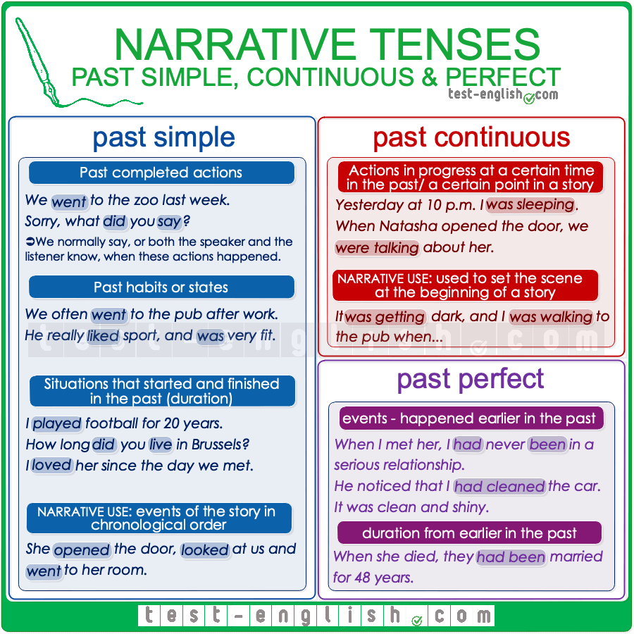

## Past simple

We use the [past simple](https://test-english.com/grammar-points/a2/past-simple-form-use/) to talk about **completed actions in the past**.

* We **ate out** yesterday. (the action is finished)

In a story, we use the past simple to talk about **past events in chronological order**, i.e. the main events of a story.

* When she **opened** the door, she **pretended** that we weren’t there and she **went** to her room.
* He **called** me and **told** me to go, but when I **arrived**, he wasn’t there.

We also use the past simple to talk about **past habits** or **past states**.

* We often **went** to the bar for a drink before dinner.
* He really **liked** sport and **was** very fit.

## Past continuous

We use the [past continuous](https://test-english.com/grammar-points/a2/past-continuous-past-simple/) to **set the scene** in a story.

* Last night, I **was walking** home and **listening** to my iPod when …
* The sun **was shining**, and lots of tourists **were lying** on the beach. Suddenly …

We use the past continuous for **actions in progress** in the past or longer actions interrupted by shorter actions in the past simple.

* After dinner, I went into the living room and saw that she **was crying**.
* When she opened the door, we **were talking** about her.

## Past perfect

We use the [past perfect](https://test-english.com/grammar-points/a2/past-perfect/) simple to talk about an earlier past: events which happened before the main event.

#### Earlier single events

We use the past perfect simple to talk about earlier events and experiences or single actions completed earlier in the past.

* When she opened the door, he **had** already **left**.
* I realised that I **had been** there before.
* When I met her, I **had** never **been** in a serious relationship.
* He noticed I **had cleaned** the car. It was smooth and shiny.

We use the past perfect simple to say **how much or how many** we had done of something earlier in the past.

* We **had driven** 500 miles, and we needed some rest.
* How many hours **had** he **slept** when you woke him up?

#### Duration from earlier in the past (stative verbs)

We use the past perfect simple with stative verbs to talk about states or situations that had started earlier in the past. We often use **how long**, **for** or **since, always**, **etc**.

* The day Anne died, they **had been** married for 48 years.
* The day I left, I **had been** in England for exactly four years.
* She told me she **had** always **hated** her sister.

In the picture below, you can see an example of a narrative with the past tenses explained.  
  
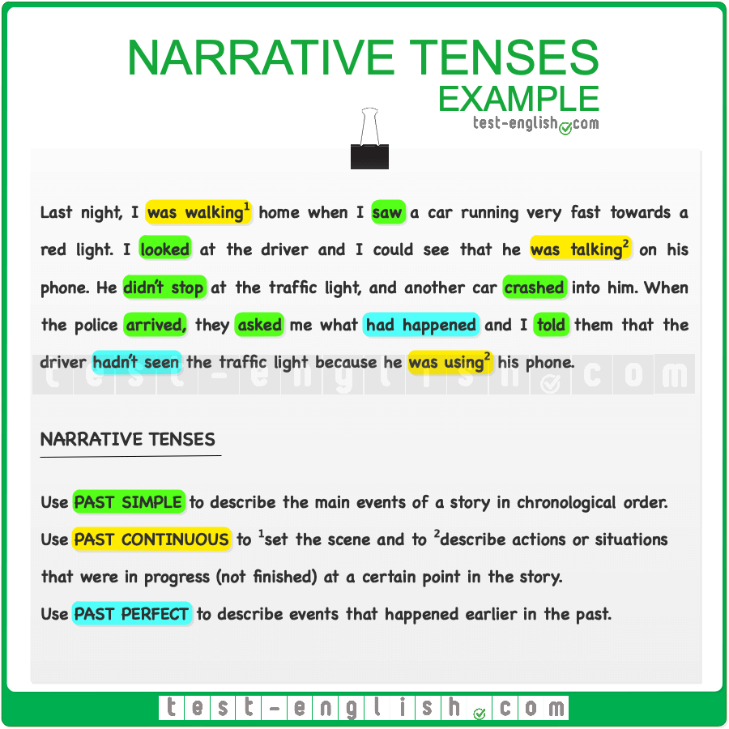

### Future

## Future forms: Grammar chart

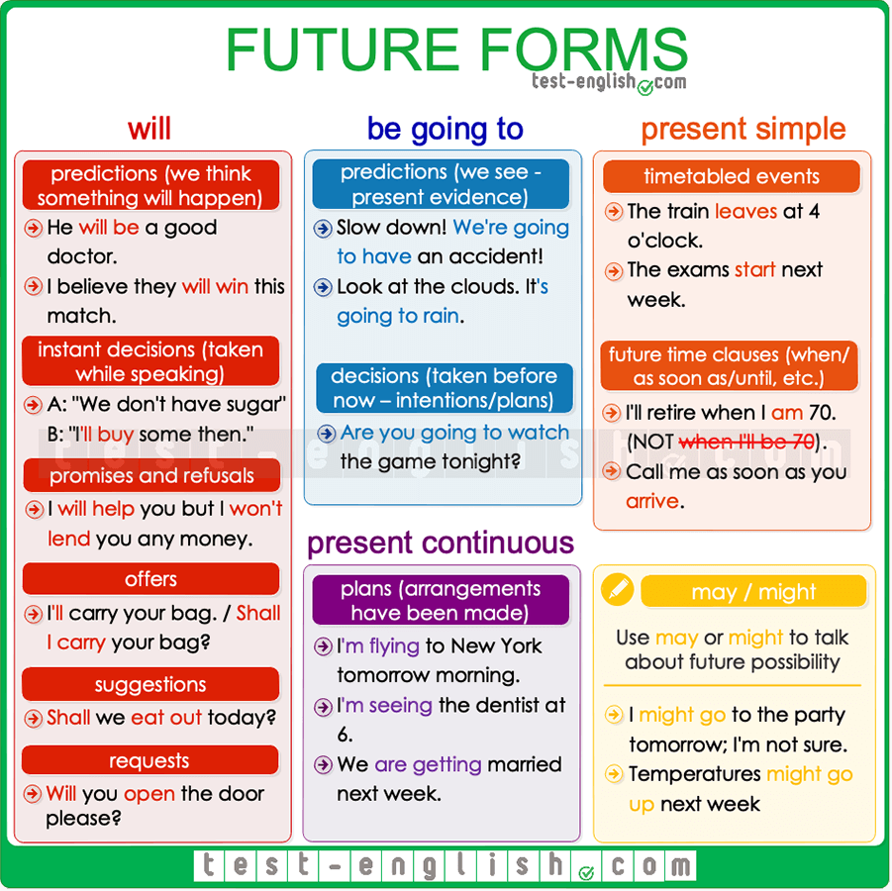

## Predictions

We use **will** to talk about something we **think** that will happen:

* I think he’**ll win** the election.
* He **will be** a good doctor.

We use **be going to** to talk about something that is very near to happen or that we **see** is going to happen (there is present evidence)

* Don’t drive like a crazy man. We’**re going to have** an accident!
* The doctor said I’**m going to have** a girl.

## Decisions

We use **will** for decisions that we take at the moment of speaking (**instant decisions)**.

* ‘Oh, we don’t have sugar.’ ‘Don’t worry, I’**ll buy** some.’

We use **be going to** for decisions that we have already taken at the moment of speaking (**intentions or plans**).

* ‘Why are you undressing?’ ‘Because I’**m going** to go to the swimming pool.’

## Arrangements

We often use the **present continuous** to talk about future events that have already been planned or decided. When we use the **present continuous** for arrangements, we must always include **when** (at 7, this evening, next month, etc.) in the sentence.

* I’**m seeing** the dentist at 6.
* We **are getting** married next week.
* I’**m flying** to New York tomorrow morning.

We can also use **be going to**for future arrangements.

* I’**m going to** play tennis with Elisabeth today.

## Future time clauses (****when****, ****as soon as****, ****until****, ****before****, ****after****)

Use the **present simple** to talk about the future in sentences with **when, as soon as, until, before** and **after**.

* I’ll retire when I**‘ll be** 70. 
* I’ll retire when I**‘m** 70. 
* I won’t call you until I **will arrive**. 
* I won’t call you until I **arrive**. 

## Other uses of ****will****

#### Promises and refusals

* I **will help** you whenever you need me.
* I **won’t lend** him my car.

#### Future facts

* The president **will visit** the Vatican next November.

#### Offers

We use **I will** in statements or **shall** **I** in questions.

* I’**ll carry** that bag for you.
* Shall I **organise** the meeting?

#### Suggestions

We use **shall we…?**

* Shall we **eat** out today?

#### Requests

When we ask someone to do something for us.

* Will you **open** the door, please?

## ****May**** or ****might**** as a future form

We use **may** or **might** for possible actions in the future (when ‘we are not sure’). Compare:

* I’**ll be** late for dinner today. (=I am sure.)
* I **might** **be** late for dinner today. (=It’s possible, but I am not sure.)
* I’**m going** to Denmark next September. (=Sure.)
* I **might go** to Denmark next September. (=Not sure.)

We use **may** or **might** for things that will possibly happen in the future, but we are not too sure. It’s like a prediction about something that we think perhaps will happen.

* The economy **might suffer** a global recession next year.
* Temperatures **may go up** next week.

We use **may** or **might not**for actions or things that will possibly not happen.

* She looks very tired. She **might not come** with us.
* We **may not have** enough time to finish the report for tomorrow.

### Verb tense reviews

### Review of the present simple and the present continuous

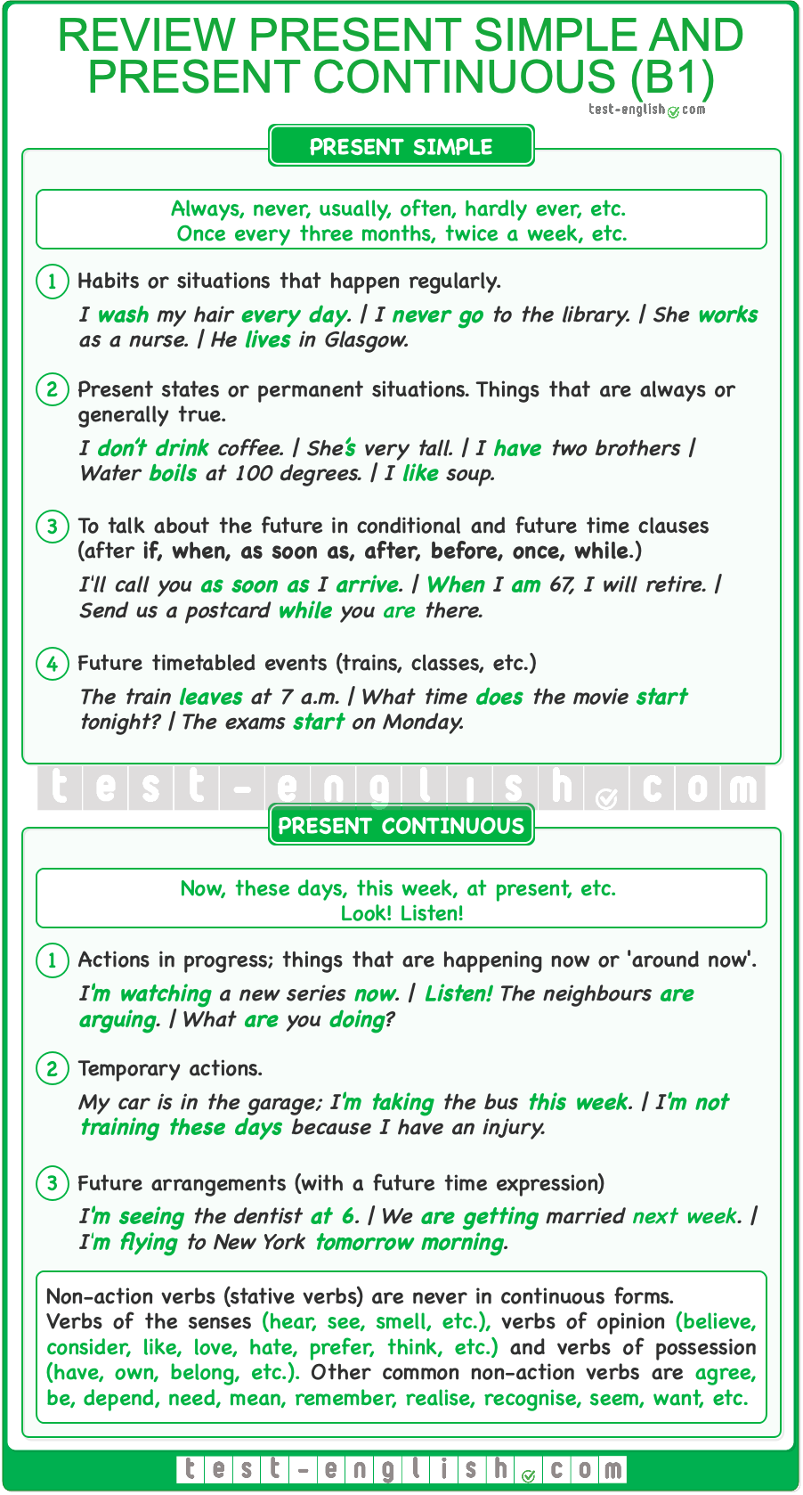

### Review of the present perfect simple and the present perfect continuous

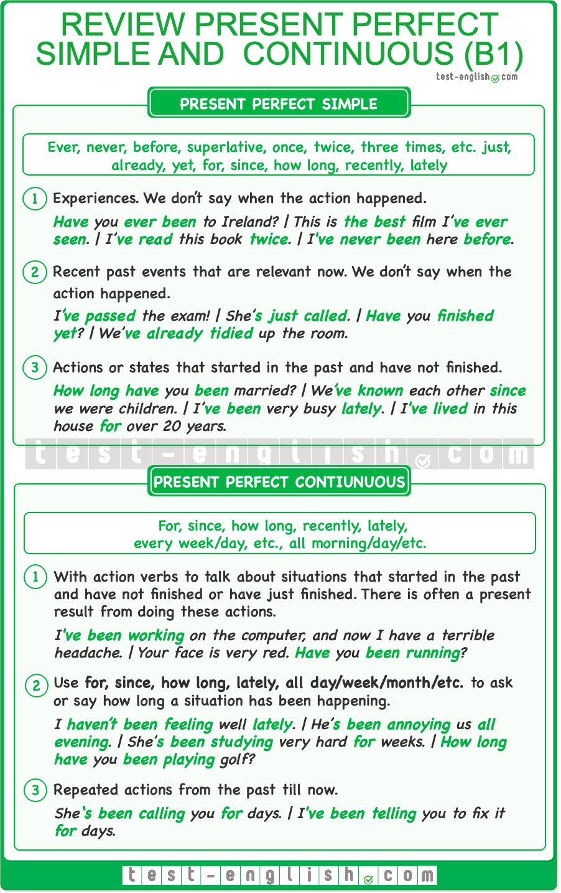

### Review of the past simple, past continuous, and past perfect

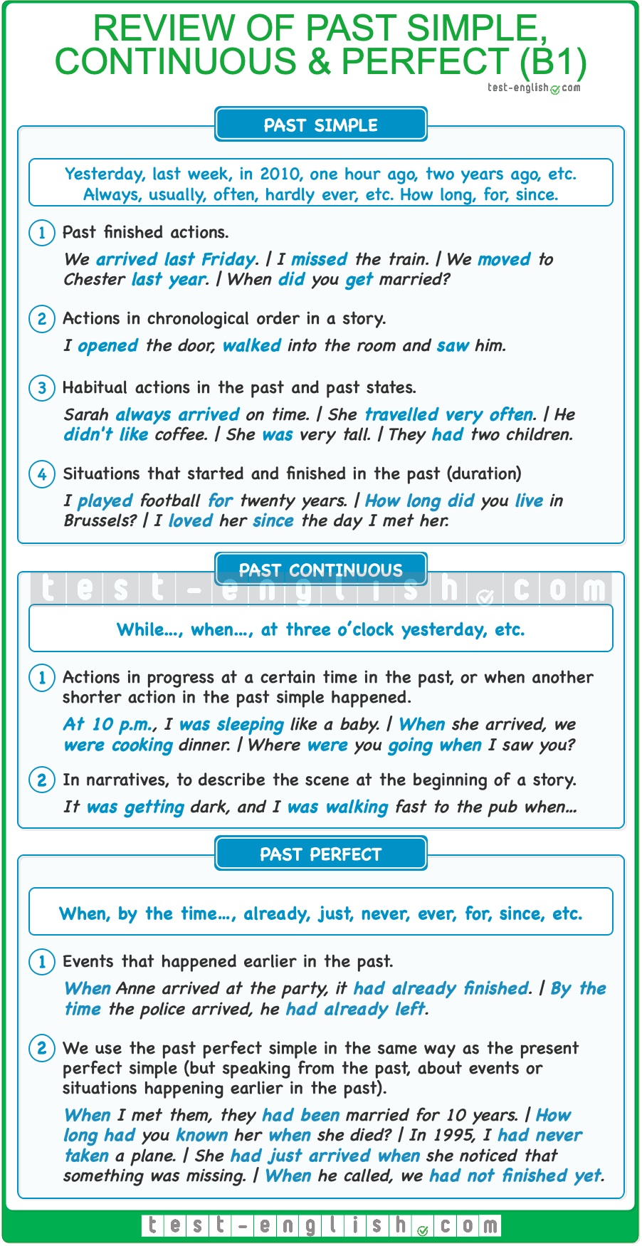

### Review of all B1 future verb forms

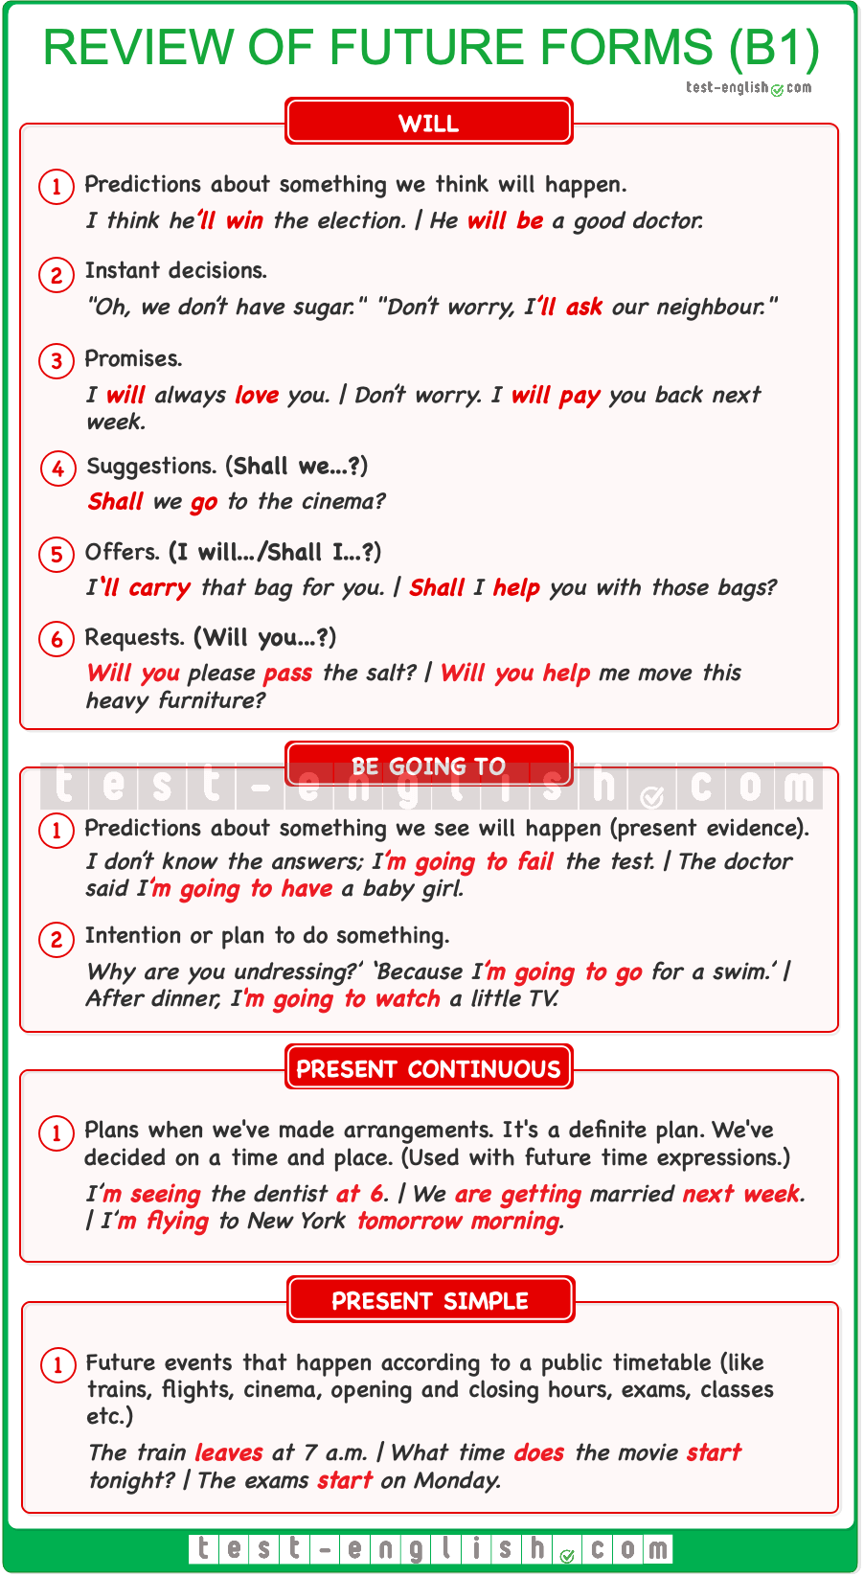

### Modals, the imperative, phrasal verbs, etc .

## ****Must/mustn’t, have to/don’t have to****: Form

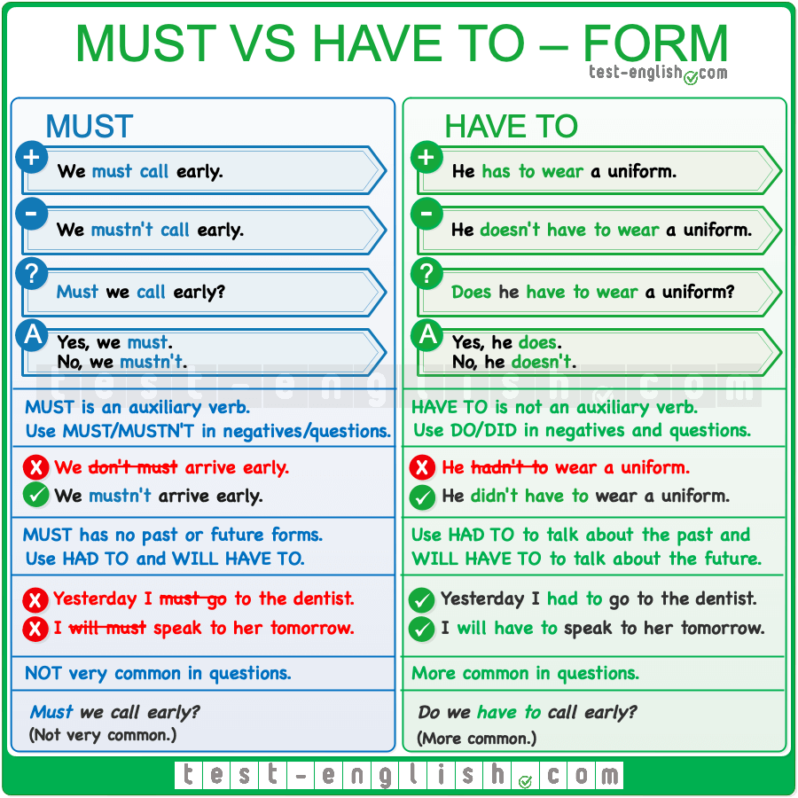

## ****Have to****

**Have to** is NOT an auxiliary verb. We need **do/does/did** to make negatives and questions in the present and past.

* **Have** you**to** get up early tomorrow? 
* **Do** you **have to** get up early tomorrow? 
* **Did** you **have to** change the sound card?
* We **don’t have to** stay until the end.

We can use **have to** in all the verb forms (present, past and perfect tenses, gerund, to infinitive, etc.)

* I don’t like **having to** get up early.
* She’**s had to** work at weekends since she started working.
* I **had to** cancel the meeting.

It is used to describe an **obligation**, a rule, or something that is necessary.

* You **have to drive** on the left in England.
* I’**ll have to get up** early tomorrow. The exam is at 8.

#### ****Have got to****

In spoken informal English, you can often use **‘ve got to** instead of **have to**.

* I can’t stay; I’**ve got to go** to the supermarket.

## ****Must****

**Must** is a modal verb, and it has a present form, which can be used to talk about the present or future. The negative form is **must not** or **mustn’t**, and the question is **must I, must you, etc**.

* I **must go** to the doctor.
* I **must get up** early tomorrow.
* You **mustn’t call** me before 8.

It is used to describe something that the speaker thinks is necessary to do.

* You **must eat** less candy.
* I **must try** to do more exercise.

We can also use **must** to express strong advice.

* You **must see** the new film; it’s amazing!

## ****Must/mustn’t, have to/don’t have to**** – Use

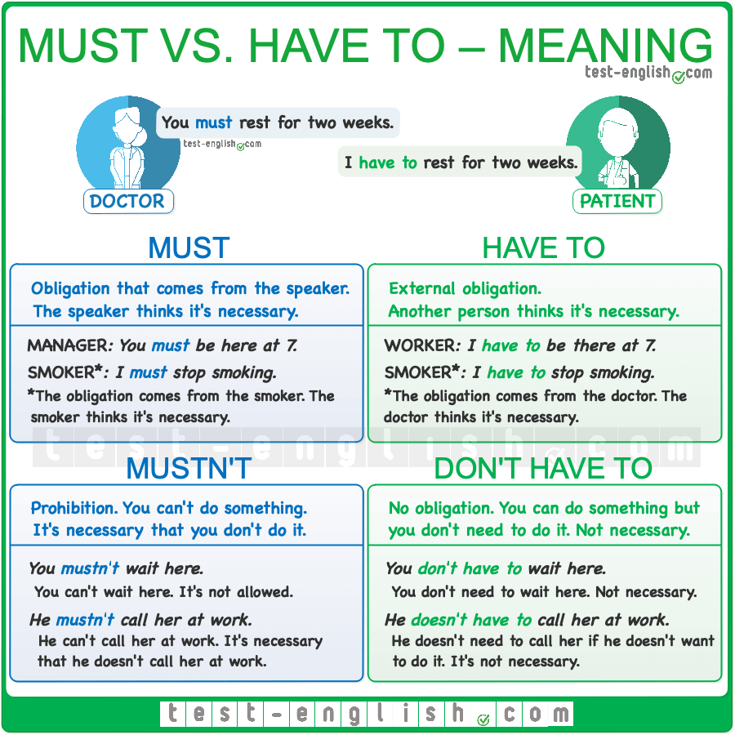

## ****Must**** or ****Have to****?

**Must** only has a present form, so we need to use **have to** for all other verb forms (past, future, perfect forms, infinitive, etc.).

* You **will have to come** with me.
* We **had to drive** very fast.

We normally use **have to** for **questions**. Questions with **must** are not common.

* **Do** we **have to sit** here?

Regarding the meaning, sometimes there is little difference between **have to** and **must**.

* I **must go** to the hospital.
* I **have to go** to the hospital.

But we normally use **have to** when there’s an **external obligation** and **must** when the obligation comes from the **opinion of the speaker**.

* We **have to get up** early tomorrow. The meeting is at nine. (external obligation)
* We **must get up** early tomorrow if we want to finish painting. (it’s the speaker’s opinion)
* You **have to wear** a suit at the meeting. (it’s a rule in the company)
* You **must buy** a new suit for the meeting. (it’s my opinion)

## ****Mustn’t**** or ****Don’t have to****?

**Don’t have to** and **mustn’t** have opposite meanings. We use **don’t have to** when we don’t need to do something, when there’s **no obligation**, and we use **mustn’t** to talk about **prohibition**, when there is obligation not to do something.

* You **mustn’t wait** here. (=it’s not allowed)
* You **don’t have to wait** here. (=you can do it, but it’s not necessary)

If you don’t have to do something, it means that you can do it if you want, but you don’t need to do it.

#### ****Can’t/be not allowed to**** = mustn’t

We can use **can’t** or **be not allowed to**  instead of **mustn’t**.

* You **mustn’t smoke** in this area. = You **are not allowed to/can’t smoke** in this area.
* Children **mustn’t eat** chewing gum. = Children **can’t/are not allowed to eat** chewing gum.

## ****Should, shouldn’t****

**Should** is used to give **advice** or an **opinion** about what we think is right or wrong.

* You **should go** to a therapist.
* *I think schools* ***shouldn’t offer*** *soft drinks to their students.*

**Should** is not as strong as **must** or **have to**.

* You **should be** patient with me. (=advice)
* You **must be** patient with me. (=strong advice)

#### ****Ought to/ought not to**** = should/shouldn’t

**Ought to** has the same meaning as **should**, although it is more formal and not as common.

* You **ought to go** to a therapist.
* You **ought not to be** so strict with your daughter.

## ****Can, could, be able to****: Ability and possibility

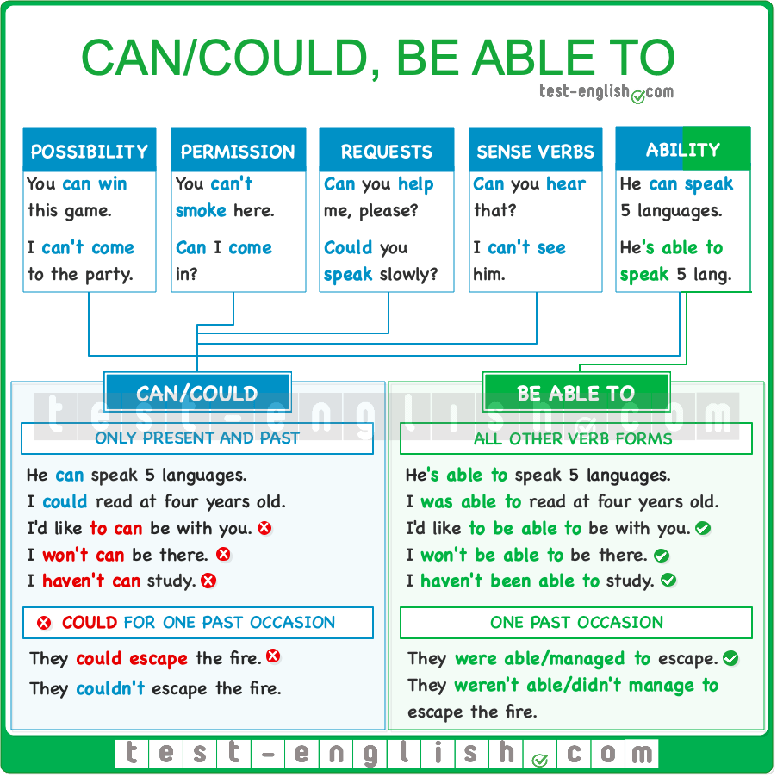

## ****Can, could****

#### Ability

We use **can/could**to describe ability, and we use **can’t/couldn’t** to describe the absence of ability.

* She **could play** the piano very well.
* Children **can’t concentrate** for long periods of time.
* I **can speak** Chinese.

#### Possibility

We also use **can** to talk about possibility.

* Anyone **can win** this competition. All the participants are very good.
* I **can’t come** to the party next week.

#### Permission

We use **can/could**to talk about something that is or was allowed, and we use **can’t/couldn’t** to talk about something that is not allowed.

* You **can’t smoke** in the house, but you **can smoke** on the terrace if you want.

We also use **can**to ask for permission.

* **Can** I **come** in?

#### Requests

We use **can/could** in requests, i.e. when we ask somebody to do something.

* **Can** you **help** me?
* **Could** you **speak** more slowly, please?

#### ****See, smell, hear, feel, taste****

Verbs of perception (**see, smell, hear, etc**.) are stative verbs and cannot be used in a continuous form. Instead, we use **can**.

* **Are** you **hearing** that? 
* **Can** you **hear** that? 
* I**‘m smelling** gas! 
* I **can smell** gas! 

## ****Be able to****

**Be able to** is often similar to **can** and we may use it instead of **can** to talk about ability. But **be able to** is more formal and is not as common.

* They **are able to do** the job faster than anyone else.

❗ **But** **can** only has present and past forms: **can**–**could**. For all other verb forms (infinitive, gerund, present perfect, etc.), we should use **be able to**.

* I’d like **to can visit** her more often. 
* I’d like **to be able to visit** her more often.  (**to**-infinitive)
* I don’t like loud music in pubs. I like **being able to talk** with my friends. (-**ing** form)
* Will we **be able to talk** to the singer after the concert? (Infinitive)
* I **haven’t been able to study** for the exam. (Present perfect)

## ****Can/could**** vs ****be able to****

We can use **can** and **be able to** to talk about general ability in the present.

* She **can speak** five languages.
* She’**s able to speak** five languages.

We can use **could** and **be able to** to talk about general ability in the past.

* My son **could walk** when he was 11 months old.
* My son **was able to walk** when he was 11 months old.

❗ **But** if we want to say that someone did something in a specific situation, we must use **was/were able to**, or **managed to** + infinitive.

* There was a fire, but all the workers **could escape**. 
* There was a fire, but all the workers **were able to/managed to escape**. 
* He didn’t have an address, but he **could find** the place. 
* He didn’t have an address, but he **was able to/managed to find** the place. 

In negative sentences, both **could** and **be able to** can be used to say that we were not capable of doing something on a specific occasion.

* It was very dark, and they **couldn’t find** the exit.
* It was very dark, and they **weren’t able to find** the exit.

## Modal verbs of deduction: Grammar chart

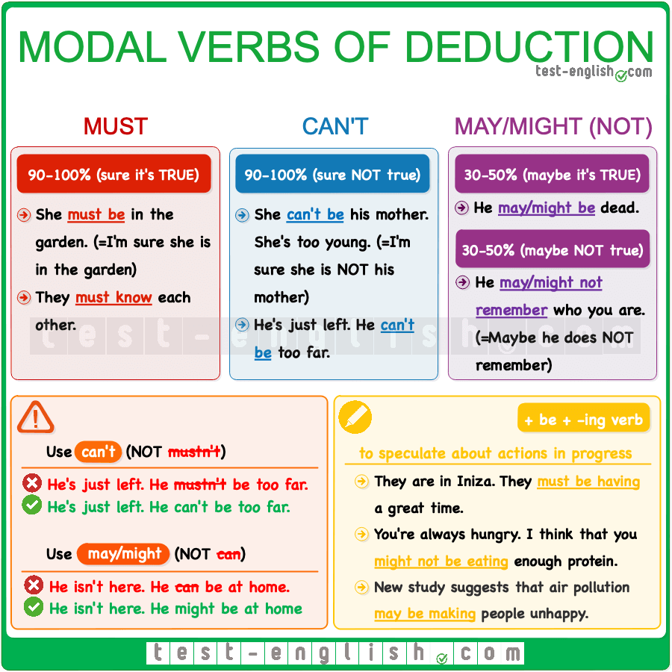

## May, might

We use **may** and **might** to talk about things that are possibly true, but we don’t know for sure.

* He’s more than 2 meters tall. He **might be** a basketball player. (=perhaps he is)
* He says Betty is his friend, but I think she **may be** his girlfriend.

We use **may not** or **might not** to talk about things that are possibly not true, but we don’t know for sure.

* You should call her. She **might not know** where you are. (=perhaps she doesn’t know)

#### Don’t use ****can**** for deduction

We don’t use **can**as a modal of deduction.

* He **can be** at home now. 
* He **might/may be** at home now. 

## Must, can’t

We use **must** when we are sure, or quite sure, that something is true.

* You **must be** tired after the long journey. (=I’m sure you are tired)
* I’m sure I had the keys when I left. They **must be** in the car.

❗ **But** we use **can’t** (NOT **mustn’t**) when we are sure, or quite sure, that something is not true.

* We’ve been walking for hours. It **mustn’t be** far from here. 
* We’ve been walking for hours. It **can’t be** far from here. 
* They’ve lived here only for a couple of months. They **can’t know** many people.

## + be + -ing

After **may, might, must** or **can’t**, we can use **be + -ing**, when we are talking about actions in progress.

* They’ve gone to Ibiza, and right now, they **must be having** a great time.
* Call him. He **might be waiting** for us.

## ****Used to****: Grammar Chart

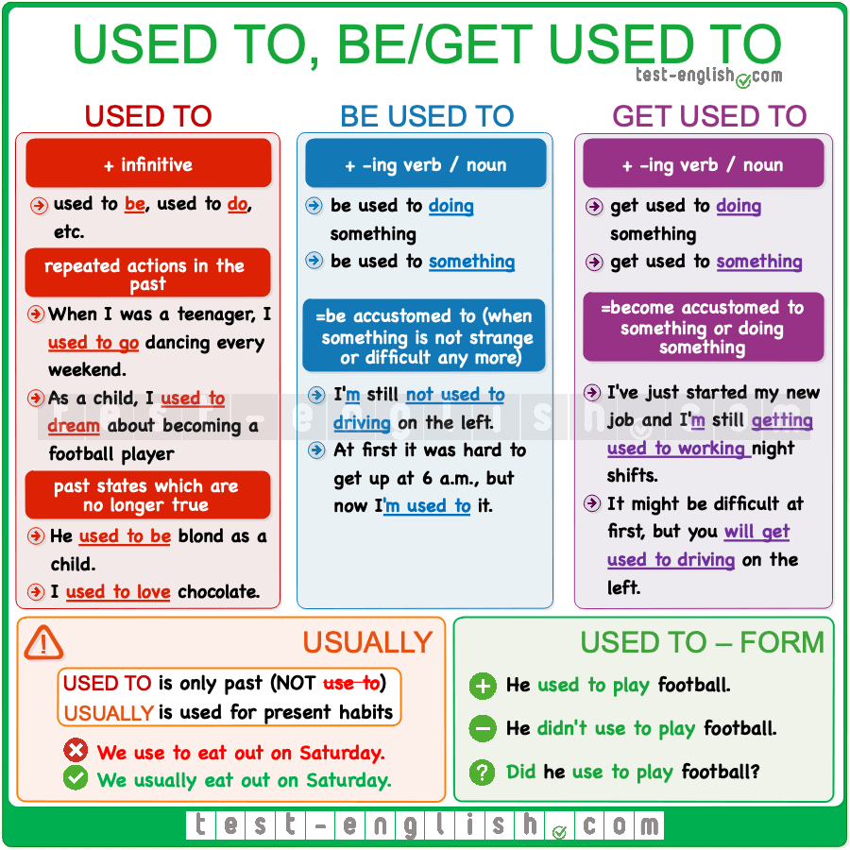

## ****Used to**** + infinitive

#### Repeated actions in the past

We can use **used to + infinitive** to talk about past habits or **things** that **we did repeatedly** in the past.

* When I was a child, I **used to go** skiing every winter.
* I **didn’t use to smoke** before I got this job.

#### Situations or states that are no longer true

We can use **used to + infinitive** to talk about situations or states (stative verbs) which were true in the past but are no longer true.

* As a child, I **used to be** blond.
* I **used to live** with my mum when I was a child.

#### ****Used to, didn’t use to, did you use to****

The negative form of **used to +**infinitive is **didn’t use to…,**and we make questions with **did you use to …**

* I**didn’t use to do** sport as a teenager.
* **Did you use to study** in the library when you were in uni?

#### I usually do

**Used to** only has a past form. If we want to talk about present habits or **things** that **we do repeatedly** in the present, we should use **usually, normally, often** with present simple.

* We **use to go** to the cinema on Friday evenings. 
* We **usually go** to the cinema on Friday evenings. 

## ****Be used to****

If you are **used to something** or **to doing something**, you are accustomed to it. Maybe it’s something that is new, strange or difficult, but you have done it for some time, and now you don’t find it new, strange or difficult any more. **Be used to** is a state, so it is never used in continuous forms. It’s normally used in simple tenses.

* When I started working, it was hard to get up at 6 a.m., but now I’**m used to** it.
* I’ve been living in England for a short time, and I’**m** still **not** **used to driving** on the left.

## ****Get used to****

If  you **get used to something** or **to doing something**, you become accustomed to something. Get used to something is the process of becoming used to something.

* I’ve just started my new job and I’**m** still **getting used to getting** up so early.
* It might be difficult at first, but you’**ll get used to driving** on the left.

## ****Used to**** + infinitive, ****be/get used to + -ing****

The past verb **used to** is always followed by and infinitive. The word **to** is part of the infinitive.

* I **used to play** basketball when I was in school.

After **be used to**, or **get used to**, we use a noun or a –**ing** verb. The word **to**is a preposition, not part of an infinitive. That is why when a verb follows, it must take the –**ing** form.

* I’**m not used to this cold** and rainy weather.
* I’m sure you**‘ll get used to work** with John. 
* I’m sure you**‘ll get used to working** with John. 

## Had better (‘d better)

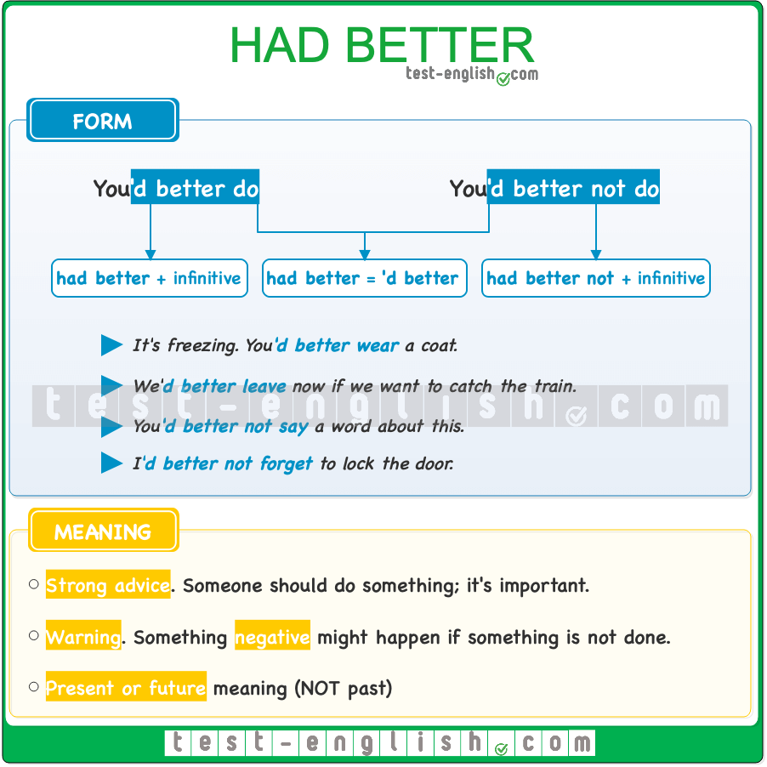

#### Use

We use **had better** to give **strong advice** or to tell someone (including ourselves) what to do.

* I**‘d better** go home. It’s getting late.
* You**‘d better** tell Mum what happened before she finds out.

**Had better** often implies that something negative will happen if something is not done, and it often sounds like a threat or a warning.

* He**‘d better** give me my money back, or he’ll be in trouble.
* You**‘d better** behave yourself if you don’t want me to get really angry.

#### Form

The word **had** is a past verb form, but the expression **had better** is only used to talk about the **immediate future**.

* You**‘d better** call me soon. I’ll be worried.

After **had better** we need to use **infinitive** without **to**.

* I**‘d better to** take a look. 
* I**‘d better** take a look. 

**Had better not** (**‘d better not**) is the negative form of **had better**.

* You**‘d better not** say a word about this.
* I**‘d better not** forget.

In spoken English, we normally use the short form **‘d better**. And in informal speech, people sometimes say just **better** (without **had**).

* You **better** go home.
* I **better** get it right this time.

#### ****Had better**** vs ****should****

We often use **should** to give **advice**, to say that something is a good thing. And we use **had better** to express **urgent advice** or a **warning**, with bad consequences if you don’t follow it.

* You **should** try the cake. It’s delicious.
* He**‘d better** hurry up or he’ll miss the cake.

## It’s time

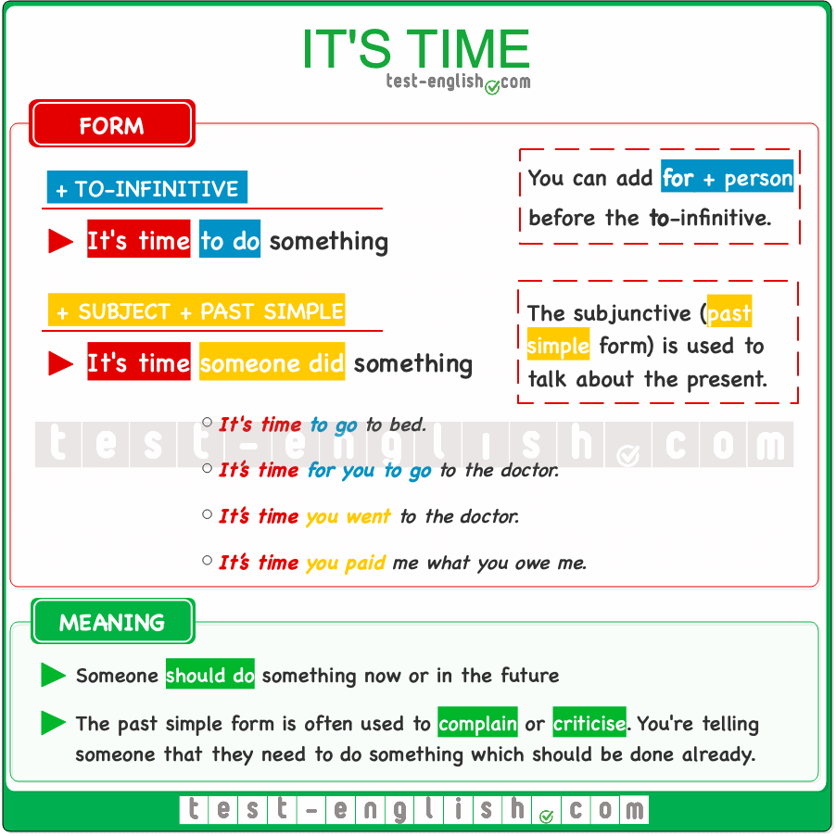

We can use **it’s time + to + infinitive** or **it’s time for someone + to** + **infinitive** to say that someone should do something now or in the future.

* **It’s time for you to go** to the doctor.
* **It’s time to make** a decision.

We can also use **it’s (about) time** + **subject** + **past simple** to say that someone should do something now or in the future.

* **It’s time you went** to the doctor.
* I really think **it’s about time you made** a decision. We can’t go on like this any longer.

🔍 **Note** that we use the past in this form, but we are talking about the future.  
  
We often use this form to **complain** or **criticise**.

* **It’s time you paid** me what you owe me.
* **It’s about time you started** looking for a job.

## Would rather & Would sooner

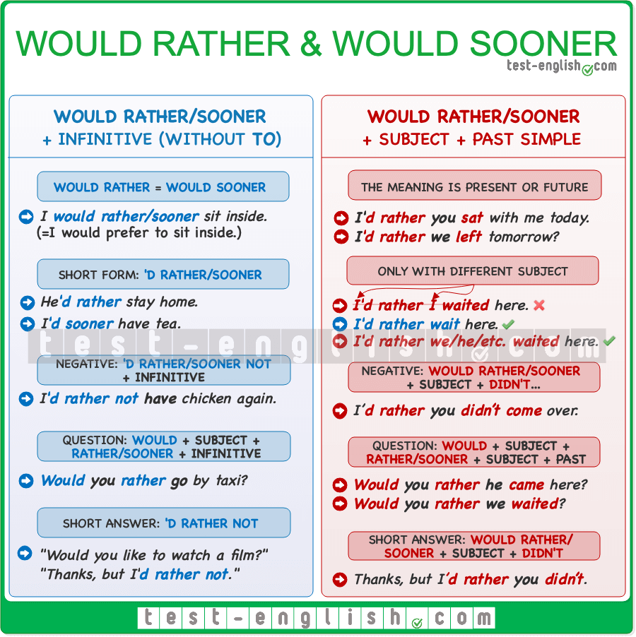

In this lesson, we’ll learn how to talk about our preferences using the phrases **would rather** and **would sooner**. These phrases help us say what we like or want to do or what we’d like other people to do. Although their meanings are similar to the phrase **would prefer**, their grammar is a little different.

* I would rather/sooner **sit** inside.
* I would prefer **to sit** inside.

**Would sooner** has the same meaning as **would rather**, and the two can be used interchangeably; however, **would rather** is much more common.

**Note** that we often use a **contraction** when we use **would rather/would sooner** in sentences and short replies.

* I **would rather sit** inside.
* I’**d rather sit** inside.

There are two primary constructions for **would rather/would sooner**, each conveying different meanings. This lesson focuses on these two structures.

### Would rather/would sooner + infinitive

We use **would rather/would sooner** + infinitive to express preferences about the present or future.

* I **would rather go** by taxi than drive.
* I**‘d rather stay** home until I feel better.

We use **would rather/would sooner** with an infinitive without **to**.

* I’d rather **to stay** home than go out. 
* I’d rather **staying** home than go out. 
* I’d rather **stay** home than go out. 

To make the **negative form**, we use **would rather/would sooner** + **not** + infinitive.

* I **would rather not have** chicken again.

We use **would** + subject + **rather/sooner** + infinitive in questions to ask about others’ preferences.

* **Would you rather go** by taxi?

We can use the form **‘d rather not** in short answers to questions and requests.

* “Would you like to watch a film tonight?” “Thanks, but I**‘d rather not**.”

### Would rather/would sooner + subject + past simple

We use **would rather/would sooner** **+ subject + past simple** to express that we would like someone else to do something. In this structure, we use the past simple, but the meaning is present or future.

* I **would rather you went** home right now.
* They**‘d rather their daughter studied** something different.

**Note** that we use this structure when the subject before and after **would rather/sooner** is different.

* I**‘d rather I waited** here. 
* I**‘d rather wait** here. 
* I**‘d rather we waited** here. 

When forming questions with this structure, we use **would + subject + rather + subject + past simple**.

* **Would you rather he came** with you?
* **Would you rather I waited** here?

To make the negative form, we use **would rather/would sooner** + **subject + didn’t…**

* I’d rather **you didn’t come** over. 
* I’d rather **not you came** over. 

The same is true in the case of **short replies**.

* Thanks, but I’d rather **you didn’t**. 
* I’d rather **not you did**. 

🔍 **Note** that although **would rather** has been used in most examples in this lesson, it could be replaced by **would sooner** in all the sentences.

## B1 Phrasal verbs 1-30

This is the first of our three B1 grammar lessons, where you will learn the most common intermediate phrasal verbs. All the verbs in these three lessons come from the [vocabulary list](https://www.cambridgeenglish.org/images/506887-b1-preliminary-2020-vocabulary-list.pdf) used for the Cambridge Preliminary English Test (PET). In each of these three lessons, you will find 30 phrasal verbs, making up a total of 90 (out of the 94 that you can see in the Cambridge Preliminary vocabulary list).

### B1 Phrasal verbs 1-10

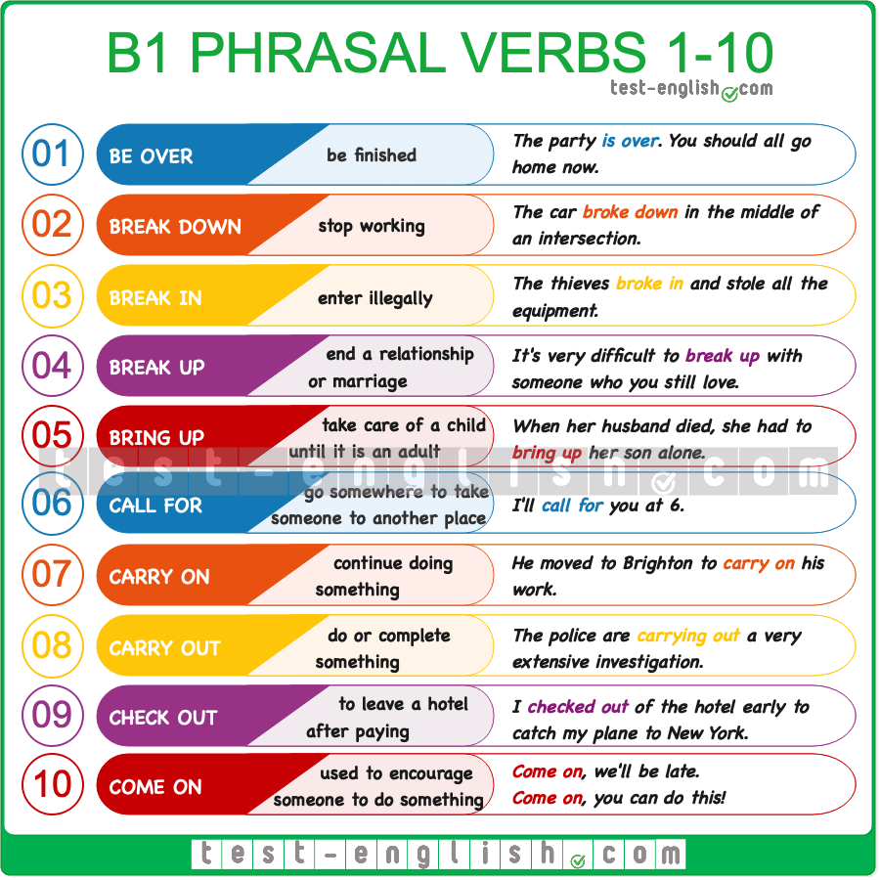

* BE OVER: If something **is over**, it has finished.
* BREAK DOWN: If a car or a machine **breaks down**, it stops working.
* BREAK IN: If someone **breaks in** or **breaks into** a building, they enter a building by force, usually in order to steal something
* BREAK UP: When a person **breaks up** with another person, or if two people **break up**, they end their romantic relationship or marriage.
* BRING UP: When a person **brings up** a child, they look after and influence this child until they are grown up
* CALL FOR: If you **call for** someone, you go to the place where they are so that you can both go somewhere.
* CARRY ON: If you **carry on** (doing something), you continue doing something.
* CARRY OUT: If you **carry out** a task, instruction, etc., you do it or act according to the plan in order to do it.
* CHECK OUT: When you **check out** of a hotel or guest house, you leave the place after paying and returning your room key
* COME ON: This expression is used to tell someone to hurry or to encourage someone to do something

### B1 Phrasal verbs 11-20

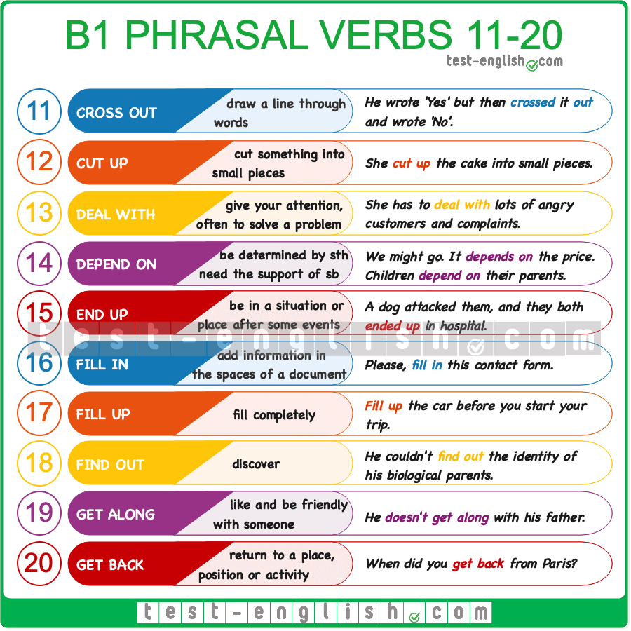

* CROSS OUT: If you **cross out** words on a page, you draw a line through them, usually because they are wrong.
* CUT UP: If you **cut** something **up**, you cut it into several pieces.
* DEAL WITH: When you **deal with** something or someone that needs attention, you give your attention to them, and you often solve a problem or make a decision concerning them.
* DEPEND ON: If something **depends on** something else, it is determined, affected or decided by that thing.
* DEPEND ON: If a person **depends on** another person, the first person needs the support or help of the other person to exist or be OK.
* END UP: If you **end up** in a particular place or situation, it means that after a series of events, you unexpectedly find yourself in that place or situation.
* FILL IN: If you **fill in** a document or form, you write the necessary information in its spaces.
* FILL UP: If you **fill up** a container or your car tank, it becomes full.
* FIND OUT: If you **find** something **out**, you learn or discover something you didn’t know.
* GET ALONG: If you **get along** with someone, you have a friendly relationship. You can also say that two people **get along**.
* GET BACK: If you **get back** (to a place, situation or activity), you return to that place, situation or activity.

### B1 Phrasal verbs 21-30

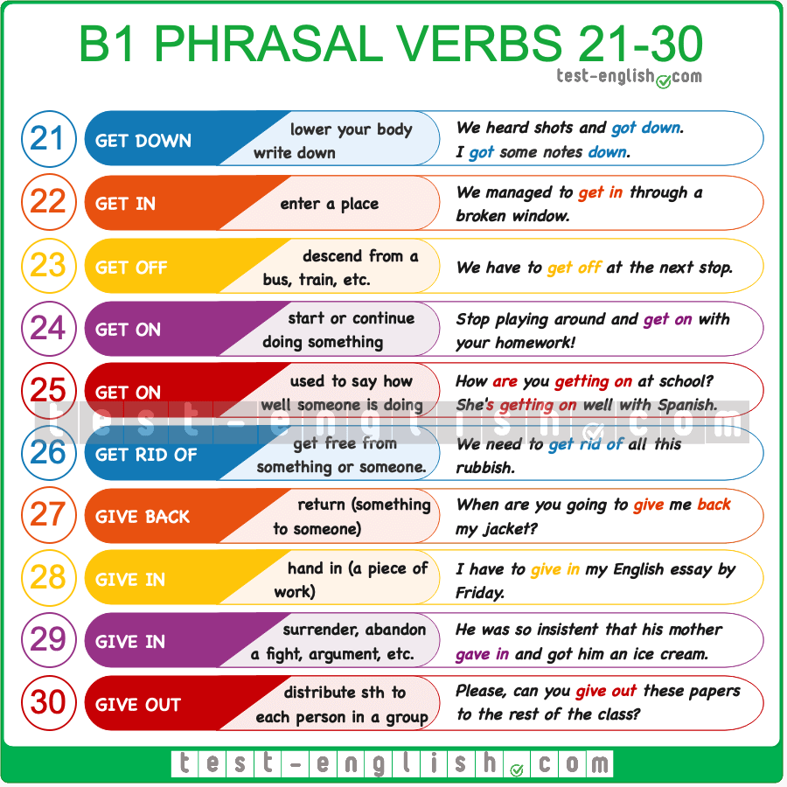

* GET DOWN: If you **get down**, you lower your body until you are sitting, kneeling, or lying on the ground. Also, if you **get** something **down**, you write something.
* GET IN: If you **get in**, you enter a place, especially when it’s difficult.
* GET OFF: When you **get off** (a bus, a train, etc.), you descend from that vehicle.
* GET ON: If you **get on** with something, you start doing it or continue doing it.
* GET ON: If you say how someone **is getting on** (with a job or in a situation), you are talking about how well they are doing.
* GET RID OF: If you **get rid of** something or someone, you get free from this thing or person so that you don’t have to deal with them anymore.
* GIVE BACK: If you **give** something **back** or **give** someone **back** something, you return it to the person who gave it to you.
* GIVE IN: If you **give in** a piece of work or something you have written, you give it or hand it to a person of authority, such as your boss, your teacher, etc.
* GIVE IN: If you **give in**, you surrender or abandon a fight, argument, etc.
* GIVE OUT: If you **give out** something, you give something to each person in a group.

## B1 Phrasal verbs 31-60

This is the second of our three B1 grammar lessons, where you will learn the most common intermediate phrasal verbs. All the verbs in these three lessons come from the [vocabulary list](https://www.cambridgeenglish.org/images/506887-b1-preliminary-2020-vocabulary-list.pdf) used for the Cambridge Preliminary English Test (PET). In each of these three lessons, you will find 30 phrasal verbs, making up a total of 90 (out of the 94 that you can see in the Cambridge Preliminary vocabulary list).

### B1 Phrasal verbs 31-40

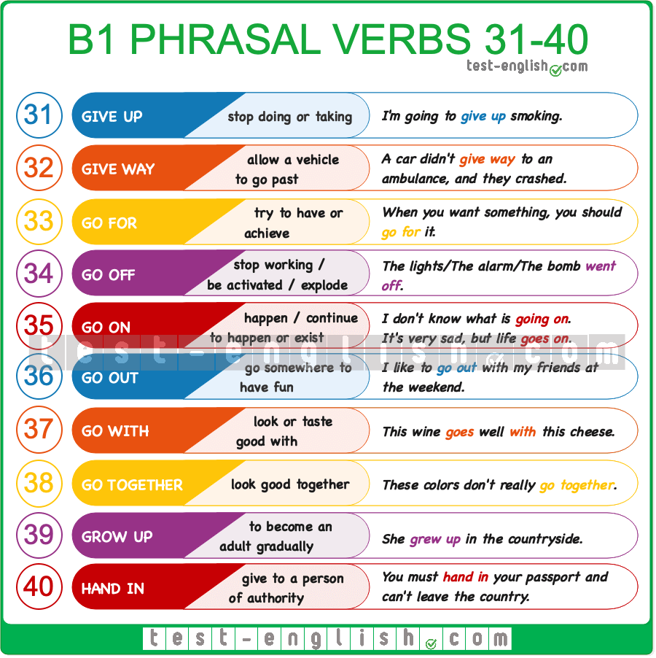

* GIVE UP: If you **give up** something, you stop doing it or taking it: “I’m going to give up smoking.”
* GIVE WAY: If you **give way** to a vehicle, you allow it to go past before you move.
* GO FOR: If you **go for** something, you try to have or achieve something.
* GO OFF: If a light or a machine **goes off**, it stops working. Also, if an alarm**goes off**, it starts to make a loud noise, and if a bomb **goes off**, it explodes.
* GO ON: If something **goes on**, it continues to happen or exist. Also, if something **is going on**, it is happening: “I don’t know what is going on.”
* GO OUT: If you **go out**, you leave your home to do something fun, such as going to a bar, a party, etc. Also, if you **go out with** someone, you have a romantic or sexual relationship.
* GO WITH: If one thing **goes with** another, they look or taste good together: “This wine goes well with this cheese.”
* GO TOGETHER: If two things **go together**, they look good together.
* GROW UP: When someone **grows up**, they change from being a child into being an adult.
* HAND IN: If you **hand in** an exam, homework, a document, or something that you have found, you give it to a teacher, police officer, or another person in authority.

### B1 Phrasal verbs 41-50

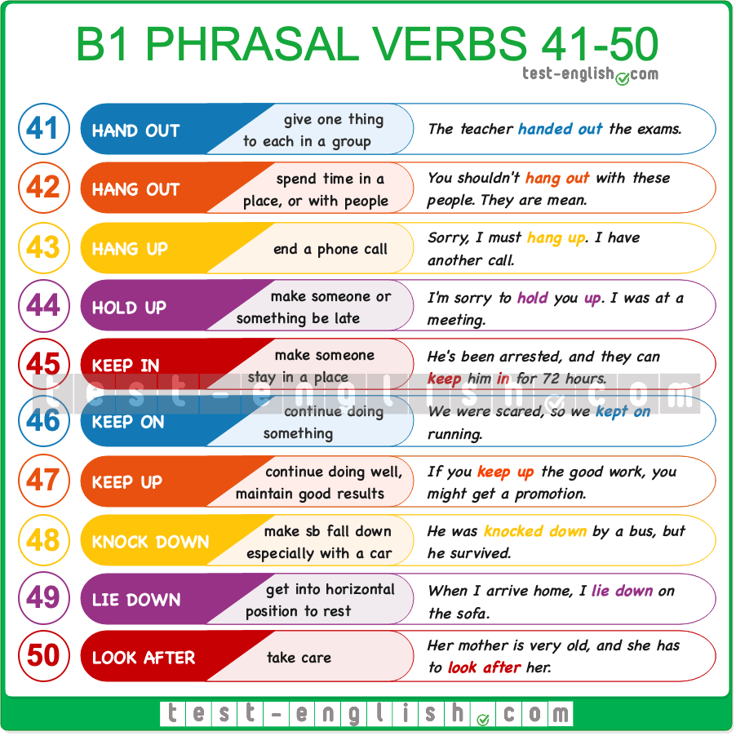

* HAND OUT: If you **hand** things **out** to a group of people, you give one or more to each person in a group.
* HANG OUT: If you **hang out** in a place or you **hang out** with someone, you spend a lot of time in that place or with those people.
* HANG UP: If you **hang up** or you **hang up** the phone, you end a phone call.
* HOLD UP: To **hold up** someone or something means to delay them or make them late.
* KEEP IN: If you **keep** someone **in** (a place), you make them stay in that place.
* KEEP ON: If you **keep on** doing something, you continue doing it.
* KEEP UP: If you **keep up** something good, you continue to do it well or maintain good results.
* KNOCK DOWN: If a person **is knocked down** by a vehicle or a driver, they are hit by this vehicle and fall to the ground and are often injured or killed. Also, to **knock** someone **down** means to hit a person so that this person falls down.
* LIE DOWN: When you **lie down**, you move into a horizontal position, usually in order to rest or sleep.
* LOOK AFTER: If you **look after** someone or something, you take care of them and try to keep them healthy or in good condition.

### B1 Phrasal verbs 51-60

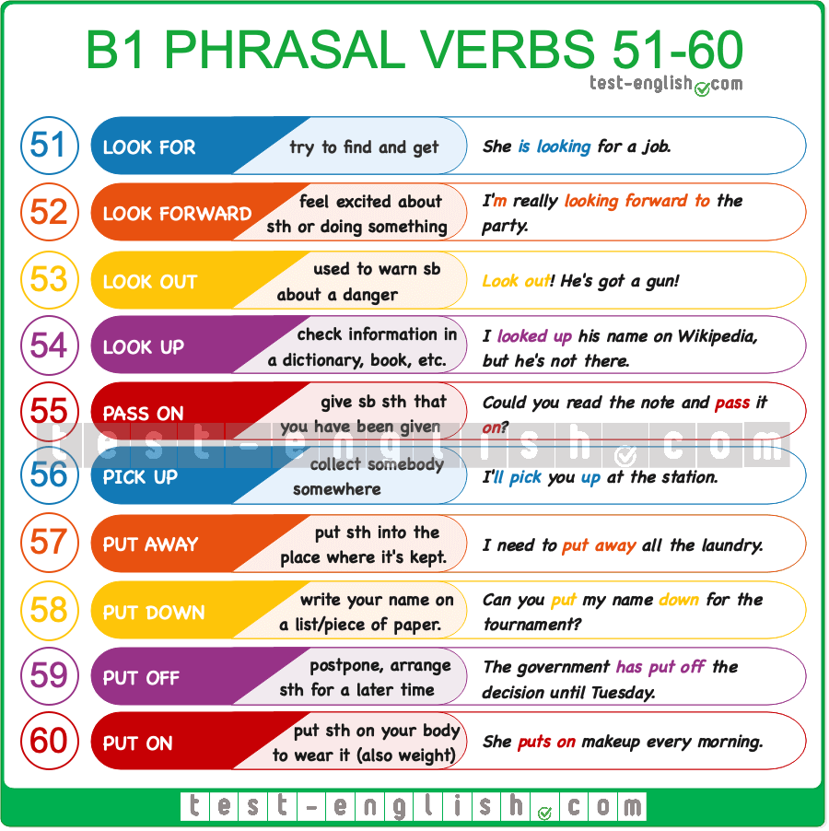

* LOOK FOR: If you **look for** something, you try to get something that you want or need.
* LOOK FORWARD TO: If you **look forward to** something that is going to happen, you want it to happen and feel excited about it.
* LOOK OUT: If you say or shout “**Look out!**” to someone, you are warning them that they are in danger.
* LOOK UP: If you **look up** a particular piece of information, you try to find it by looking in a book, on a list, or using a computer.
* PASS ON: If you **pass** something **on** (to someone), you give something to someone, especially something that someone else has given you.
* PICK UP: When you **pick up** someone or something that is waiting, you go to the place where they are and take them somewhere, usually in your car.
* PUT AWAY: If you **put** something **away**, you put it into the place or container where it is normally kept.
* PUT DOWN: If you **put** something **down**, especially your name, on a list or piece of paper, you write it down.
* PUT OFF: If you **put off** something or doing something, you arrange to do it at a later time.
* PUT ON: If you **put on** weight, you become fatter. Also, if you **put on** clothes, glasses or make-up, you place them on your body to wear them.

## B1 Phrasal verbs 61-90

This is the third of our three B1 grammar lessons, where you will learn the most common intermediate phrasal verbs. All the verbs in these three lessons come from the [vocabulary list](https://www.cambridgeenglish.org/images/506887-b1-preliminary-2020-vocabulary-list.pdf) used for the Cambridge Preliminary English Test (PET). In each of these three lessons, you will find 30 phrasal verbs, making up a total of 90 (out of the 94 that you can see in the Cambridge Preliminary vocabulary list).

### B1 Phrasal verbs 61-70

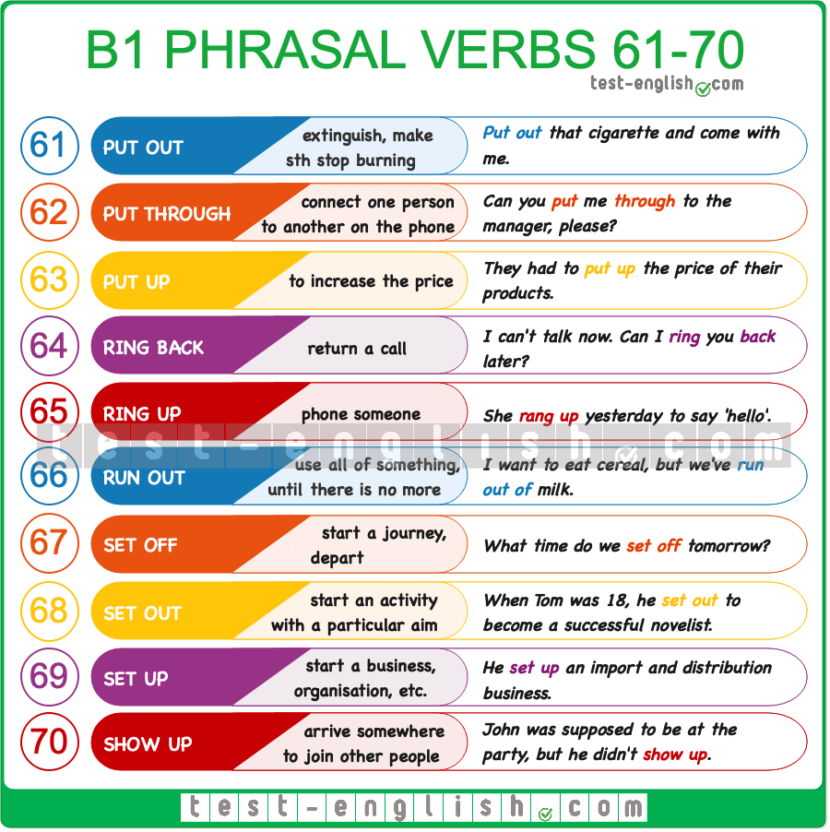

* PUT OUT: If you **put out** a fire, cigarette, etc., you make it stop burning.
* PUT THROUGH: If you **put through** a call or the person calling, you connect them with the person they want to speak to.
* PUT UP: If you **put up** the price of something, you increase its price.
* RING BACK: If you **ring** someone **back**, you return a previous call they made to you.
* RING UP: If you **ring up** (someone), you phone them.
* RUN OUT: If you **run out of** something, you have no more of it left because you have used it all.
* SET OFF: When you **set off**, you start a journey.
* SET OUT: If you **set out** to do or achieve something, you start an activity with a particular aim.
* SET UP: If you **set up** a business, organisation, etc., you start it.
* SHOW UP: If someone **shows up**, they arrive somewhere to join other people.

### B1 Phrasal verbs 71-80

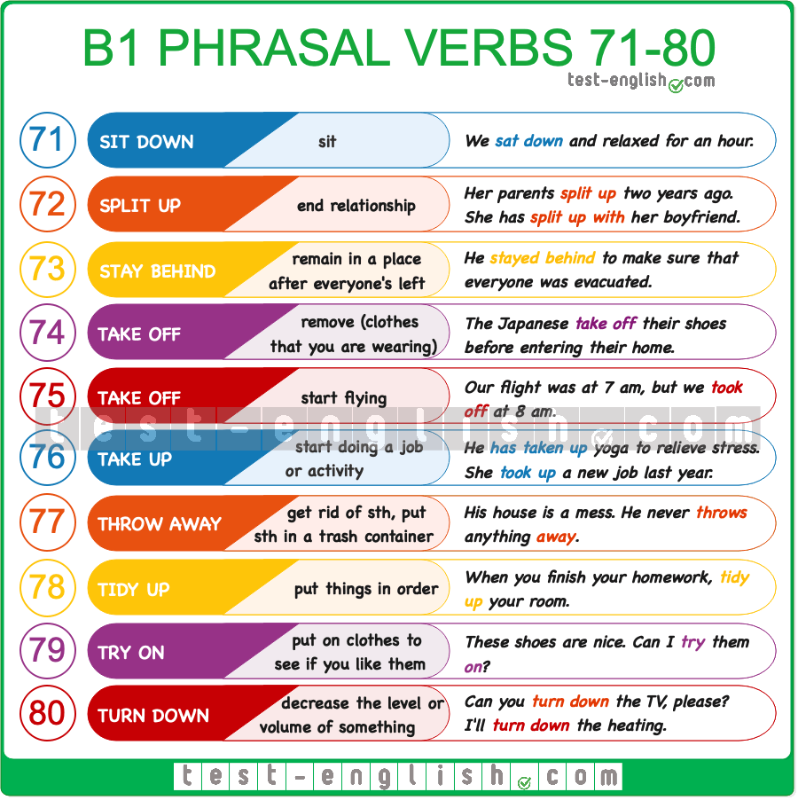

* SIT DOWN: The verbs **sit down** and **sit** mean the same.
* SPLIT UP: If two people **split up**, or if someone **splits up with** someone else, they end their relationship.
* STAY BEHIND: If you **stay behind**, you remain in a place after everyone else has left.
* TAKE OFF: If you **take off** a piece of clothing, you remove it.
* TAKE OFF: When an aeroplane **takes off**, it leaves the ground and starts flying
* TAKE UP: If you **take up** an activity or a subject, you start doing it as a job, habit or interest.
* THROW AWAY: If you **throw away** something, you get rid of it, for example, by putting it in a trash container.
* TIDY UP: When you **tidy up** a place, you put things back in their right places so that everything is neat.
* TRY ON: If you **try on** a piece of clothing, you put it on to see if it fits and you like it.
* TURN DOWN: If you **turn down** the level or volume of something, you decrease it.

### B1 Phrasal verbs 81-90

* TURN INTO: If someone or something **turns into** someone or something else, they change and become this other thing/person; or if you **turn** someone or something **into** someone or something else, you make them change.
* TURN OFF: When you **turn off** a piece of equipment, you make it stop working, usually by pressing a button.
* TURN ON: When you **turn on** a piece of equipment, you make it start working, usually by pressing a button.
* TURN UP: If you **turn up** the level or volume of something, you increase it.
* WAKE (UP): When you **wake (up)** or when someone or something **wakes** you **(up)**, you become conscious after sleeping.
* WASH UP: When you **wash up**, you clean part of your body with soap and water, especially your hands and face. Also, if you **wash up**, you wash the things you have used for cooking and eating a meal, such as glasses, plates, pans, etc.
* WEAR OUT: If something **wears out** or if you **wear** something **out**, it is used so much that it can no longer be used.
* WORK OUT: When you **work out**, you do physical exercises to be fit and strong.
* WRAP UP: If you **wrap** something **up**, you cover it by putting something like paper or cloth around it.
* WRITE DOWN: When you **write** something **down**, you write it on a piece of paper using a pen or pencil.

### Conditionals, ****if****, ****wish****, etc.

## First conditional: Grammar chart

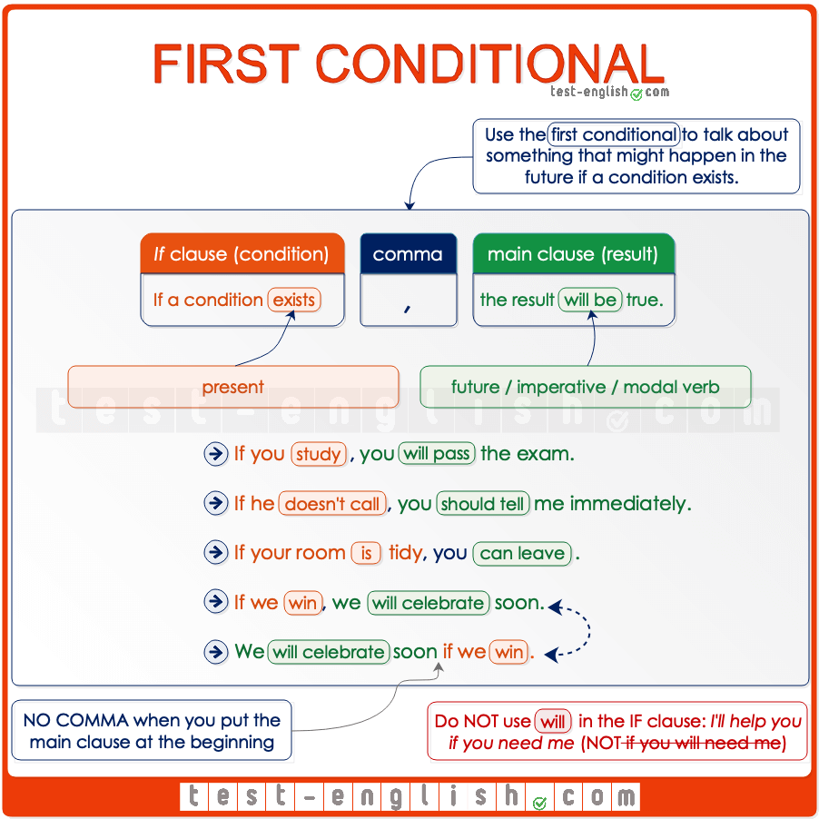

#### ****If**** clause and main clause

All conditional sentences have two parts: the **if** **clause** and the **main clause**. It doesn’t matter which clause comes first, but when the **if clause** comes first, we should put a **comma** after it.

* If it rains**,** we’ll stay home
* We’ll stay home **if** it rains.

#### ****If**** + present, future

In the first conditional, the verb in the **if clause** is **present,** and the verb in the **main clause** is future (**will**).

* If you **don’t go** to sleep, you’**ll be** very tired tomorrow.

The ****if clause****may have a present or a future meaning, but the **verb** is **always** **in the present** (NOT future)

* If you **will be** a good boy tomorrow, mummy will buy you a present. 
* If you **are** a good boy tomorrow, mummy will buy you a present. 

#### Main clause: ****will****, modal verb, imperative

In the **main clause**, we can use **may, might, can, must,** or **should** instead of **will**.

* If he doesn’t train harder, he **may/might** lose the championship.
* If your room is tidy, you **can** leave.
* If you want to lose weight, you **must/should** eat less sugary things.

Or we can also use an **imperative** instead of **will**.

* If you arrive after midnight, **ring** me on my mobile.

#### ****Unless**** = if (not)

We can also use **unless**in conditional sentences to mean **if** … (**not**)

* I won’t go on holiday **unless** I save some money.
* = I won’t go on holiday **if** I **don’t** save some money.

## Future time clauses: Grammar chart

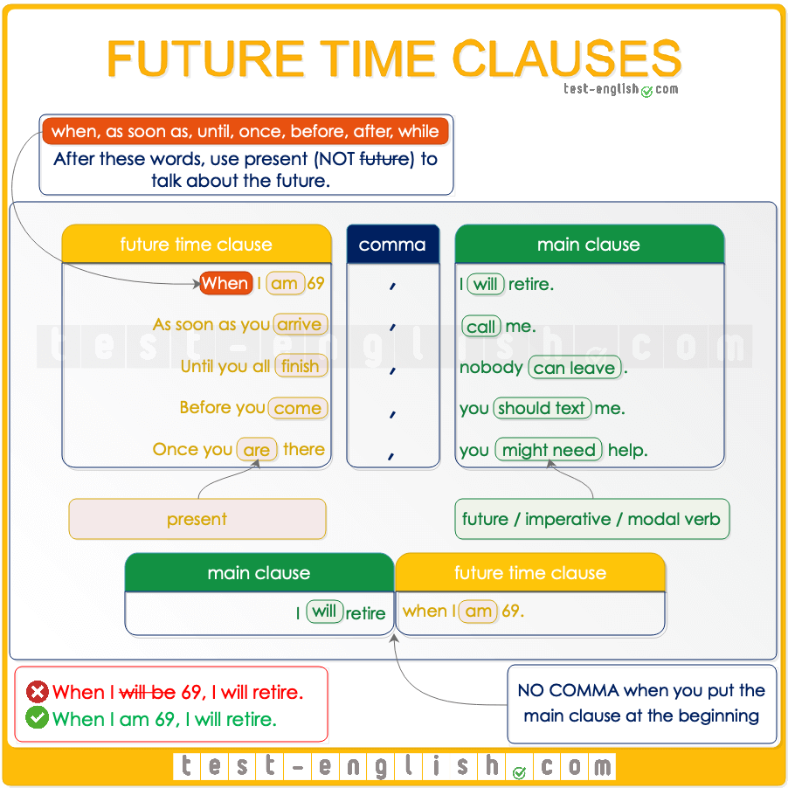

#### ****When, as soon as, before, after, until****

When we use a verb after **when, as soon as, before, after** or **until** to talk about the future, we must use this verb in the present tense (NOT future). We use the future in the other part of the sentence.

* I’ll retire when I‘ll be 70. 
* I’ll retire when I‘m 70. 
* I won’t call you until I will arrive. 
* I won’t call you until I arrive. 

#### Similar to first conditional

Future time clauses are similar to the first conditional. There’s a **main clause** and a **when/after/etc. clause**. We use the verbs in these clauses in the same way as in the first conditional.  
  
We use a comma when the **when/after/etc. clause** is at the beginning of the sentence. But we don’t use a comma if the **when/after… clause** is at the end of the sentence.

* I’ll retire when I’m 70.
* When I’m 70**,** I’llretire.

We use the present in the **when/after/etc. clause** and we use the future in the **main clause**.

* Before you go to sleep, daddy will tell you a story.

In the **main clause**, we can also use **may, might, can, must, should** or an **imperative** instead of **will**.

* As soon as you finish, you can leave.
* After you arrive, call me.

## Second conditional: Grammar chart

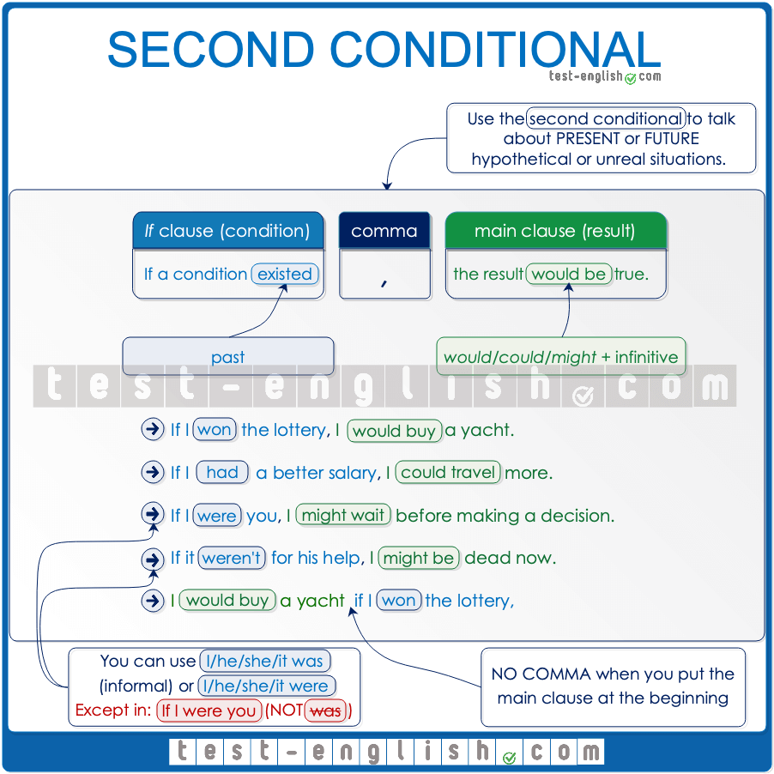

## ****If**** clause and main clause

We use **if** + **past tense** to talk about an imaginary present or future situation (although the verb is in the past, the meaning is present or future). And we use **would** + **infinitive**to talk about the result or consequence of that imaginary situation.

* If we **had** a mansion in the country, we’**d go** there every weekend.
* **Would** you **travel**around the world if you **won** the lottery?

#### Comma

When the **if** **clause** comes first, we normally put a **comma** after it. We don’t use a comma when the **main clause**comes first, and the **if clause**comes second.

* If I won the lottery**,** I’d buy a mansion.
* I’d buy a mansion **if** I won the lottery.

#### ****Unless**** = if (not)

We can also use **unless**in conditional sentences to mean **if** … (**not**)

* I wouldn’t live in a big city **unless** I had a lot of money.
* = I wouldn’t live in a big city **if** I **didn’t** have a lot of money.

## ****Would, could, might****

In the main clause, we can use **could** or **might** instead of **would**.

* If there **was** a fire, it **would be** difficult to escape.
* If you **were** a bit taller, you **could be** a basketball player.
* We **might** save enough money if we both **worked** overtime.

## ****Was**** or ****were****?

In the second conditional, we can use **if I/he/she/it were** (more formal) instead of **if I/he/she/it was** (spoken English).

* If **I** **were/was** fit, I would run a marathon.
* We wouldn’t have any problems **if** **he were/was**more reasonable.

But we use **were** (NOT **was**) when we give advice with the expression **if I were you**.

* If I were you, I would stay home and rest.
* I wouldn’t pay any attention to what he says **if I were you**.

## First and second conditionals: Grammar chart

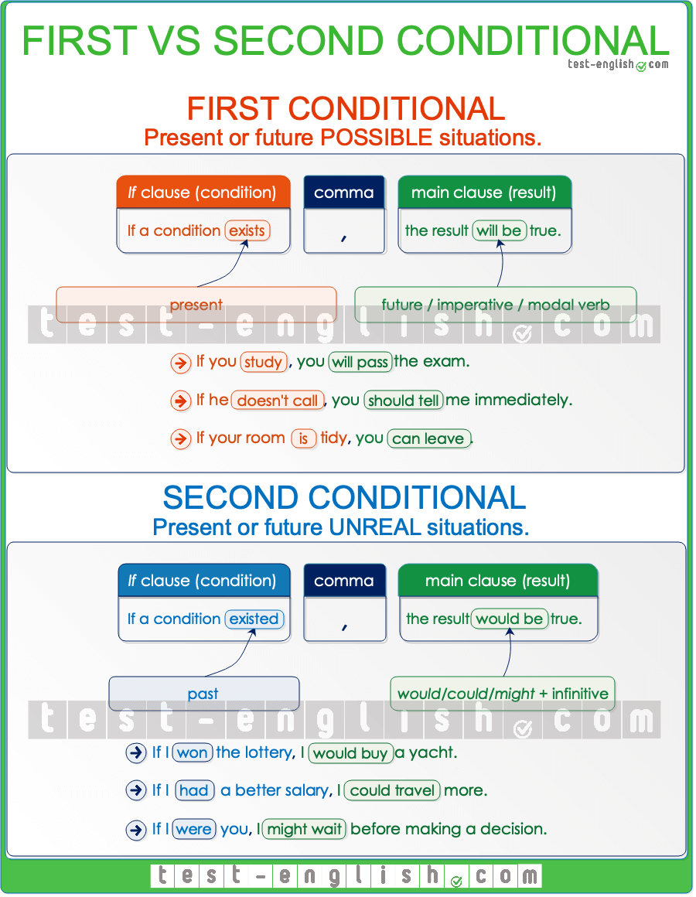

## First conditional vs Second conditional

We use the [first conditional](https://test-english.com/grammar-points/b1/first-conditional-future-time-clauses/) and the [second conditional](https://test-english.com/grammar-points/b1/second-conditional-unreal-situations/) to talk about present or future situations.  
  
  
We use the first conditional to talk about possible situations or events that may easily happen, and we use the second conditional to talk about unrealistic situations.

* If I **see** Sara, I’**ll tell** her to call you. (=possible)
* If I won the lottery, I’**d buy** a new house.  (=unrealistic)

Sometimes, we use either the first or second conditional depending on how probable we think the situations are to happen.

* If I **find** her, I’ll tell her that I love her. (=I think it’s possible that I find her)
* If I **found** her, I’**d tell** her that I love her. (=I think it’s improbable that I find her)

## Third conditional: Grammar Chart

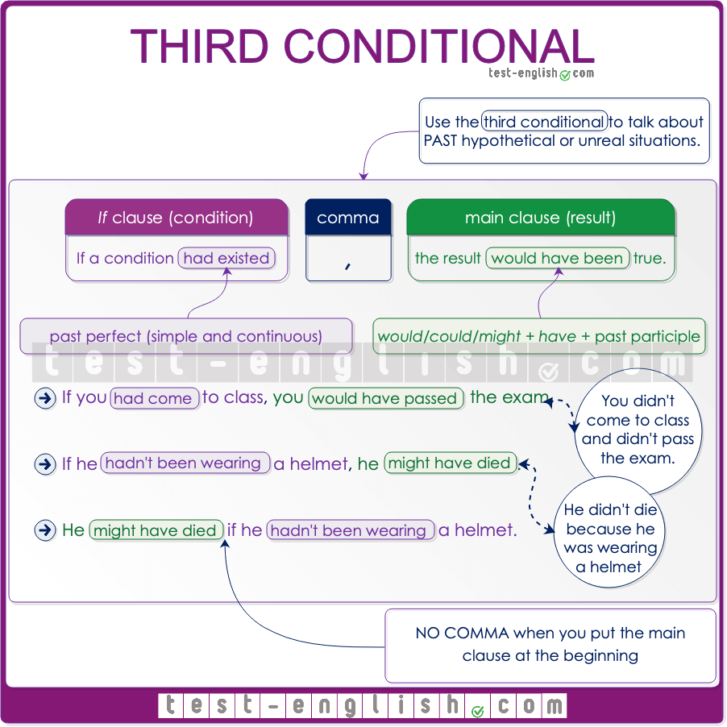

## ****If**** clause and main clause

We use the **past perfect** in the **if**-clause of a third conditional sentence to talk about an **imaginary or hypothetical** situation in the past, and we use **would have, could have** or **might have** + **past participle** in the main clauseto talk about the result or consequence of that imaginary situation.

* If you **had come** to class more often, you **would have passed** the test.
* If he **hadn’t taken** his helmet, he **could have died**.
* If the jacket **had been** a bit cheaper, I **might have bought** it.

#### Comma

As with all conditional types, we use a **comma** after the **if**–clause when it goes at the beginning of the sentence, but we don’t use a comma when the **if**-clause goes at the end.

* If I **hadn’t overslept**, I **wouldn’t have been** late.
* I **wouldn’t have been** late if I **hadn’t overslept**.

#### ****Unless****

We can also use **unless**in conditional sentences to mean **if** … (**not**)

* I wouldn’t have arrived on time **unless** I had taken a taxi.
* = I wouldn’t have arrived on time **if** I had**n’t** taken a taxi.

### Passive

## Passive voice in the different verb tenses

To make a passive verb form, we have to use **be** in a particular verb tense and add the **past participle** of the main verb after it. You can see how to use the passive voice with different tenses below.  
  
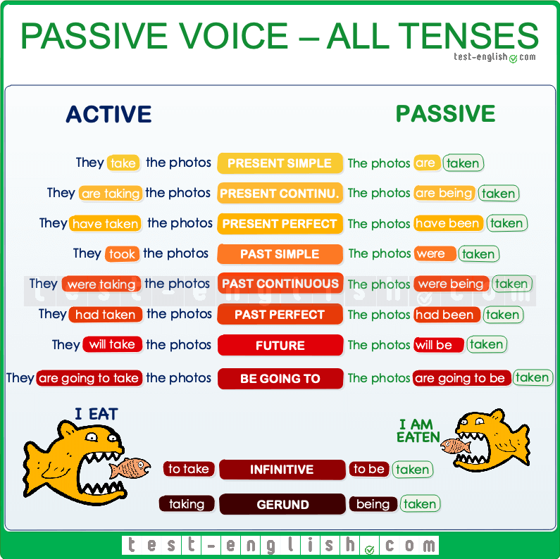

## Active and passive

In a [passive sentence](https://test-english.com/grammar-points/a2/present-past-simple-passive/), the object of an active sentence becomes the subject. In a passive voice sentence, the subject is the receiver of the action, not the doer of the action.

‣ They take the photos in Africa. (active)

‣ The photos are taken in Africa. (passive)

## Active and passive voice

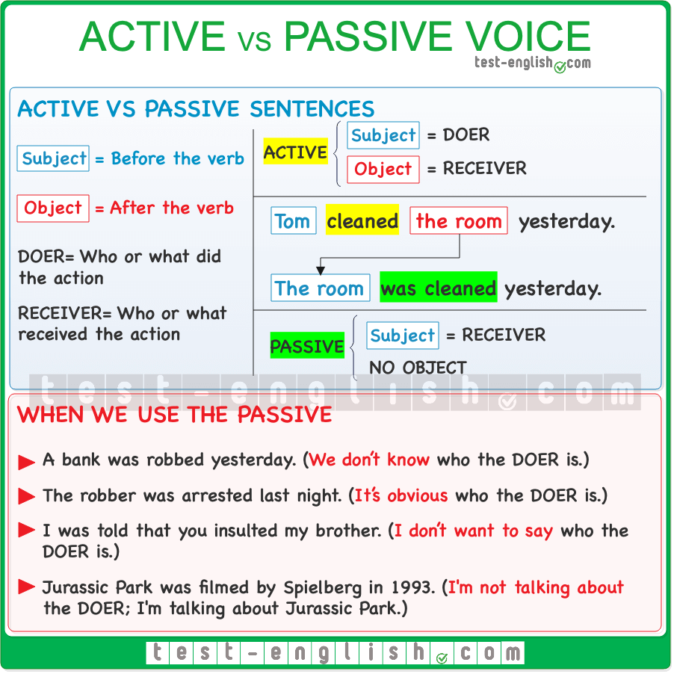

### Active sentences vs passive sentences

When **A does B**, we have two possible ways of talking about it: **active** or **passive.** In active sentences, **A is the subject** (before the verb). In passive sentences, **B is the subject**. Check the following examples:

Somebody cleaned the classroom yesterday. (Active)

The classroom was cleaned every day. (Passive)

As you can see, the object of an active sentence is the subject of a passive sentence. You can learn how to form the passive in all the different verb tenses [here](https://test-english.com/grammar-points/b1/passive-verb-forms/).

### When do we use the passive?

The passive is more formal than the active and is more common in written language. We often use the passive when we don’t know, when it is obvious, or when we don’t want to say who or what is responsible for the action.

* A bank **was robbed** yesterday. (We don’t know who robbed the bank.)
* The robber **was arrested**last night. (It’s obvious that the police arrested the robber.)
* I **was told** that you insulted my brother. (I don’t want to say who told me.)
* Jurassic Park **was filmed** by Spielberg in 1993. (I’m talking about Jurassic Park and not about Spielberg.)

The passive voice is very common in the **news** and in **formal writing**.

* Arsenal **have been defeated** 3‐0, and they are now 4th in the table.
* The British embassy in Israel **has been destroyed** by an earthquake.
* The Catalan election **will be held** next September.

### Passive voice + ****by****

We can use **by**to say who or what is responsible for the action.

* The painting was bought **by a very rich American**.
* Penicillin was invented **by Alexander Fleming**.

### Reported speech

## What is indirect speech or reported speech?

When we tell people what another person said or thought, we often use **reported speech** or indirect speech. To do that, we need to change verb tenses (present, past, etc.) and pronouns (**I, you, my, your, etc**.) if the time and speaker are different. For example, **present tenses** become **past**, **I** becomes **he** or **she**, and **my** becomes **his** or **her**, etc.

* Sally: ‘**I** **don’t have** time.’ ⇒ Sally said that **she didn’t have** time.
* Peter: ‘**I am tired** .’ ⇒ He said that **he was** tired.

## Omission of ****that****

We often leave out **that** after reporting verbs like **say, think**, **etc.**

* She **said she** was late. (=She said that she was late.)
* I **thought I** would get the job.

## ****Say**** or ****tell****?

The most common verbs we use in reported speech are **say** and **tell**. We must pay attention here. We say **tell somebody** **something** and **say something (to somebody)**.

* They **said me** (that) they would help me. 
* They **told me** (that) they would help me. 
* He **told** (that) he didn’t have a car. 
* He **said** (that) he didn’t have a car. 

## Tense changes in indirect speech

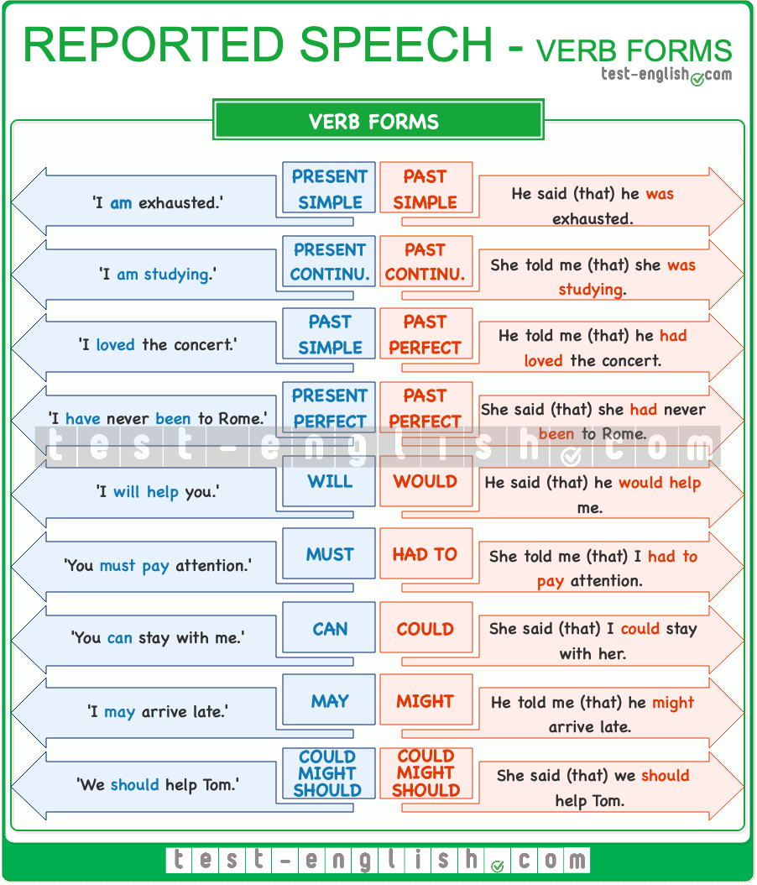

When a person said something **in the past**, and **now** we tell somebody what that person said, the time is different, and for this reason, the verb tenses change. Look at a summary of these changes.

## Changes in expressions

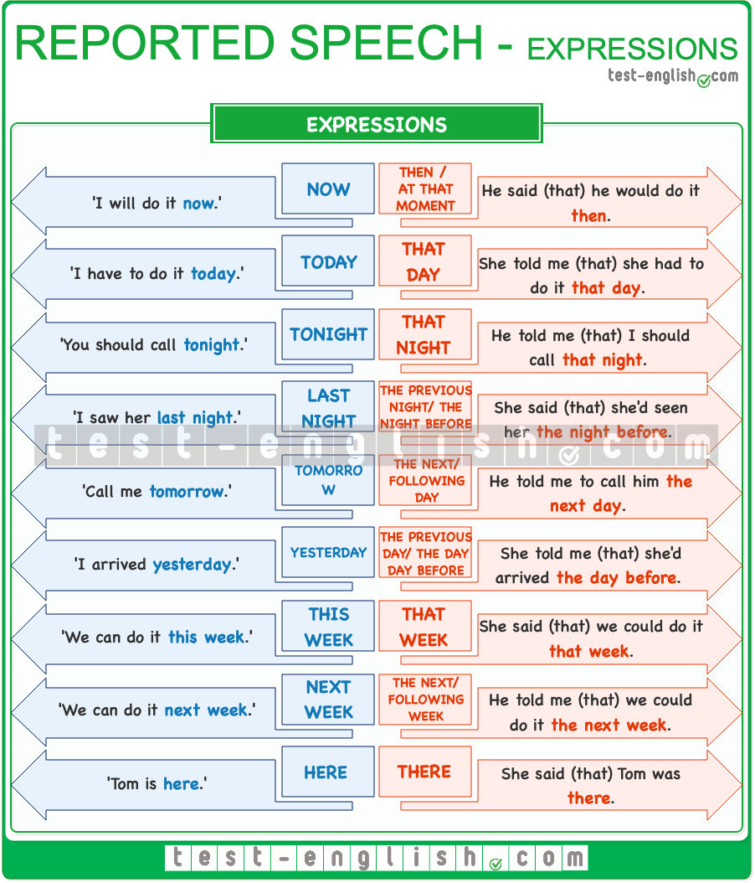

There are adverbs or expressions of time and place that change when we report what someone says. Here you have a list.

## Questions and imperatives in indirect speech

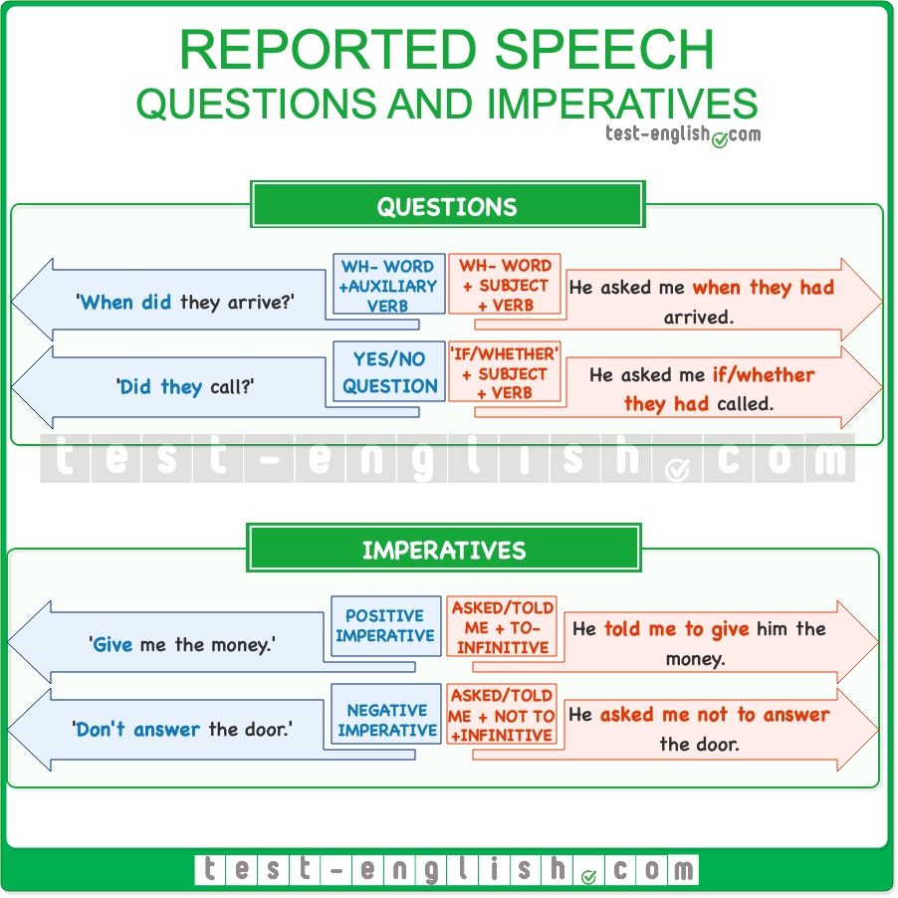

We use the normal order of words in **reported questions**: subject + verb. We don’t use an auxiliary verb like **do** or **did**.  
  
When we report an order or instruction, we use the form **ask** or **tell someone to do something**.

## Pronoun changes in indirect speech

In reported or indirect speech, we must also pay attention to the use of pronouns. When a person tells us something, he or she uses the first person (**I, me, my, we, us, our**) to talk about himself or herself and the second person (**you, your**) to talk about us, the person listening. But when we tell someone else what that person said, we are going to use the third person (**he, she, his, her, etc.**) to talk about the speaker and the first person (**I, me, my**) to talk about ourselves, the listener.

* ‘**I** will help **you**.’ ⇒ **He** said that he **would** help me.
* ‘That’s **my** pen.’ ⇒ She said that it was **her** pen.
* ‘**I** need **your** help.’ ⇒ She said that **she** needed **my** help.

### -ing and the infinitive

## When do we use gerund or infinitive?

When we have to use a verb after another verb or a certain kind of word, we sometimes use an infinitive or a gerund. It often depends on the word that comes before. Here’s a list of the main situations in which we use infinitives or gerunds.  
  
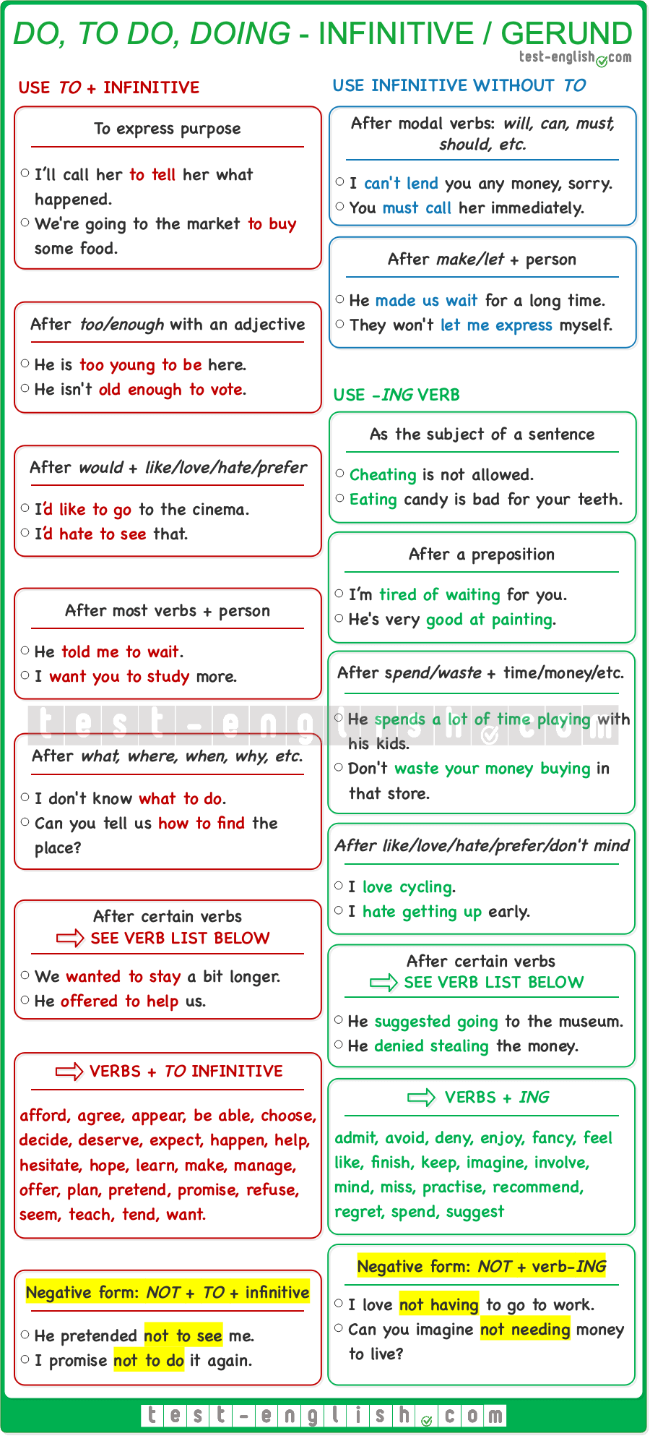

## Verbs that take gerund or infinitive with a change of meaning

#### Forget

**Forget to do something**: Used to talk about things that we need to do, and we forget to do them.

* I think we **forgot to lock** the door when we left.
* Don’t **forget to call** me when you finish.

**Forget doing something**: It’s normally used in negative sentences. Used to talk about memories –generally about past events that we will not forget.

* I’ll never **forget walking** on that amazing beach for the first time.

#### Remember

**Remember to do something**: Used to talk about things we need to do.

* He didn’t **remember to turn off** the heating after class.
* Please **remember to close** the windows if you leave.

**Remember doing something**: Used to talk about memories. We remember things from the past.

* I **remember eating** on this same chair the day I graduated.
* I **remember mentioning** the issue to Elisabeth last week.

#### Try

**Try to do something**: When we try to do something, we make an effort to achieve something that we maybe will or will not accomplish.

* Could you please **try to be** a bit less rude?
* I’ll **try to convince him**, but I’m not sure that’s going to change anything.

**Try doing something**: Used when we have an objective, and we try something as an experiment to see if it helps us achieve that objective. We try something in order to achieve an objective.

* A: “I need to sleep, but I can’t.” B: “Why don’t you **try drinking** a glass of hot milk?”
* I can’t contact Jane. I’**ve tried calling** her home number and also on her mobile, but nothing.

#### Stop

**Stop to do something**: Used when we stop doing an activity so as to start doing a different one.

* We had been driving for hours, so we had **to stop to eat** something and go to the toilet. (=We stopped driving in order to eat.)

**Stop doing something**: It means to finish doing something that we are doing.

* Could you **stop biting** your nails?
* I need to **stop smoking** once and forever.

### Articles, nouns, pronouns, and determiners.

## ****A/an, the****, no article

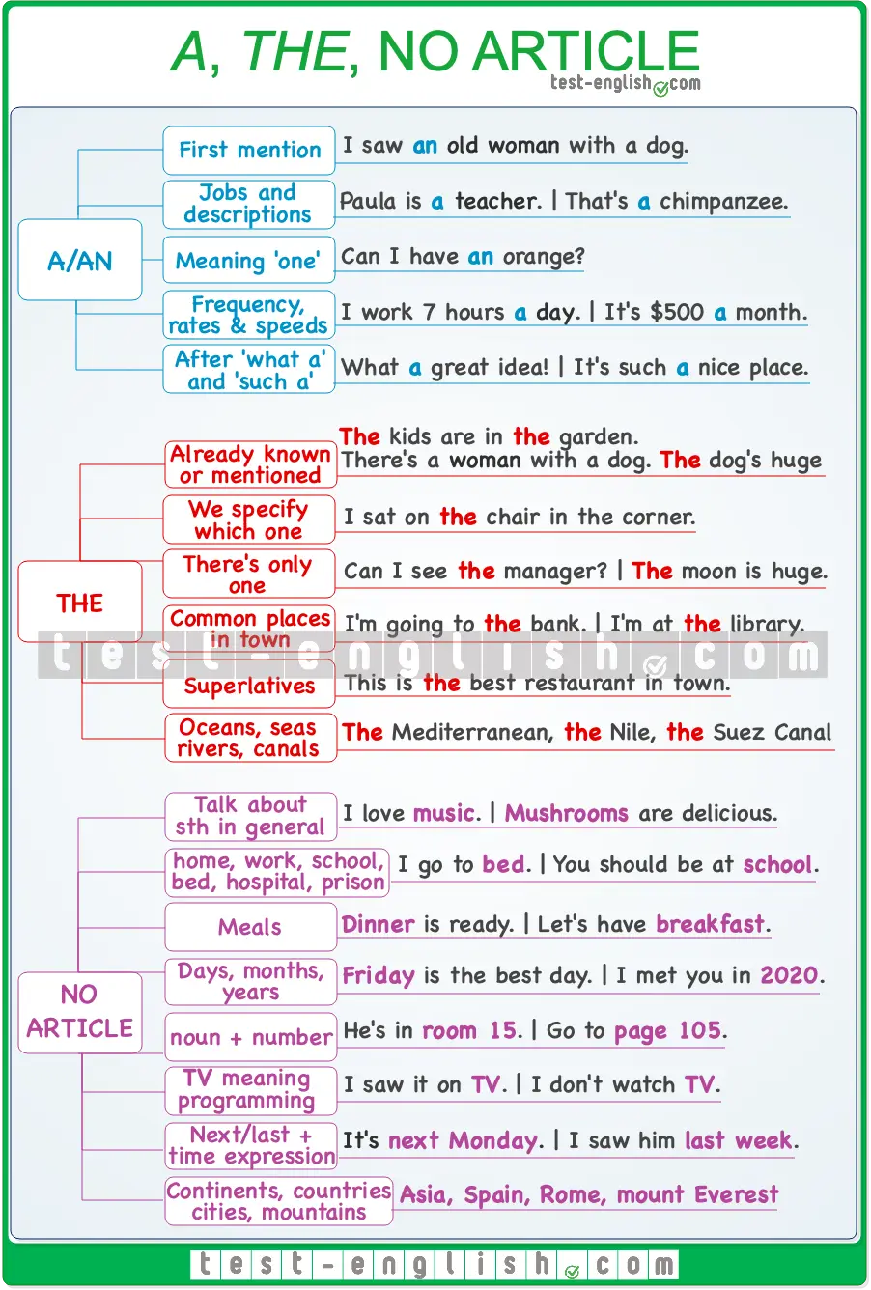

## Use ****a/an****

➟ When we mention something for the first time.

* I saw **an** old woman with **a** dog.

➟ To say what kind of person or thing something/somebody is.

* That’s **a** chimpanzee.
* When I was **a** teenager, I enjoyed sleeping.
* Paula is **a** teacher.

➟ When we mean ‘one’.

* Can I have **an** orange?

➟ For frequency, rates and speeds etc.

* I work 6 hours **a** day, and I go to English classes three times **a** week.
* The rent is €500 **a** month.
* We were driving at 70 km **an** hour.

➟ In the expressions **what a**/**such a** + singular countable noun.

* What **a** fantastic idea!
* Yesterday was such **a** horrible day!
* This is such **a** difficult problem!
* Thanks, you are such **a** good friend.

❗ **Note** that you cannot use singular countable nouns alone (without **a**/**the**/**my**/**etc**.)

* I don’t have **driving license**. 
* I don’t have **a** driving license. 
* I have **car**. 
* I have **a** car. 
* When I was **teenager**… 
* When I was **a** teenager… 

## Use ****the****

➟ With things or people already mentioned, or when we know which things or people we are talking about.

* A man and a woman sat in front of me. **The** man was British, but I think **the** woman wasn’t.
* ‘Where are **the** kids?’ ‘They’re in **the** garden.’ (=Both speakers know which kids and which garden).

➟ When a noun is made specific by details we give after it.

* I sat on **a** chair (maybe one of many).
* I sat on **the** chair **in the corner**.
* I saw **the** man who tried to rob me.

➟ When there is only one of something: **the earth, the moon, the planet, the internet, the universe, the sky, the city**(=not the country)**, the country**(=not the city)**, etc.**

* I need to talk to **the** manager. (=There’s only one manager.)
* I’d like to live in this country, but not in **the** capital.
* **The** moon looks beautiful today.

➟ With places in a town where we commonly go (**the park, the cinema, the doctor, etc**.)

* I’m going to **the** bank.
* I found Peter at **the** station.
* I’m at **the** library.

➟ With superlatives

* This is **the** best restaurant in town.

➟ With the names of oceans, seas, rivers and canals (**the** Mediterranean, **the** Amazon, **the** Panama canal, etc.).

## Use no article

➟ To describe something in general (with plural or uncountable nouns).

* Love and health are more important than money.
* Women drive more cautiously than men.

🆚 Compare:

* I love music. (= music in general)
* The party was great. I loved the music. (=specific music)

➟ With **home, work, bed, hospital, school, university, prison** when we speak in general (as the place used to live, work, sleep, be hospitalised, learn or be imprisoned.)

* David isn’t **at school** this morning. (=learning)
* She has been **in bed** all morning. (=sleeping or resting)
* Maria is **in hospital**. (=hospitalised, as a patient)
* They are going to send him **to prison** (=to be imprisoned)

❗ **But** we use the article if we refer to these places just as places or buildings –when they are not used for their main purpose.

* I found the keys under **the** bed.
* I’m going to **the** school to pick up my children.
* Yesterday I went to **the** hospital to visit my grandmother.

➟ With names of meals (**breakfast, lunch, dinner**)

* **Dinner** is served at 8.
* I always have **breakfast** with my children.

➟ With names of years, months and days of the week.

* **Friday** is my favourite day of the week.
* I think **2020** will be an excellent year.

➟ With **noun + number**.

* He is in **room 15**.
* Go to **page 86**.

➟ With **TV** (when used as a broadcasting service, NOT as an appliance)

* I saw it **on TV**.
* I don’t **watch TV**.

❗ **But** Turn off **the** TV. I’ve bought **a** new TV.  
  
➟ With **next** and **last** **+ time expression** (when they mean before or after **NOW**)

* The meeting is **next Thursday**.
* I saw him **last week**.

❗ **But** Last year we spent three weeks in London. **The last week** in London was one of the best in my life. (=It does not mean ‘the week before NOW’)  
  
➟ With most names of places, such as continents (Europe, Africa, etc.), countries (Spain, China, etc.), cities or towns (Rome, Bangkok, etc.), mountains (mount Everest, Annapurna, etc.)  
  
❗ **But** names of countries that are plural or that include words such as **State**, **Republic**, or **Kingdom** are used with **the**: **the** US (the United States), **the** UK (the United Kingdom), **the** Philippines, **the** Netherlands, **the** Czech Republic.

## Reflexive pronouns

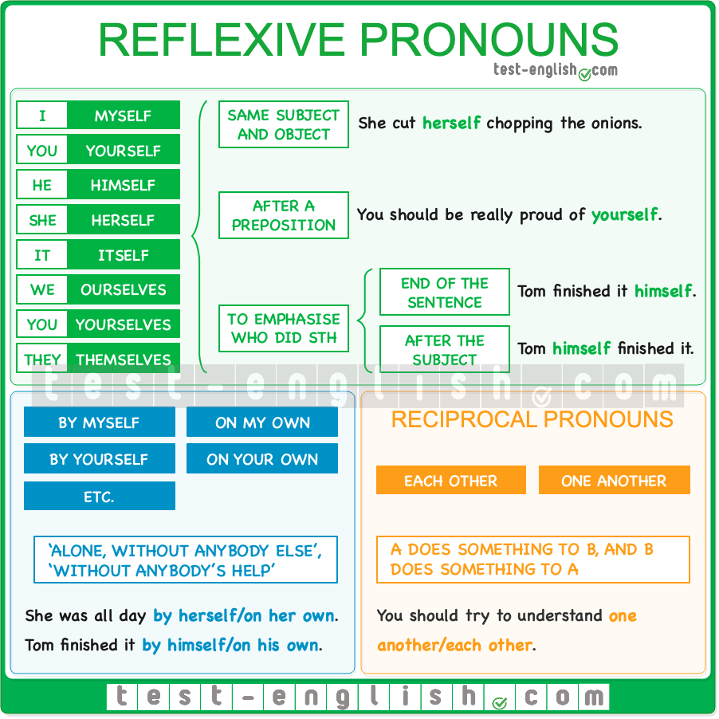

The reflexive  pronouns are **myself, yourself, himself, herself, itself, ourselves, yourselves, themselves**.

#### Same subject and object

The reflexive pronouns are normally used when the subject and the object are the same person.

* She cut **herself** chopping the onions.
* We really enjoyed **ourselves** at the party.
* Talking to **oneself** is not necessarily a sign of madness.

#### After preposition

We can use reflexive pronouns after most prepositions if they refer back to the subject.

* He should be really proud of **himself**.
* With the 3-D printer and this scanner, you can print a small version of **yourself**.

#### To emphasise who did the action

We also use a reflexive pronoun to emphasise that the subject does the action and nobody else. In this sense, we can use the reflexive at the end of the sentence or after the subject.

* I will talk to Anna **myself**.
* I think you should do it **yourself** instead of having it done.
* Paul **himself** designed everything.

#### Verbs with NO reflexive pronoun

Students of English often make mistakes when they use some verbs which are used reflexively in their language but not in English. Some of these verbs are **concentrate, dress**, **shave**, **wash**, **relax**, **hurry**, or **open**.

* The first thing I do is **wash**, **shave**, and **dress**.
* When I arrive home, I only want to **relax** on the sofa.
* Please **hurry**, or we’ll be late.
* The door **opened**, and everybody got in.

#### ****By myself, on my own****

We can say **by myself, by yourself, etc.** to mean ‘alone, without anybody else’, or ‘without anybody’s help’.

* My son doesn’t like to be **by himself**; he always wants us around.
* She raised her four children **by herself**.

We can also say **on my own, on your own, etc.**

* I was **on my own** all morning.
* She did it **on her own**.

## Reciprocal pronouns

We use **each other** or **one another** when person A does something to person B and person B does something to person A.

* When the twins found **each other**, they had been living apart for more than ten years.
* You should try to understand **one another**.

## ****Much, many, little, few, some, any, no****: Grammar chart

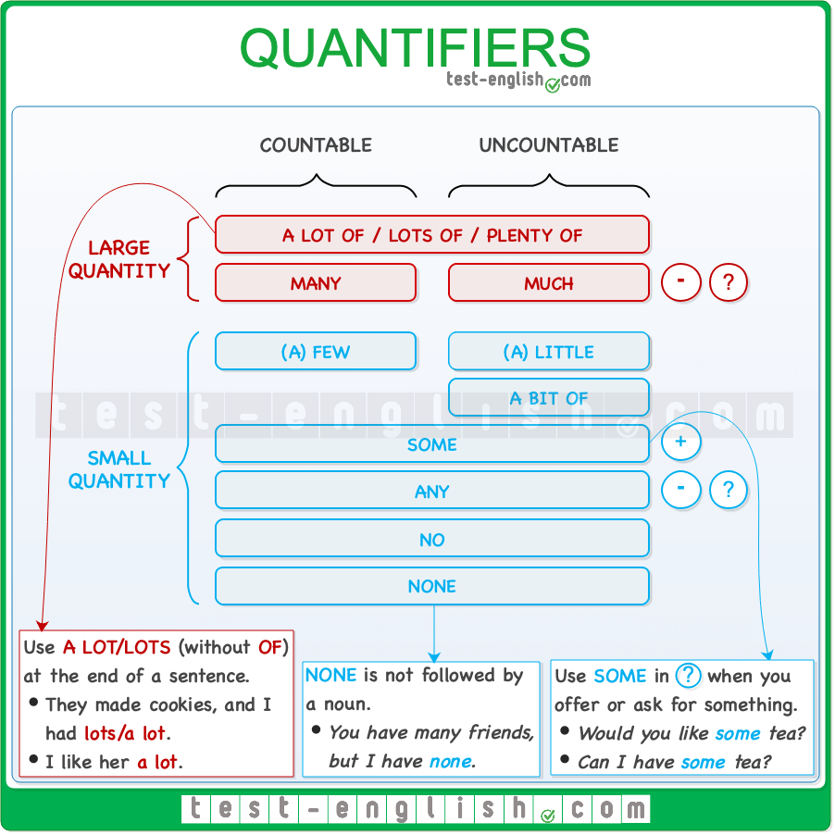

## ****Many/much****

#### ****Many**** for countable, ****much****for uncountable in (?) and (-)

We use **many** before **plural** (countable) nouns and **much** before **uncountable** nouns. We use them in **negative** sentences and **questions**. We don’t often use them in affirmative sentences.

* There isn’t **much coffee** in the jar.
* Were there **many people** in the party?

#### ****Too much/too many, so much/so many****

🔍 **Note** that **much**/**many** are more common in negatives and questions than in affirmative sentences. However, we use **too much** and **too many** or **so much** and **so many** in affirmative sentences.

* There’s **too much salt** in the soup.
* You eat **too many biscuits**.
* There were **so many people** that we had to leave.
* He ate **so much cake** that it made him sick.

#### ****How much/how many****

We use **how many** and **how much** to ask about quantity.

* **How many concerts** have you ever been to?
* **How much coffee** have you had today?

## ****A lot of/lots of/plenty of****

#### Before both countable and uncountable

We use **a lot of**, **lots of**(more informal), or **plenty of** before both **plural** (countable) and **uncountable** nouns. We normally use them in positive sentences.

* She spends **a lot of time** watching TV.
* We had **lots of good** moments together.
* We’ve got **plenty of time**.

#### ****Of**** before noun; no ****~~of~~**** ~~at the end of a sentence~~

~~We must always use~~ **~~a lot of~~** ~~or~~ **~~lots of~~** ~~including~~**~~of~~** ~~at the end. However, we can use the expressions~~ **~~a lot~~** ~~or~~ **~~lots~~**~~(without~~**~~of~~**~~) at the end of a sentence.~~

* ~~‘How many beers did you have?’ ‘I don’t know; I had~~ **~~lots/a lot~~**~~.’~~
* ~~I like her~~**~~a lot~~**~~.~~
* ~~I don’t want any more cake, thanks. I’ve had~~ **~~plenty~~**~~.~~

## ****~~(A) few/(a) little/a bit of~~****

#### ****~~Few~~**** ~~for countable;~~ ****~~little~~**** ~~for uncountable~~

~~We use~~ **~~(a) few~~** ~~before~~ **~~plural~~**~~(countable) nouns and~~ **~~(a) little~~** ~~or~~ **~~a bit of~~** ~~(more informal) before~~ **~~uncountable~~** ~~nouns in affirmative, negative and interrogative sentences.~~

* ~~I have to do~~ **~~a few things~~** ~~this afternoon.~~
* ~~He always gets good results with very~~ **~~little effort~~**~~.~~
* ~~Can you put~~ **~~a bit of sugar~~** ~~in the tea?~~

#### ****~~Few~~**** ~~or~~ ****~~a few~~****~~?~~ ****~~Little~~**** ~~or~~ ****~~a little~~****~~?~~

**~~A few~~** ~~means ‘some but not many; enough’, and~~ **~~a little~~**~~means ‘some but not much; enough’ .~~**~~Few~~**~~means ‘almost none; not enough’.  
  
Normally, the difference between~~ **~~a few~~**~~/~~**~~little~~** ~~(WITH~~ **~~a~~**~~) and~~ **~~few~~**~~/~~**~~little~~** ~~(WITHOUT~~**~~a~~**~~) is that~~ **~~a few/little~~** ~~is positive in meaning, and~~ **~~few~~**~~/~~**~~little~~** ~~is negative. Compare:~~

* ~~There’s~~ **~~little milk~~** ~~in the fridge; we have to buy more. (=Not enough; we need more)~~
* ~~‘Shall I buy some beers?’ ‘No, it’s OK, there are~~ **~~a few~~**~~in the fridge.’ (=Enough; we don’t need more)~~
* ~~‘Do you speak English?’ ‘~~**~~No~~**~~, I speak very~~ **~~little English~~**~~.’ (=Negative)~~
* ~~‘Do you speak English?’ ‘~~**~~Yes~~**~~, I speak~~ **~~a little English~~**~~.’ (=Positive)~~

## ****~~Some/any/no~~****

#### ****~~Some~~**** ~~in (+) and~~ ****~~any~~**** ~~in (?) and (-)~~

~~We use~~ **~~some~~** ~~in~~ **~~affirmative~~** ~~sentences and~~ **~~any~~** ~~in~~ **~~negative~~** ~~sentences and~~ **~~questions~~**~~.~~

* ~~There isn’t~~**~~any sugar~~** ~~in the cupboard.~~
* ~~Have you got~~ **~~any new friends~~**~~?~~
* ~~I have~~ **~~some questions~~** ~~to ask you.~~

#### ****~~No~~**** ~~in (+)~~

~~We use~~ **~~no~~** ~~in~~ **~~affirmative~~** ~~sentences.~~

* ~~There are~~**~~no~~** ~~biscuits left.~~
* *~~I have~~* ***~~no~~*** *~~questions to ask.~~*

#### ~~With both countable (plural) and uncountable~~

**~~Some~~**~~,~~ **~~any~~**~~and~~ **~~no~~**~~can be used before~~ **~~countable and uncountable~~** ~~nouns. But if we use them before a countable noun, the noun must be~~ **~~plural~~**~~.~~

* ~~Is there~~ **~~any student~~** ~~in the classroom? ~~
* ~~Are there~~ **~~any students~~** ~~in the classroom? ~~
* ~~There are~~ **~~no~~** ~~students in the classroom.~~

#### ****~~Some~~**** ~~for offers and requests~~

~~We use~~**~~some~~** ~~(NOT~~**~~any~~**~~) in interrogative sentences when we are offering or requesting (=asking for) something.~~

* ~~Would you like~~ **~~some~~** ~~help?~~
* ~~Can I have~~ **~~some~~** ~~tea, please?~~

## ****~~None~~****

**~~None~~**~~is a pronoun. It means ‘zero’. We use it in affirmative sentences as a pronoun to replace countable and uncountable nouns. This means that it’s not followed by a noun.~~

* ~~There were three bottles before we left, and now there are~~ **~~none~~**~~.~~
* ~~‘How much cake did you have?’ ‘~~**~~None~~**~~.’~~

#### ****~~None of~~****

~~We can also use~~**~~none of~~** ~~+ noun (countable or uncountable).~~

* **~~None~~** ~~of the questions were answered.~~

## ****All/both****: Grammar chart

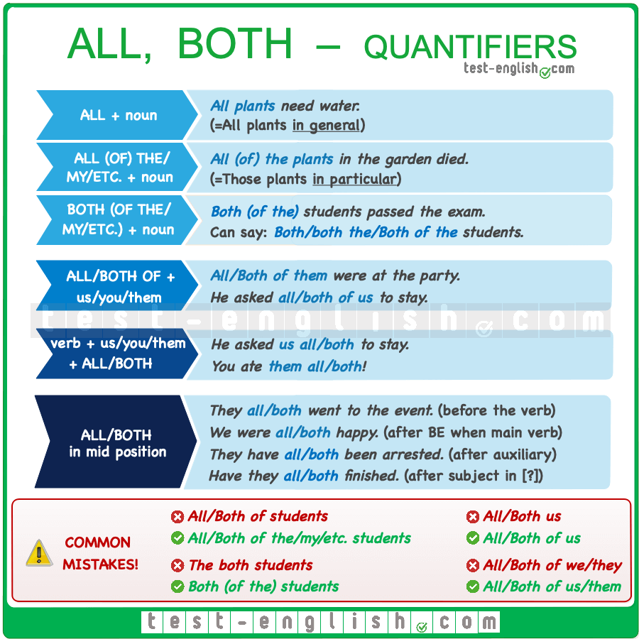

## ****All/all the; both/both (the)****

We can use **both** or **both the/my/etc. + noun** in the same way to refer to two people or things.

* **Both students/Both the students** passed the exam.
* They won **both matches/both the matches**.

We use **all + noun** (without **the**) to refer to things/people in general.

* **All students** hate homework. (**all** + plural countable nouns)
* **All music** makes people feel something. (**all** + uncountable nouns)

We use **all + the/my/etc. + noun** to refer to particular people or things.

* **All the students in my class** hate homework. (**all the** + plural countable nouns)
* **All the music I download** makes me feel something. (**all the** + uncountable nouns)

#### ****All (of) the; both (of the)****

We can use **all/both + of** before **both/all of the/my/Tom’s + noun**. But it is often omitted.

* **All (of) the students in my class** hate homework.
* **Both (of the) students** passed the exam.

But we cannot use **both/all of + noun** when there isn’t a determiner, i.e. **the, my, this etc.**, before the noun.

* **All/Both of students** passed the exam. 
* **All/Both of the students** passed the exam. 

## ****All/both****: word order with pronouns

#### ****All of us / both of them / etc.**** (subject)

We can use **all/both of + you/us/them** before a verb (as the subject of a sentence).

* **All of us** were at the party.
* **Both of them** are wrong.

❗ **Note** that **of** is necessary; we cannot omit it.

* **All us** were at the party. 
* **All of us** were at the party. 

#### ****Us all / them both / etc.**** (object)

We can use **you/us/them + all/both** after a verb (as the object of a sentence).

* The judge sent **them all** to jail. (=The judge sent all of them to jail.)
* She loves **them both**. (=She loves both of them.)

## ****All/both****: word order with verbs (mid position)

**All** and **both** can be used in mid position. Mid position is:  
  
➟ Before the verb.

* We **both like** going to the cinema. (=Both of us like going to the cinema.)
* They **all left** without saying goodbye. (=All of them left without saying goodbye.)

➟ After the verb **be** when it’s the only verb in a sentence.

* The boys **were all** happy. (=All the boys were happy.)
* The players **are both** tired. (=Both [the] players are tired.)

➟ After an auxiliary verb or after the first auxiliary verb if there is more than one.

* They **are all going** to disappear. (=All of them are going to disappear.)
* The robbers **have both been** arrested. (=Both [the] robbers have been arrested.)

➟ In questions, mid position is after the subject.

* Have **they both** finished?

## ****Both, either, neither****: Grammar chart

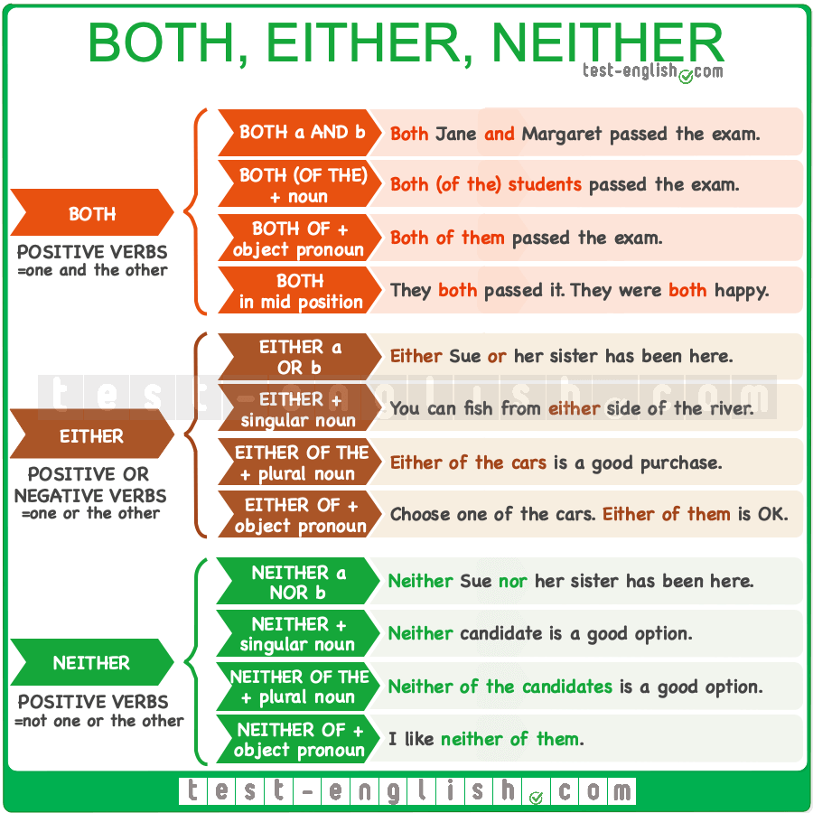

We use **both**, **either** and **neither** to talk about two things or people.

**Both**= A and B (the two things or people)

**Either**= A or B (one thing/person or the other thing/person)

**Neither**= not A and not B (zero out of two things or people)

## ****Both / either / neither**** + noun

We can use **both/either/neither + noun**

* I like **both cars**.
* You can park on **either side** of the street.
* **Neither parent** was at the meeting.

🔍 **Note** that we use **both + plural noun** and **either/neither + singular noun**.

## ****Both (of) / either of / neither of****

We can use **both (of)** / **either of** / **neither of**+ **the/these/my/her/Peter’s/etc.** + noun

* **Both (of) your** parents are really nice.
* **Either of those** two dates is perfect for the wedding. (=We can choose one or the other)
* **Neither of the** tennis players had a great game.

🔍 **Note** that we don’t need **of** after **both**.

* **Both of your** parents are really nice. = **Both your** parents are really nice.

We can use **both of** / **either of** / **neither of**+ **us/you/them**

* **Both them** did very well in the exam. 
* **Both of them** did very well in the exam. 
* Can **either of you** give me a coin for the vending machine?
* **Neither of us** knows the truth.

## ****Both / either / neither**** (without a noun)

We can use **both/either/neither**alone, without a noun.

* A: Do you speak French or Spanish? B: I speak **both**.
* A: Do you want tea or coffee? B: **Either**. I don’t mind.
* A: Which car do you prefer? B: **Neither**. I think both of them are horrible.

## ****Both … and …/ either … or … / neither … nor …****

We can say **both … and …/ either … or … / neither … nor …** to mention the two things or people that we are talking about.

* She ate **both** the rice **and** the meat.
* **Both** Susan **and** Peter helped me with my report.
* You need to speak one foreign language, **either** Spanish **or** French.
* You can **either** wait here **or** go home.
* I like **neither** maths **nor** physics.
* He **neither** called **nor** texted.

## Remember this!

Use **either** and **neither** with a singular verb.

* **Either** candidate is good.
* **Neither** of the candidates is good.

**(not) either**= **neither**.

* I do**n’t** like **either** of the options. = I like **neither** of the options.

The word **neither** is negative, so we use it with positive verbs.

* **Neither** John nor Paula **can’t come**. 
* **Neither** John nor Paula **can come**. 

We also use the word **both** with positive verbs. We can only use **either** with negative verbs.

* I did**n’t** like **both/neither** of the pictures. 
* I did**n’t** like **either** of the pictures. 

## ****No, any, none****: Grammar chart

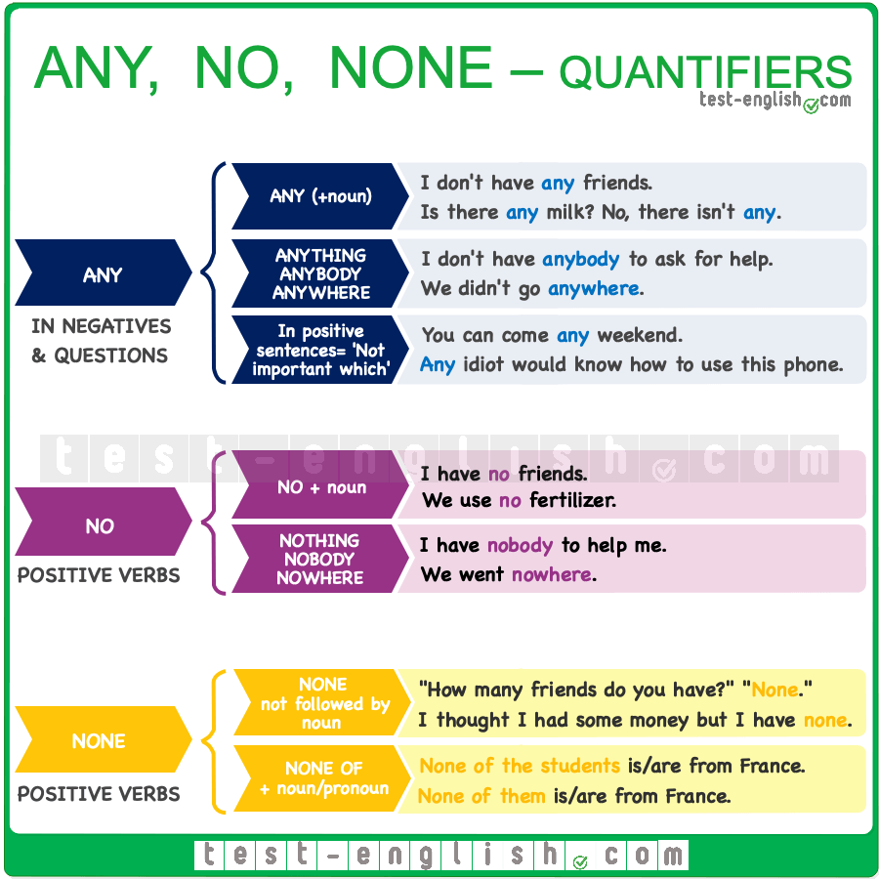

## ****No****/****any**** + noun

We use **no** + noun in sentences with a positive verb, and we use **any**+ noun in negatives and questions. **No**= **not a** or **not any**

* I have **no** friends.
* I don’t have **any** friends.
* Do you have **any** friends?

## ****Any**** without noun

We can also use **any** as a pronoun, i.e. not followed by a noun.

* ‘Is there any milk left?’ ‘No, there isn’t **any**.’

## ****Any**** in affirmative sentences

We can also use **any**in affirmative sentences when it means ‘one or some, but it is not important which’.

* You can come **any** weekend. (=One weekend; it doesn’t matter which)
* **Any** idiot would know how to use this phone.

## ****None****

We use **none** as a pronoun, i.e. not followed by a noun. We use **none** to replace countable or uncountable nouns.

* ‘How many friends do you have?’ ‘**None**.’
* I thought there was some coffee, but there’s **none**.’

We can also use **none of the/my/Tom’s/etc.** + noun or **none of** + **us/you/them**.

* **None of my students** is/are from France.
* **None of them** is/are from France.

🔍 **Note** that when **None of …** is the subject of a sentence, we can use the verb in singular (more formal) or plural form (more informal).

## ****Nothing/anything, nobody/anybody, nowhere/anywhere****

We use **nothing, nobody,** and **nowhere** with positive verbs and **anything, anybody,** and **anywhere** in negative sentences and questions. **Nothing, nobody, nowhere** = **not anything, not anybody, not anywhere**

* There’s **nothing** that we can do. (=There is**n’t anything** that we can do.)
* Have you seen John **anywhere**?
* We saw **nobody**. (=We didn’t see **anybody**)
* **Nothing** happened.

#### ****Anything, anybody, anywhere**** in affirmative sentences

We can use **anything/anybody/anywhere** in affirmative sentences to mean ‘it doesn’t matter what/who/where.’

* We can do **anything**. (=It doesn’t matter what.)
* **Anybody** in the school could help us. (=It doesn’t matter who.)
* We can go **anywhere**. (=It doesn’t matter where.)

## Another, other, others, the other, the others

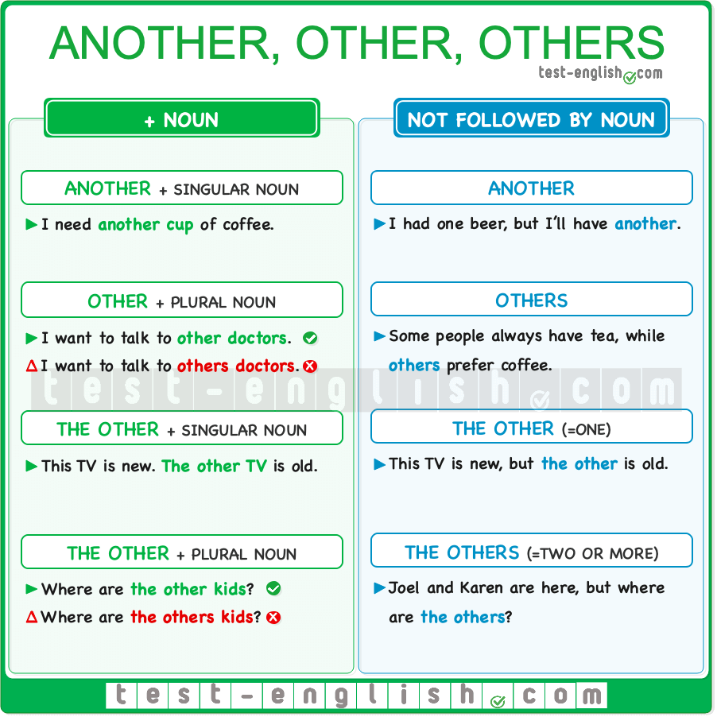

### ****Another**** vs ****other**** (determiners)

We can use **another** and **other** as determiners, i.e. **before a noun**.  
  
Use **another**+ a singular noun.

* I need **another cup** of coffee.

Use **other**+ a plural noun.

* I want to talk to **other doctors**.

❗ **Note** that determiners don’t have a plural form. We say:

* I want to talk to **others doctors**. 
* I want to talk to **other doctors**. 

### ****Another**** vs ****others**** (pronouns)

We can use **another** as a pronoun, i.e. not followed by a noun.

* I’ve already had one beer, but I’ll have **another**.

**Others** is always a pronoun, i.e. **never followed by a noun**.

* I don’t want to use these glasses. Aren’t there any**others**? (=other glasses)

### ****Other**** vs ****others****

We normally use **other + a plural noun**.

* I want to see **other shops** before deciding.

**Others** is a pronoun, i.e. **not followed by a noun**.

* A lot of volunteers have joined us, but we need to find **others**.

### ****The other, the others****

#### ****The other**** + noun

Use **the other** + a singular noun to mean ‘the second of two things or people, or the opposite of a set of two’.

* This computer here is new. The other computer is about five years old.

We could also say **the other one** instead of **the other computer**.  
  
Use**the other**+ a plural noun to mean ‘the remaining people or things in a group or set’.

* Joel and Karen are here, but where are the other kids? (the remaining kids in the group)

#### ****The other**** or ****the others**** (without a noun)

We can also use **the other** as a pronoun (not followed by a noun).

* This computer here is new. The other is about five years old.

We can also use **the others** as a pronoun (not followed by a noun).

* Joel and Karen are here, but where are the others? (the remaining kids in the group)

### Relative clauses, relative pronouns and adverbs

## Defining vs non-defining: Grammar chart

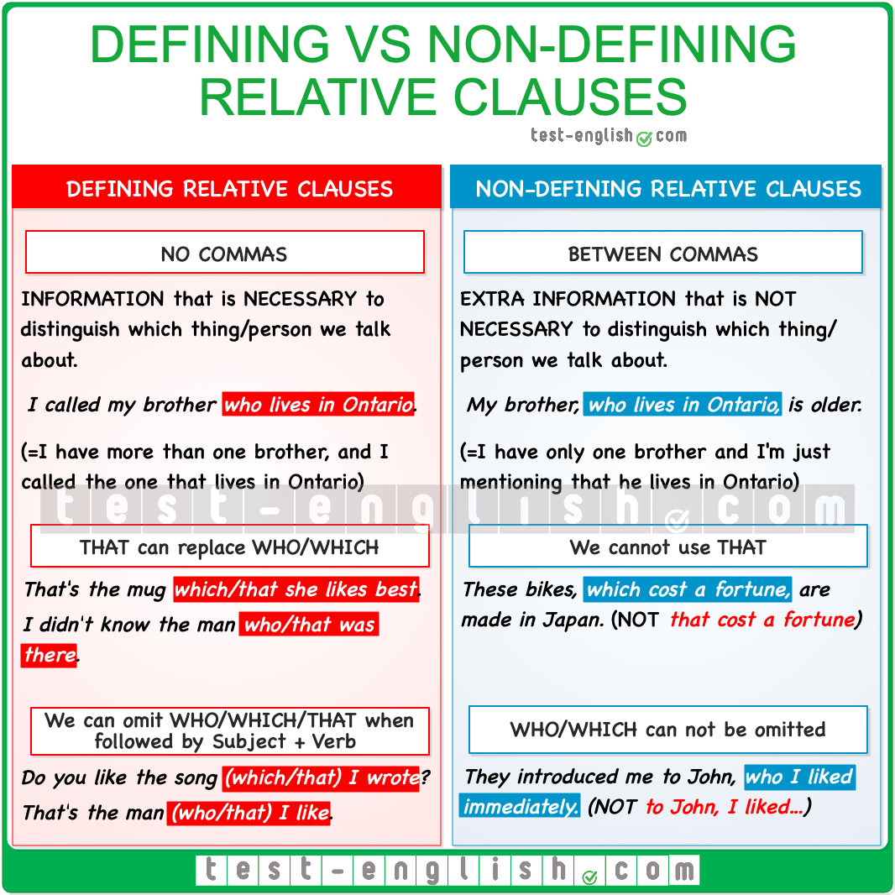

## Defining relative clauses

Defining relative clauses carry **essential information** because they **identify which** thing or person we are talking about, and they are used **without commas**.

* This is the music **which was used at the show**.
* Have they found the prisoner **who escaped last week**?

#### We can use ****that****

In defining relative clauses, we can use **that** instead of **which**or **who**.

* This is the music **that** was used at the show.
* Have they found the prisoner **that** escaped last week?

#### When can we omit ****who/which/that****?

**Who/which/that** can be **omitted** if they are followed by **subject + verb**

* Can you pass me the box **(which/that)** I keep in the top drawer?
* You are not the man **(who/that)** I thought you were.

## Non-defining relative clauses

Non-defining relative clauses are used **between commas**, and they add **extra information**, which is **not necessary** to know who or what we are talking about.

* This music, **which I really like**, was used at the show.
* My sister, **who I truly admire**, is coming for Thanksgiving.

#### We cannot use ****that****, and we cannot omit ****who/which****

In non-defining relative clauses (between commas), we cannot use **that**, and we cannot omit **who/which**.

* This music, **that I really like**, was used at the show. 
* This music, **which I really like**, was used at the show. 
* My sister,**I truly admire**, is coming for Thanksgiving. 
* My sister, **whom I truly admire**, is coming for Thanksgiving. 

## Defining vs non-defining relative clauses

In a defining relative clause, the information is essential to identify who or what we are talking about, whereas in non-defining relative clauses, we just add extra information, which is not necessary. Compare:

* My brother **who lives in Cardiff** is much older than me. (=I have more than one brother, and the relative clause helps identify which brother I am talking about)
* My brother,**who lives in Cardiff**, is much older than me. (=I have only one brother, so we don’t need the relative clause to know who I am talking about)

## Relative pronouns and adverbs

Here, you can see a grammar chart with the relative pronouns and adverbs that we normally use in relative clauses.  
  
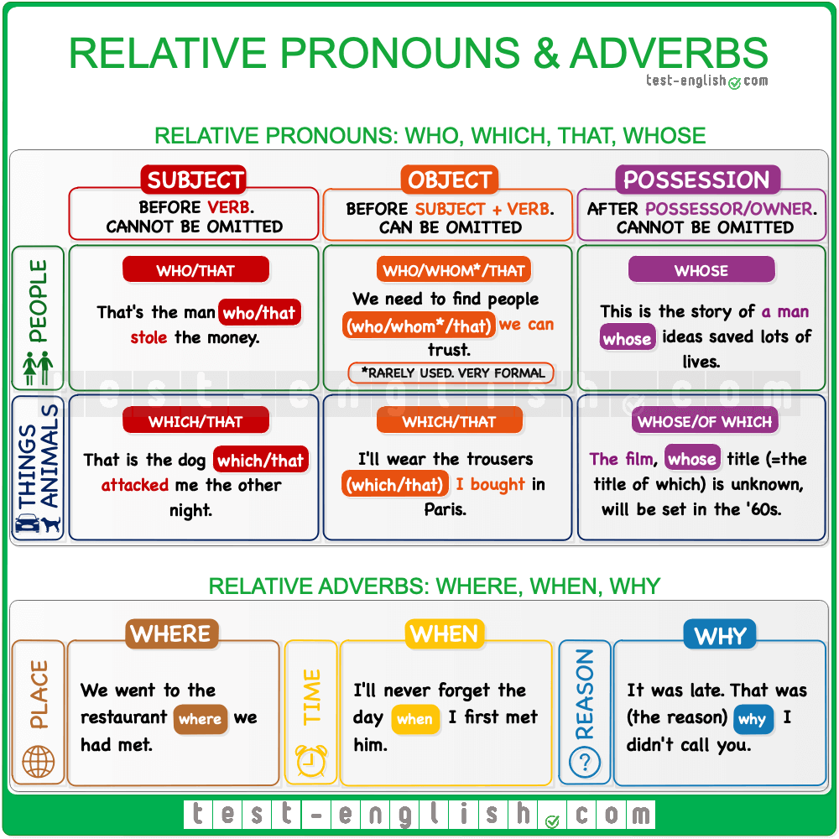

## Common mistakes

#### Two subjects

When **who**, **which**, or **that** is the subject of a relative clause, we don’t use another pronoun or noun after it because we can only have one subject (**who**, **which**, or **that**).

* I saw a man **who he was** very tall. 
* I saw a man **who was** very tall. 
* That is the painting **that it was** stolen from the gallery. 
* That is the painting **that was** stolen from the gallery. 

#### ****That**** between commas

We cannot use the relative pronoun **that** in a non-defining relative clause (between commas)

* The victim, **that** suffered a concussion, said he didn’t remember the accident. 
* The victim, **who** suffered a concussion, said he didn’t remember the accident. 

### Auxiliary verbs

## Question tags: Aren’t you? don’t you?

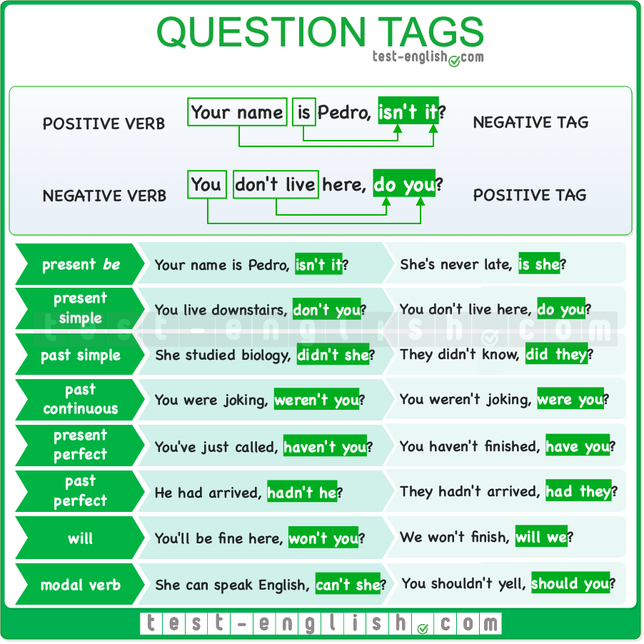

### Meaning

Question tags are used at the end of statements to turn the statements into questions. We usually use question tags to confirm something that we believe to be true or to invite the listener to agree or disagree with a statement.

When we use question tags, the way our voice goes up or down at the end can change the meaning.

**Voice goes up ⤴**  
  
This means we’re not sure about what we’re saying, and we’re really asking for help to know if it’s true or not. For example, “You’re coming to the party, aren’t you?” said with your voice going up is like saying, “Please tell me if you are coming because I don’t know.”  
  
**Voice goes down ⤵**  
  
This means we’re pretty sure about what we’re saying, and we just want the other person to agree with us. For example, “It’s hot today, isn’t it?” said with your voice going down is like saying, “I think it’s hot and I believe you think so too, right?”

### Form

Use the **same auxiliary verb** as in the main sentence. If there is no auxiliary verb, use **do** for present and **did** for past.  
  
Use a **comma** before the question tag and a **subject pronoun** at the end (**I, you, he, she, it, we, you, they**).

* You are his brother, **aren’t you**?
* He will be there, **won’t he**?
* You work here, **don’t you**?
* Sam used to live in Scotland, **didn’t he**?

If the main sentence is **positive**, use a **negative** auxiliary.  
  
If the main sentence is **negative**, use a **positive** auxiliary.

* You like it, **don’t you**?
* You don’t like it, **do you**?

#### ****Aren’t I?****

❗ **Note** when we have an affirmative sentence with **I am**, the question tag is **aren’t I?**

* I’m totally wrong, **aren’t I**?

### Adjectives and adverbs

## Comparative and superlative adjectives

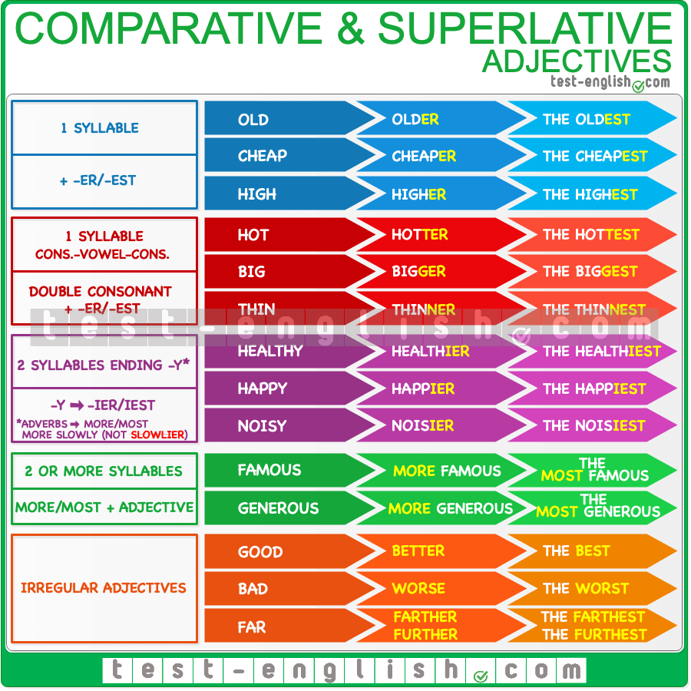

## The comparative form

We use the comparative form of the adjective to compare **two things**.

* White meat is **healthier than** red meat.
* Travelling by bus is **more comfortable than** travelling by train.

#### Less … than

We can also use the form **less** + adjective + **than**. **Less** is the opposite of **more**.

* Peter is **less considerate than** Marta. (=Marta is more considerate)

#### (Not) as … as

We can also use the form **(not) as** + adjective + **as**.

* Peter is**n’t as considerate as** Marta. (=Marta is more considerate)

#### Than me / than I am

After **than** or **as … as**, we use an object pronoun (**me, you, him, etc**.) or a subject pronoun (**I, you, he, she, etc**.) + auxiliary verb.

* My sister is taller **than me**.
* My sister is taller **than I am**.

#### Much/a lot/a bit more…

Before the comparative (**more** or **-er**), we can use **much**, **a lot** or **a bit**.

* He’s **a bit taller** than me.
* Florence is **much more** interesting than Pisa.
* This car is **a lot more** expensive.

#### Any/no more than

We can use **any**/**no** + comparative (any better, no faster, any more expensive, etc.). We use **any** in negative sentences and **no** with positive verbs.

* Your performance was **no better** than mine.
* Your performance wasn’t **any better** than mine.

## Superlative adjectives

We use the superlative form of an adjective or adverb to compare more than two things.

#### The most… in…

After the superlative, we use **in** + names of **places** or singular words for **groups of people** (class, school, team, family, etc.)

* She is the best student **of** the class. 
* She is **the best** student **in** the class. 
* He’s **the tallest in** the family.
* Messi is **the best player in** the world.

We normally use **of** + periods of time or a number of people (of the year, of my life, of my brothers, of the students, etc.).

* It was the best evening **of my life**.
* I am the tallest **of my brothers**.

#### The most… I have ever…

We often use the superlative with the **present perfect tense** and **ever**.

* This is **the best** movie I’**ve ever watched**.
* She is **the most beautiful** woman I **have ever seen**.

#### The/my/Tom’s best …

Before the superlative, we always use **the**, or **my/your/his/etc.**, or **Tom’s/Jenny’s/etc.**

* He is **the best**.
* This is **my most expensive** jacket.
* This is **Paul’s best** friend.

#### The least

The opposite of **the most** is **the least**

* He is **the least hardworking** student in the class.

## Comparing actions with adverbs

We can use the comparative or superlative form of **adverbs** to compare **actions**.

* She drives fast, but I drive **faster**.
* He plays well, but I play **better** than him.

With adverbs ending in –**ly**, you must always use **more** to form the comparative and **most** to form the superlative

* She speaks**quietlier** than her boss. 
* She speaks **more quietly** than her boss. 
* He cooks well, but**slowlier** than his workmates. 
* He cooks well, but **more slowly** than his workmates. 

For adverbs that have the **same form as adjectives**, the comparative and superlative forms are like adjectives: add –**er** to form the comparative and –**est** to form the superlative. The most common of these adverbs are: **late-later, early-earlier, fast-faster, hard-harder, long-longer**.

* He works **harder** than me.
* She always arrives **earlier** than her boss.
* It took us **longer** than usual to arrive because of the traffic.

## ****-Ed/-ing**** adjectives

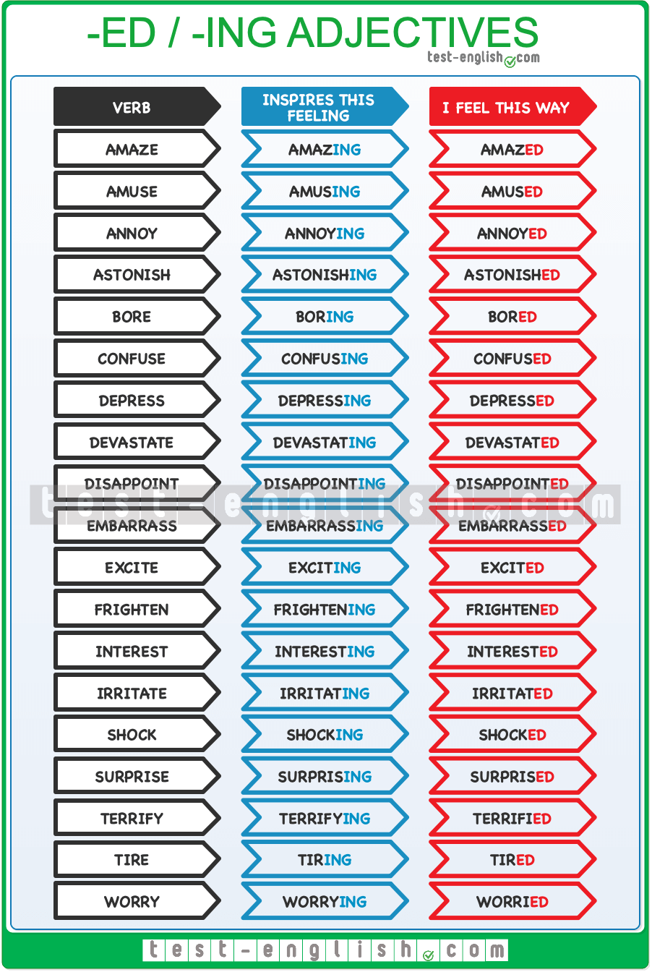

A lot of adjectives are made from verbs by adding **-ing** or **-ed**. They are called participial adjectives they take the forms of the present (**-ing**) and past participle (**-ed**) of the verb.

#### ****-Ed**** adjectives

**-ed** adjectives are used to describe **how we feel**. Look at the following examples:

* We’re **tired**. Can we stop running?
* I’m **bored**. Let’s play cards.
* I was **surprised** to see her.

#### ****-Ing**** adjectives

**-ing** adjectives are used to talk about the **things that produce these feelings**. Check the examples below:

* Running is very **tiring**. We don’t want to run.
* This film is very **boring**. Let’s play cards.
* Her visit was very **surprising**. We weren’t expecting her.

## ****So, such, such a, so much, so many****: Grammar chart

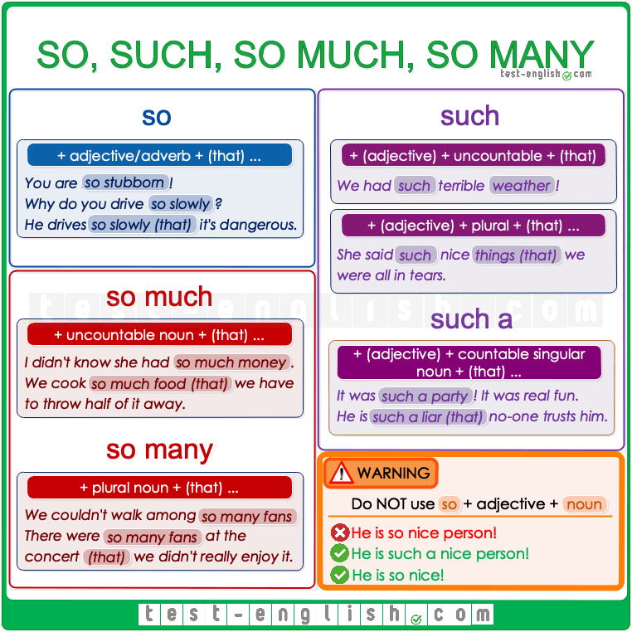

## ****So, such****

#### ****So**** + adjective/adverb + ****(that…)****

We use **so** + adjective or adverb

* Why don’t you try to understand? You are **so stubborn**!
* He gets on my nerves. You drive **so slowly**.

We often use **so**+ adjective or adverb + (**that**…)

* He is **so good (that)** he gets bored when he plays against me.
* John drives **so slowly (that)** other drivers get impatient around him.

#### ****Such a**** + (adjective) + noun + ****(that…)****

We use **such a** + (adjective) + countable singular noun

* I love her. She is **such a brilliant actress**.
* It was **such a party**! We had a lot of fun.

We often use **such a** + (adjective) + countable singular noun + (**that…**)

* It had been **such a terrible day (that)** I just wanted to go to bed.
* He is **such a liar (that)** nobody trusts him any more.

#### ****Such**** + (adjective) + noun + ****(that…)****

We use **such** + (adjective) + uncountable noun or plural noun

* The trip was a disaster. We had **such terrible weather**!
* Everybody loves being with Tom. He tells **such funny stories**!

We often use **such** + (adjective) + uncountable noun or plural noun + (**that…**)

* We had **such terrible weather (that)** we decided to go back home.
* She said **such nice things (that)** we were all moved.

## ****So/such****: Use

We can use **so**and **such** to make the meaning of an adjective, adverb or noun stronger –meaning ‘very’ or ‘really’.

* Why did you do it? You are **so stupid**!
* He was **such a terrible father** that now his kids don’t want to be around him.

We can also use **so** and **such** to mean ‘like this’:

* Sorry I didn’t call. I didn’t know it was **so important** for you. (=important like this).
* I don’t understand how you could make **such a terrible mistake**. (= a mistake like this)

## ****So much/so many**** + noun

#### ****So much**** + uncountable noun + ****(that…)****

We use **so much** + uncountable noun

* Did you see her house? I didn’t know she had **so much money**.
* I wish you wouldn’t spend **so much time** on the phone.

We often use **so much** + uncountable noun + (**that…**)

* She always cooks **so much food that** we have to throw half of it away.
* There is **so much furniture that** it’s difficult to walk around the house.

#### ****So many**** + plural noun + ****(that…)****

We use **so many** + plural noun

* He couldn’t even walk among **so many fans**.
* You don’t need to repeat everything **so many times**.

We often use **so many** + plural noun + (**that…**)

* There were **so many people** at the concert **(that)** we didn’t really enjoy it.
* *She had* ***so many problems******(that)*** *she just didn’t know what to do.*

## Compound adjectives with numbers: Grammar chart

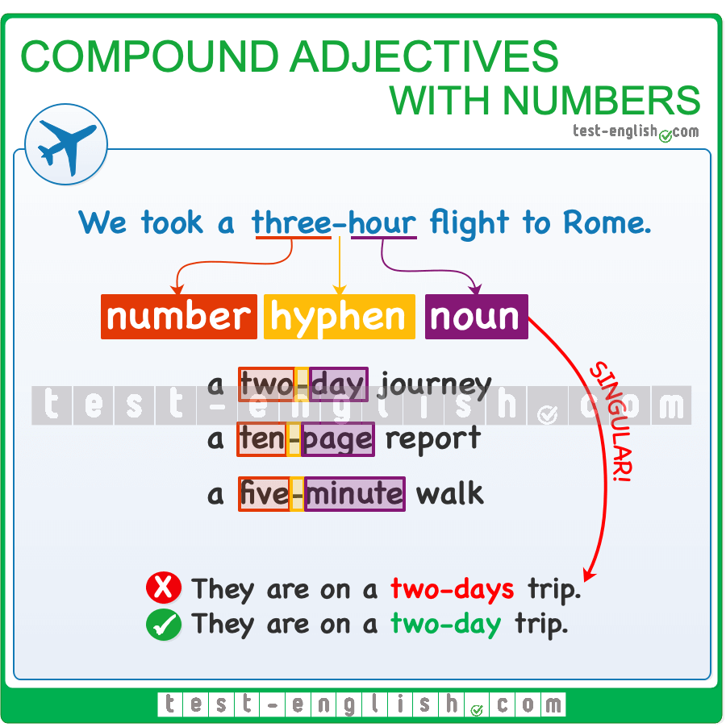

### Adjectives

[Adjectives](https://test-english.com/grammar-points/a1/adjectives/) are words used before a noun or after the verb **be** or a verb of the senses (**feel, look, smell, sound, taste**) to describe something.

* They have an **expensive** car.
* Your idea is **fantastic**.
* John looks **tired**.

### Compound adjectives

**Compound adjectives** are made of two or more words: a **well-dressed** man, a **part-time** job, a **first-class** train ticket, etc.

We should join the different words in a compound adjective with a hyphen to show that they go together and are part of the same idea.

### Number + noun

We can use number + noun as a compound adjective before another noun.  
  
This construction is often used with nouns of measurement, such as **foot, metre, mile, pound, kilogram, second, minute, hour, pound, dollar, etc.**.  
  
There are two things that you should remember about number-noun compound adjectives:  
  
Use a singular noun. Remember adjectives have no plural form in English:

* A **two-days** journey 
* A **two-day** journey 

Use a hyphen to connect the number to the noun that follows it. This allows the reader to know that both words function as a unit that modifies the noun after it:

* A **30-minute** show
* A **two-day** journey
* A **50-metre** pool
* An **eight-core** processor
* A **two-bedroom** apartment

🔍 **Note** that you can write **metre, litre** (UK spelling) or **meter, liter** (US spelling).  
  
Sometimes, a compound adjective is made up of more than one word:

* A **10-million-dollar** house
* A **seven-year-old** child

### Number + part of the body + ****-ed****

When we use a number + noun as a compound adjective, and the noun is a part of the body, then we have to add **-ed** after the part of the body.

* A **three-legged** table
* A **seven-headed** dragon
* A **one-eyed** alien
* A **four-armed** robot

❗ **Note** that the consonant is doubled when the last syllable of the noun is stressed and is made of consonant + vowel + consonant: *le****gg****ed*.

### Conjunctions and clauses

## Clauses of contrast, purpose and reason

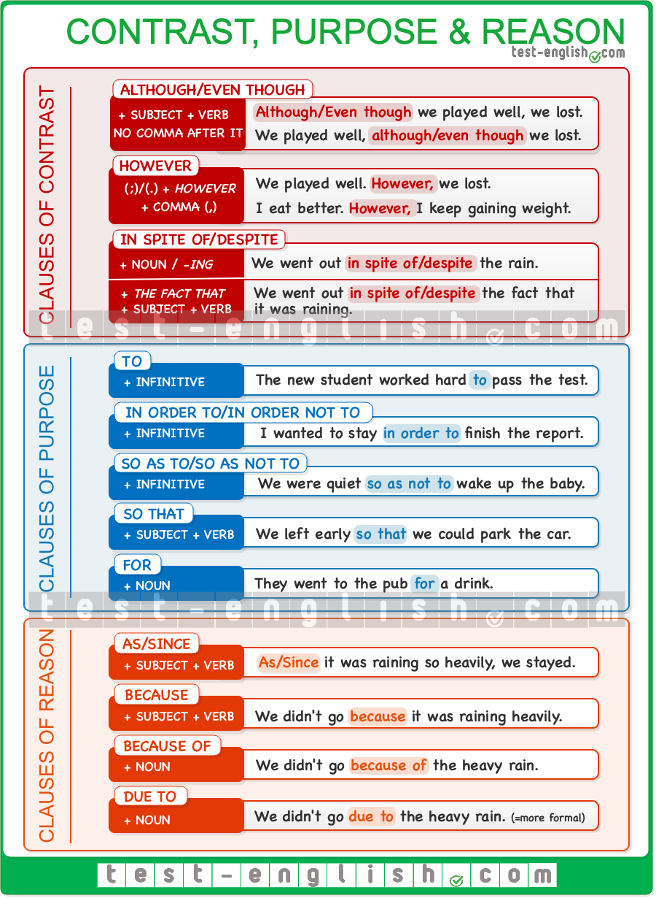

## Clauses of contrast

#### ****Although, even though****

We can use **although**/**even though** at the beginning or in the middle of a sentence followed by a clause (subject + verb). We NEVER use a comma after **although** or **even though**.

* **Although/Even though** we had a bad game, we won.
* We won, **although/even though** we had a bad game.

#### ****However****

We use **however** to connect two different sentences. We normally use **however** after a full stop (.) or a semi-colon (;). **However**should ALWAYS be followed by a comma.

* We didn’t like the hotel. **However,** we had a fantastic time.
* We went to the beach; **however,** the weather wasn’t perfect.

#### ****Despite/in spite of****

**Despite** and **in spite of** are normally followed by a noun or a –**ing** verb. They can go at the beginning or in the middle of the sentence.

* **Despite/In spite of** the rain, we went to the concert.
* They arrived **despite/in spite of** leaving very early.

We can use a clause (subject + verb) after **despite**/**in spite of**+ **the fact that**.

* We went out **despite/in spite of** **the fact that**it was raining.

## Clauses of purpose

#### ****To**** + infinitive

The most common way to express purpose in English is **to** + infinitive.

* The student worked hard **to pass** the test.

#### ****In order to/so as to**** + infinitive

**In order to** or **so as to** + infinitive are more common in formal English, mainly in writing. The negative forms are **in order not to** and **so as not to** + infinitive.

* We were asked to stay **in order to** **finish** the project.
* He left home early **in order not to** **be** late.
* Use a plastic hammer **so as to avoid** damage.
* They walked quietly **so as not to wake up** the children.

#### ****So that**** + clause

We can also use **so that** + subject + verb to express purpose. We normally use a **modal verb** with this connector. (**could**, **can**, **would**, etc.)

* We left early **so that we could** park near the centre.
* He made some flashcards **so that it would** be easier for his mum to remember the instructions.

#### ****For**** + noun

We can also use **for** + noun to express purpose.

* We went to the bar **for a drink**.
* Would you like to go to the park **for a run**?

## Clauses of reason

When we want to explain the reason why something happened or why someone did something, we use a clause of reason introduced by a conjunction (**as**, **since**, **because**) or a noun phrase introduced by **because of** or **due to**.

#### ****Because****

We use **because** before a clause (subject + verb). It can be used at the beginning or at the end of a sentence (at the end is more common). A comma is used when the clause of reason is at the beginning of the sentence.

* We didn’t go **because** it was raining heavily.
* **Because** the event was cancelled, they lost their deposits.

#### ****As/since****

We use **as** and **since** in a very similar way to **because**. They are followed by subject + verb and can be used at the beginning or at the end of a sentence. However, **as** and **since** are more formal expressions and are more common in written than spoken English.

* The government urged people to stay indoors **since/as**more rain is forecast for the entire weekend.
* **As/Since** the roads were blocked, the victims had to be rescued by helicopter.

#### ****Because of****

We use **because of** before a noun.

* The concert was postponed **because of** the heavy rain.

#### ****Due to****

**Due to**means ‘because of’ although it is more formal. We also use **due to** before a noun.

* *The event was cancelled****due to*** a lack of interest.
* *I couldn’t enjoy the meal****due to***their constant arguing.

### Prepositions

## Verbs & prepositions: Dependant prepositions

Some verbs are usually followed by a preposition before the object of the verb. These prepositions are called dependant prepositions. Check the list of some of the most common of these verbs below.  
  
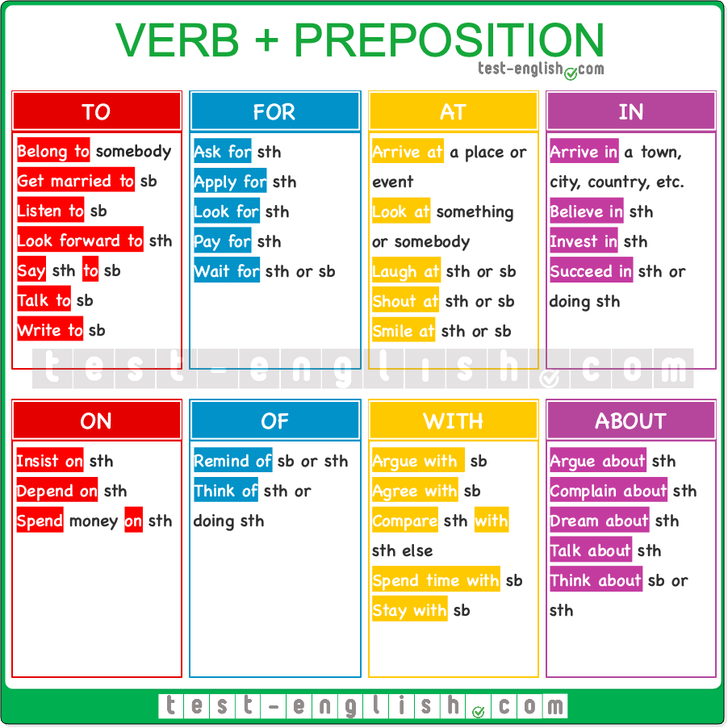

### Example sentences

#### To

* He **got married to** his high school sweetheart last summer.
* She **belongs to** a book club.
* I always **listen to** music on my way to work.
* I **look forward to** the weekend.
* He **said to** me that he would be late.
* We **talk to** our parents every weekend.
* She **writes to** her pen pal in New Zealand every month.

#### For

* She **asked for** a piece of advice.
* He **applied for** the job but didn’t get it.
* They **are looking for** the keys but can’t find them.
* I **paid for** the groceries.
* I**‘m waiting for** Sandra.

#### At

* She **arrived at** the airport on time.
* He **laughed at** the comedian’s joke.
* He **looked at** the painting in awe.
* They **shouted at** the team in encouragement.
* She **smiled at** me when I entered the room.

#### In

* She **arrived in** New York yesterday.
* He **believes in** being honest at all times.
* They **invest in** real estate as part of their business.
* They **succeeded in** passing all their exams.

#### On

* He **depends on** public transport to get to work.
* She **insists on** having fresh coffee in the morning.
* They **spend** a lot of money **on** gadgets.

#### Of

* She **reminds** me **of** her mother.
* He **thinks of** a new idea every day.

#### With

* She **argues with** her brother a lot.
* He **agrees with** the proposed plan.
* They **compare with** each other too often.
* We **spend time with** our family during the holidays.
* He has decided to **stay with** his cousin for the summer.

#### About

* She **argues about** politics frequently.
* He **complains about** the weather constantly.
* She **dreams about** becoming an astronaut.
* We often **talk about** our future plans.
* He **thinks about** changing his job frequently.

## Adjectives & prepositions – dependant prepositions

Some adjectives are usually followed by a preposition. These prepositions are called dependant prepositions. Check the list of some of the most common of these adjectives below.  
  
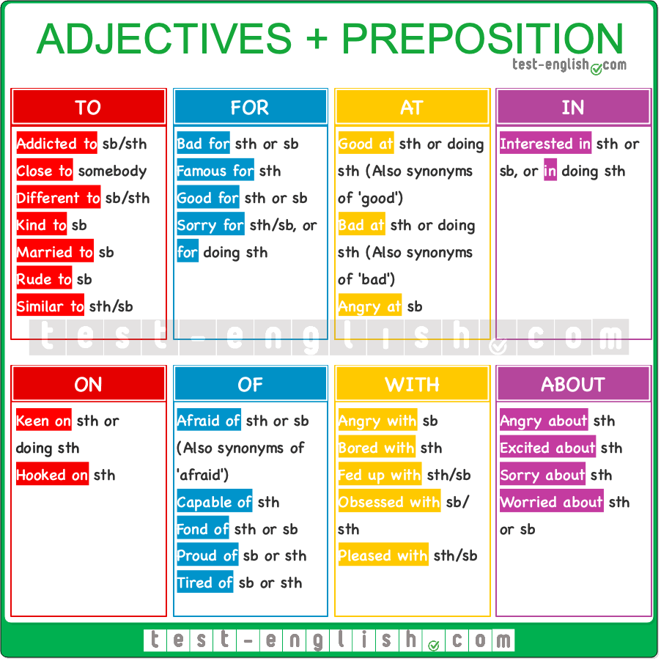

### Example sentences

#### To

* She is **addicted to** coffee.
* He is very **close to** his grandmother.
* This recipe is **different to/from** the one I usually use.
* It’s important to be **kind to** animals.
* My aunt is **married to** a musician.
* It’s not nice to be **rude to** strangers.
* Your handwriting is **similar to** mine.

#### For

* Smoking is **bad for** your health.
* Italy is **famous for** its delicious food.
* Walking is **good for** your heart.
* I am **sorry for** any inconvenience caused.

#### At

* She is **good at** mathematics.
* He’s **bad at** lying; you can always tell the truth.
* He was **angry at** himself for making that mistake.

#### In

* Are you **interested in** learning Spanish?

#### On

* My brother is **keen on** playing the guitar.
* She got **hooked on** the new TV series.

#### Of

* Many children are **afraid of** the dark.
* You are **capable of** achieving great things.
* She is very **fond of** her pets.
* They are **proud of** their cultural heritage.
* I’m **tired of** doing the same routine every day.

#### With

* She was **angry with** him for forgetting her birthday.
* He’s **bored with** the same lunch every day.
* She is **fed up with** the constant delays.
* He is **obsessed with** collecting stamps.
* They were **pleased with** the results of the test.

#### About

* She is **angry about** the cancelled flight.
* We’re **excited about** our upcoming vacation.
* I am **sorry about** the broken window.
* They are **worried about** the weather for the wedding.

## ****During, for, while****: Grammar chart

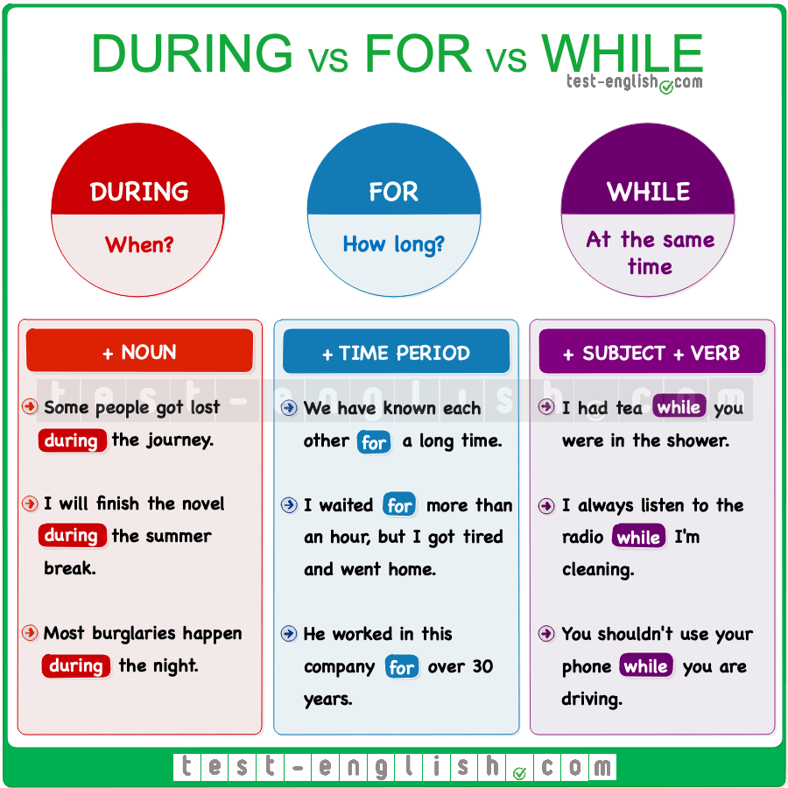

## ****During****

We use **during** + noun to talk about **when** something happens. With **during**, we answer the question **when**.

* Some people got lost **during** the journey.
* I will finish the novel **during** the summer break.
* Most burglaries happen **during** the night.

## ****For****

We use **for** + length of time to say **how long** something happens. With **for**, we answer the question **how long**.

* We have known each other **for** a long time.
* I waited **for** more than an hour, but I finally left.
* He worked in this company **for** over twenty years.

## ****While****

We use **while** + subject + verb to talk about two things that are happening at the same time.

* I had breakfast **while** you were in the shower.
* I always listen to the radio **while** I’m cleaning.
* You shouldn’t use your phone **while** you are driving.

#### ****During**** vs ****For****

The difference between **during** and **for** is that **during**refers to ‘when’ something happens and **for** refers to ‘how long’ something happens. Compare:

* Every day I run **for** one hour. (=How long do you run?)
* I usually run **during** the weekend. (=When do you run?)

#### ****During**** vs ****While****

The main difference between **during** and **while** is that we use **while** + clause (subject + verb), and we use **during** + noun. Compare:

* I fell asleep **during** the film.
* I fell asleep **while** I was watching the film.

## ****For, since, from****: Grammar chart

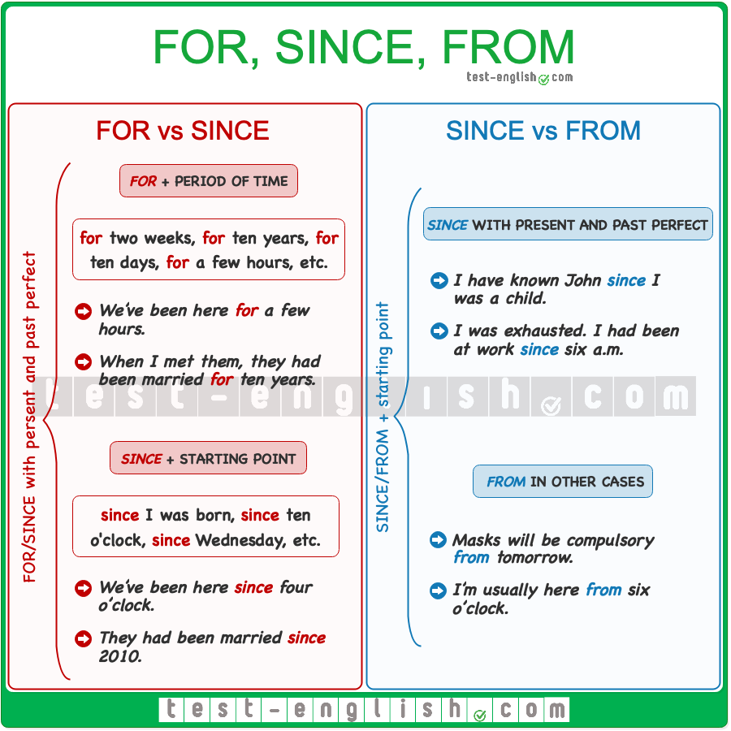

## ****For**** vs ****Since****

We can use **for** and **since** with the present perfect or past perfect simple or continuous.  
  
We use **for** + a period of time, e.g. **for** two weeks, **for** ten years, **for** ten days, **for** a few hours, etc.

* We’**ve been** here **for** a few hours.
* He**’s been studying for** a long time.
* When I met them, they**had been** married **for** ten years.

We can also use **for** with the past simple when an action or event started in the past and also finished in the past after some time. Compare:

* I have lived in London **for** 20 years. (=I am living in London now. The action has not finished.)
* I lived in London **for** 20 years. (=I am not living in London now. The action started and finished in the past.)

We use **since** + a starting point (the moment that marks the beginning of a period of time), e.g. **since** I was born, **since** 10 o’clock, **since** last Wednesday, etc.

* We’**ve been** here **since** 4 o’clock.
* He**’s been studying since** he got up.
* They**had been** married **since** 2010.

## ****Since**** vs ****from****

We use **since** and **from** + starting point. They are used to mark the beginning of something: an action, a state or an event.

We normally use **since** with the present or past perfect to talk about the duration of an action, event or state. **Since** indicates the starting point of this action, event or state.

* I have known John **since** I was a child.
* He’s been working for us **since** he finished school.
* I was exhausted; I had been at work **since** six a.m.

We use **from** in other cases.

* Masks will be compulsory **from** tomorrow.
* I’m usually here **from** six o’clock.

When we use **from** to indicate the starting point of something, we can also use **to**or **until/till** to mark its endpoint.

* I work **from** 8 a.m. **to** 6 p.m. (or **until/till** 6 p.m.)
* *The city reported 400 new COVID-19 cases* ***from*** *Friday* ***to*** *Sunday.*(or **until/till** Sunday)